Supplementary Information:
Supplementary figures:
Figure S1. Full amoA (A) and 16S rRNA (B) gene trees for the bacterial ammonia oxidiser reference sequences.
A)
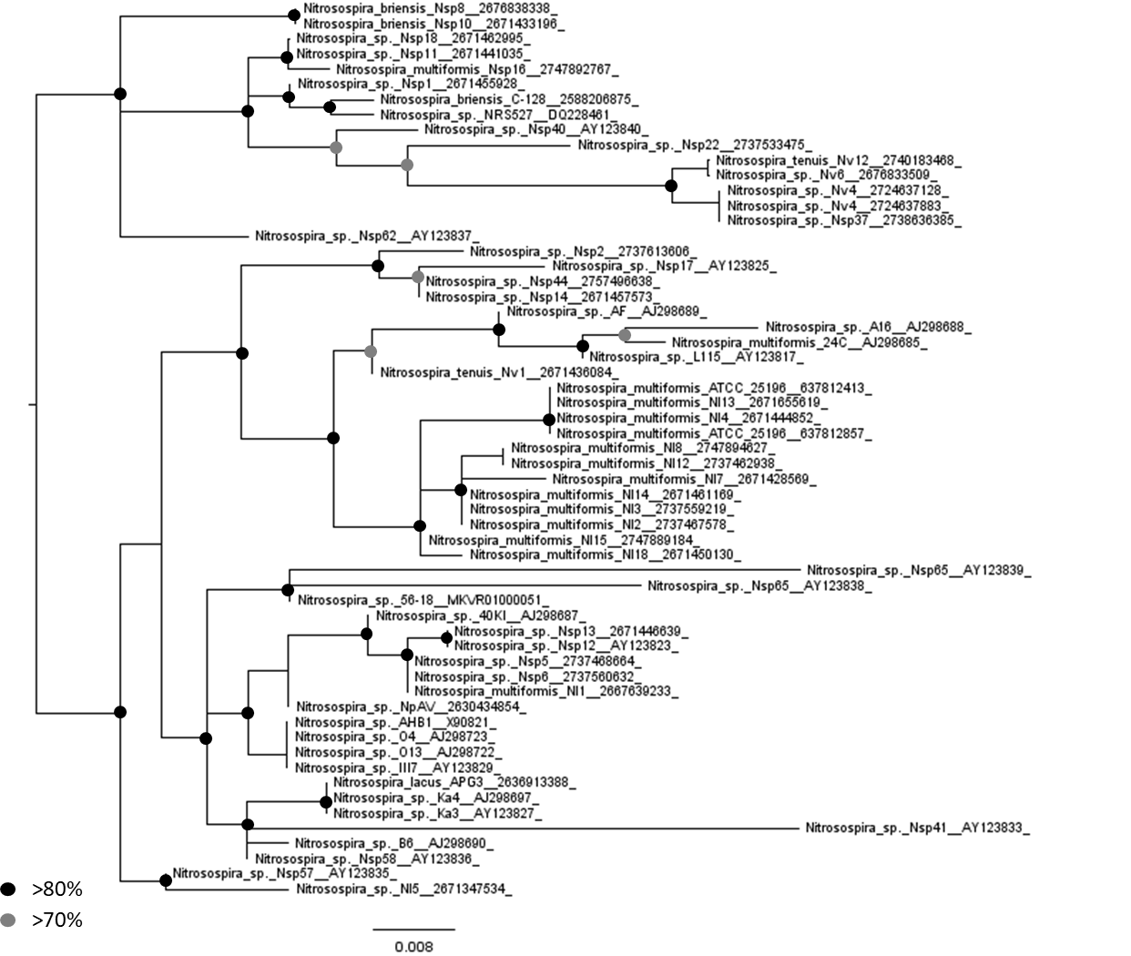

B)
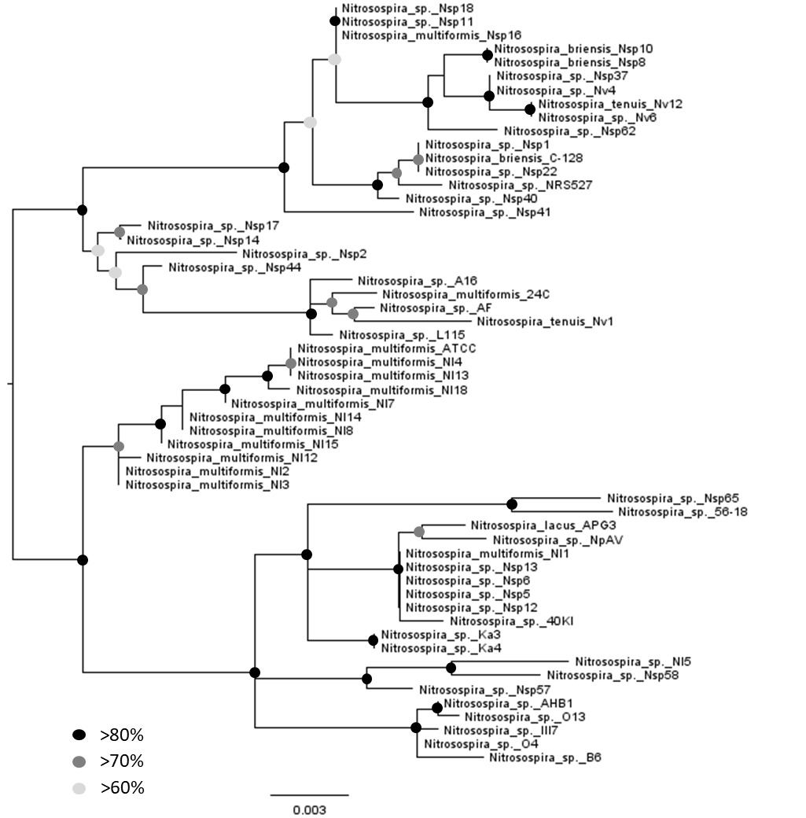

Figure S2. Congruence of amoA and 16S rRNA gene phylogenetic trees for the bacterial ammonia oxidiser reference sequences. Shades of blue indicate similarity between the most common nodes between the two trees.
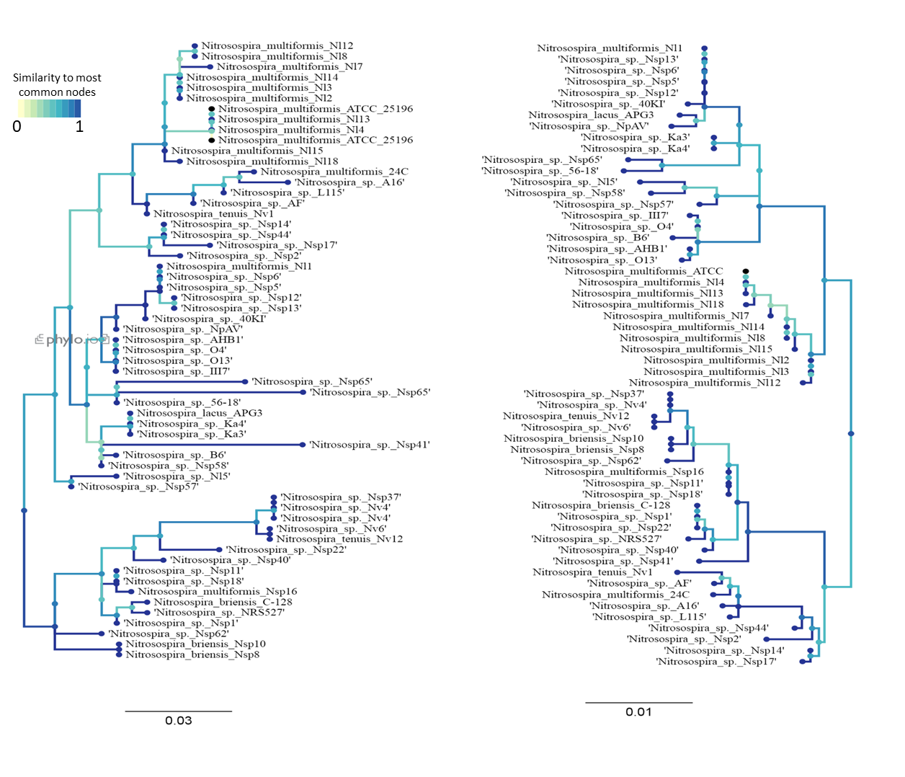

Figure S3: Full bacterial amoA gene tree including the environmental sequences (assembled using the MiSeq ‘Assembly’ pipeline) and the reference sequences.
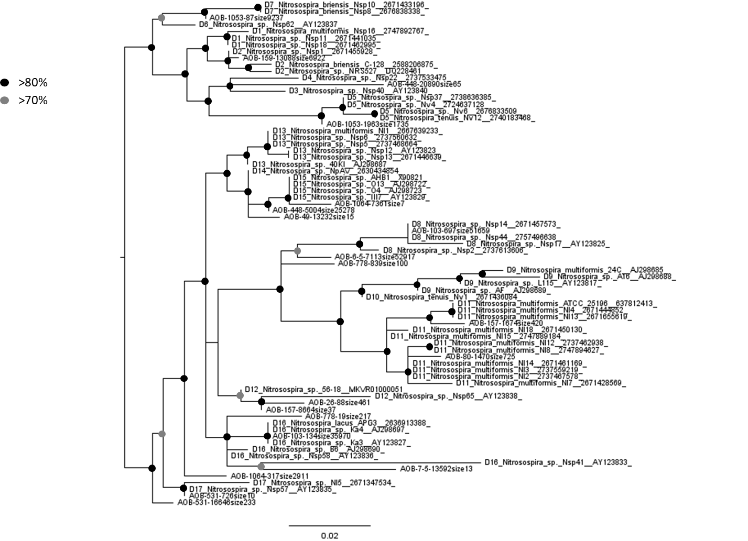

Figure S4: Congruence between two phylogenetic trees of 370 archaeal amoA sequences (see Gubry-Rangin et al., 2015) with (A) or without (B) the sequence gap corresponding to the MiSeq AOA gap pipeline. Branch colour corresponds to congruence between the two trees.

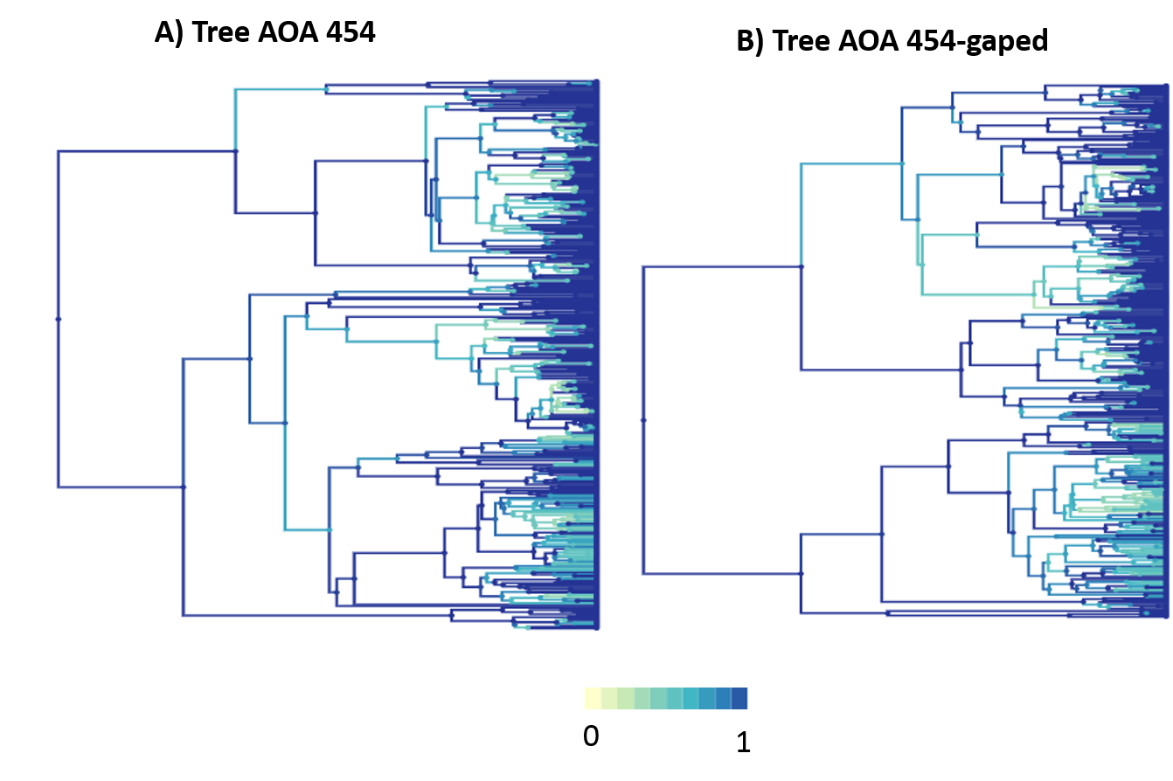

Supplementary tables:
Table S1. Identification of sequences of the 56 terrestrial Nitrosospira AOB strains used in this study. For strains with >1 copy, only the sequences used in this study are presented. n.a. – not applicable.
Organism | amoA gene ID | 16S rRNA gene ID
Nitrosospira multiformis Nsp16 | 2747892767 | 2747891151
Nitrosospira sp. Nsp18 | 2671462995 | 2671464162
Nitrosospira sp. 1 Nsp11 | 2671441035 | 2671440229
Nitrosospira briensis C-128 | 2588206875, 2588206327, 2588205525 | NZ_CP012371
Nitrosospira sp. Nsp1 | 2671455928 | 2671452938
Nitrosospira sp. NRS527 | DQ228461 | AF353158
Nitrosospira sp. Nsp22 | 2737533475 | 2737532035
Nitrosospira sp. Nsp40 | AY123840 | AY123787
Nitrosospira multiformis 24C | AF042171 | AF408634
Nitrosospira sp. L115 | AY123817 | AY123796
Nitrosospira tenuis Nv1 | 2671436084 | 2671436341
Nitrosospira sp. A16 | AJ298688 | AJ005544
Nitrosospira sp. AF | AJ298689 | X84658
Nitrosospira briensis Nsp10 | 2671433196 | 2671432470
Nitrosospira briensis Nsp8 | 2676838338 | 2676836691
Nitrosospira sp. Nsp62 | AY123837 | AY123790
Nitrosospira tenuis Nv12 | 2740183468 | 2676833655
Nitrosospira sp. Nv6 | 2676833509 | 2740183743
Nitrosospira sp. Nsp37 | 2738636385 | 2738633597
Nitrosospira sp. Nv4 | 2724637883, 2724637128 | 2724637574
Nitrosospira multiformis ATCC 25196 | 637812857, 637812413, 637810885 | AY123807
Nitrosospira multiformis Nl13 | 2671655619 | 2671654789
Nitrosospira multiformis Nl4 | 2671444852 | 2671442926
Nitrosospira multiformis Nl18 | 2671450130 | 2671449885
Nitrosospira multiformis Nl15 | 2747889184 | 2747888193
Nitrosospira multiformis Nl14 | 2671461169 | 2671459434
Nitrosospira multiformis Nl7 | 2671428569 | 2671429534
Nitrosospira multiformis Nl8 | 2747894627 | 2747894303
Nitrosospira multiformis Nl12 | 2737462938 | 2737462066
Nitrosospira multiformis Nl2 | 2737467578 | 2737465391
Nitrosospira multiformis Nl3 | 2737559219 | 2737556968
Nitrosospira sp. Nsp2 | 2737613606 | 2737612607
Nitrosospira sp. Nsp14 | 2671457573 | 2671456229
Nitrosospira sp. Nsp44 | 2757496638, 2757494294, 2757494089 | 2757496171
Nitrosospira sp. Nsp17 | AY123825 | AY123804
Nitrosospira sp. Nsp5 | 2737468664 | 2737469961
Nitrosospira multiformis Nl1 | 2667639233, 2667638847, 2667636517 | 2667636937
Nitrosospira sp. Nsp13 | 2671446639 | 2671447611
Nitrosospira sp. Nsp6 | 2737560632 | 2737561558
Nitrosospira sp. Nsp12 | AY123823 | AY123801
Nitrosospira sp. 40KI | AJ298687 | X84656
Nitrosospira sp. NpAV | 2630434854 | 2630432220
Nitrosospira sp. Nsp65 | AY123838, AY123839 | AY123813
Nitrosospira sp. 56-18 | MKVR01000051 | MKVR01000014.1:c34397-32855
Nitrosospira sp. III7 | AY123829 | AY123809
Nitrosospira sp. O13 | AJ298722 | AJ012108
Nitrosospira sp. O4 | AJ298723 | AJ012107
Nitrosospira sp. AHB1 | X90821 | X90820
Nitrosospira sp. Ka4 | AJ298697 | AJ012106
Nitrosospira sp. Ka3 | AY123827 | AY123806
Nitrosospira lacus APG3 | 2636913388 | 2636911585
Nitrosospira sp. Nsp41 | AY123833 | AY123788
Nitrosospira sp. B6 | AJ298690 | X84657
Nitrosospira sp. Nsp58 | AY123836 | AY123789
Nitrosospira sp. Nsp57 | AY123835 | AY123791
Nitrosospira sp. Nl5 | 2671347534 | 2671347268

Table S2. Statistical results of the canonical correspondence and permutation analyses performed on the AOB amoA communities clustered at different identity cut-offs.
Identity = 100% ; Number of clusters = 3868
Call: cca(formula = Clusters ~ pH + C + N + CN + Moisture + LOI +
vegetation, data = Facteur[1:8])

Inertia Proportion Rank
Total 12.6945 1.0000
Constrained 4.5538 0.3587 9
Unconstrained 8.1406 0.6413 23
Inertia is scaled Chi-square

Eigenvalues for constrained axes:
CCA1 CCA2 CCA3 CCA4 CCA5 CCA6 CCA7 CCA8 CCA9
0.8032 0.7069 0.6536 0.5810 0.5085 0.4061 0.3528 0.2890 0.2528

Eigenvalues for unconstrained axes:
CA1 CA2 CA3 CA4 CA5 CA6 CA7 CA8
0.7089 0.6253 0.5917 0.5382 0.4919 0.4831 0.4576 0.4336
(Showing 8 of 23 unconstrained eigenvalues)
Permutation test for cca under reduced model
Permutation: free
Number of permutations: 999

Model: cca(formula = Clusters ~ pH + C + N + CN + Moisture + LOI + vegetation, data = Facteur[1:8])
Df ChiSquare F Pr(>F)
Model 9 4.5538 1.4296 0.001 ***
Residual 23 8.1406
---
Signif. codes: 0 ‘***’ 0.001 ‘**’ 0.01 ‘*’ 0.05 ‘.’ 0.1 ‘ ’ 1
Permutation test for cca under reduced model
Terms added sequentially (first to last)
Permutation: free
Number of permutations: 999

Model: cca(formula = Clusters ~ pH + C + N + CN + Moisture + LOI + vegetation, data = Facteur[1:8])
Df ChiSquare F Pr(>F)
pH 1 0.6672 1.8852 0.001 ***
C 1 0.6593 1.8628 0.001 ***
N 1 0.5577 1.5756 0.001 ***
CN 1 0.5227 1.4769 0.002 **
Moisture 1 0.4820 1.3618 0.015 *
LOI 1 0.4414 1.2472 0.072 .
vegetation 3 1.2235 1.1522 0.106
Residual 23 8.1406
---
Signif. codes: 0 ‘***’ 0.001 ‘**’ 0.01 ‘*’ 0.05 ‘.’ 0.1 ‘ ’ 1
Identity = 97% ; Number of clusters = 187
Call: cca(formula = Clusters ~ pH + C + N + CN + Moisture + LOI +
vegetation, data = Facteur[1:8])

Inertia Proportion Rank
Total 4.4355 1.0000
Constrained 2.0083 0.4528 9
Unconstrained 2.4272 0.5472 23
Inertia is scaled Chi-square

Eigenvalues for constrained axes:
CCA1 CCA2 CCA3 CCA4 CCA5 CCA6 CCA7 CCA8 CCA9
0.6766 0.4015 0.3666 0.1763 0.1309 0.1100 0.0694 0.0528 0.0242

Eigenvalues for unconstrained axes:
CA1 CA2 CA3 CA4 CA5 CA6 CA7 CA8
0.4459 0.3753 0.2368 0.1910 0.1812 0.1564 0.1431 0.1231
(Showing 8 of 23 unconstrained eigenvalues)
Permutation test for cca under reduced model
Permutation: free
Number of permutations: 999

Model: cca(formula = Clusters ~ pH + C + N + CN + Moisture + LOI + vegetation, data = Facteur[1:8])
Df ChiSquare F Pr(>F)
Model 9 2.0083 2.1146 0.001 ***
Residual 23 2.4272
---
Signif. codes: 0 ‘***’ 0.001 ‘**’ 0.01 ‘*’ 0.05 ‘.’ 0.1 ‘ ’ 1
Permutation test for cca under reduced model
Terms added sequentially (first to last)
Permutation: free
Number of permutations: 999

Model: cca(formula = Clusters ~ pH + C + N + CN + Moisture + LOI + vegetation, data = Facteur[1:8])
Df ChiSquare F Pr(>F)
pH 1 0.44840 4.2490 0.001 ***
C 1 0.27747 2.6293 0.006 **
N 1 0.20377 1.9309 0.020 *
CN 1 0.28338 2.6853 0.003 **
Moisture 1 0.15234 1.4436 0.112
LOI 1 0.19678 1.8647 0.032 *
vegetation 3 0.44619 1.4094 0.083 .
Residual 23 2.42718
---
Signif. codes: 0 ‘***’ 0.001 ‘**’ 0.01 ‘*’ 0.05 ‘.’ 0.1 ‘ ’ 1
Identity = 95% ; Number of clusters = 71
Call: cca(formula = Clusters ~ pH + C + N + CN + Moisture + LOI +
vegetation, data = Facteur[1:8])

Inertia Proportion Rank
Total 3.2686 1.0000
Constrained 1.5383 0.4706 9
Unconstrained 1.7303 0.5294 23
Inertia is scaled Chi-square

Eigenvalues for constrained axes:
CCA1 CCA2 CCA3 CCA4 CCA5 CCA6 CCA7 CCA8 CCA9
0.6433 0.3564 0.1501 0.1477 0.0856 0.0686 0.0377 0.0362 0.0128

Eigenvalues for unconstrained axes:
CA1 CA2 CA3 CA4 CA5 CA6 CA7 CA8
0.3975 0.3461 0.2169 0.1526 0.1356 0.0991 0.0843 0.0800
(Showing 8 of 23 unconstrained eigenvalues)
Permutation test for cca under reduced model
Permutation: free
Number of permutations: 999

Model: cca(formula = Clusters ~ pH + C + N + CN + Moisture + LOI + vegetation, data = Facteur[1:8])
Df ChiSquare F Pr(>F)
Model 9 1.5383 2.2719 0.001 ***
Residual 23 1.7303
---
Signif. codes: 0 ‘***’ 0.001 ‘**’ 0.01 ‘*’ 0.05 ‘.’ 0.1 ‘ ’ 1
Permutation test for cca under reduced model
Terms added sequentially (first to last)
Permutation: free
Number of permutations: 999

Model: cca(formula = Clusters ~ pH + C + N + CN + Moisture + LOI + vegetation, data = Facteur[1:8])
Df ChiSquare F Pr(>F)
pH 1 0.42334 5.6271 0.001 ***
C 1 0.22256 2.9583 0.003 **
N 1 0.17875 2.3759 0.016 *
CN 1 0.23958 3.1845 0.002 **
Moisture 1 0.09317 1.2385 0.264
LOI 1 0.10060 1.3372 0.198
vegetation 3 0.28028 1.2418 0.172
Residual 23 1.73034
---
Signif. codes: 0 ‘***’ 0.001 ‘**’ 0.01 ‘*’ 0.05 ‘.’ 0.1 ‘ ’ 1
Identity = 90% ; Number of clusters = 14
Call: cca(formula = Clusters ~ pH + C + N + CN + Moisture + LOI +
vegetation, data = Facteur[1:8])

Inertia Proportion Rank
Total 1.4662 1.0000
Constrained 0.7205 0.4914 9
Unconstrained 0.7457 0.5086 12
Inertia is scaled Chi-square

Eigenvalues for constrained axes:
CCA1 CCA2 CCA3 CCA4 CCA5 CCA6 CCA7 CCA8 CCA9
0.4842 0.1066 0.0653 0.0241 0.0192 0.0187 0.0018 0.0005 0.0001

Eigenvalues for unconstrained axes:
CA1 CA2 CA3 CA4 CA5 CA6 CA7 CA8 CA9 CA10
0.31029 0.19680 0.11418 0.05716 0.03395 0.01682 0.01435 0.00089 0.00047 0.00046
CA11 CA12
0.00023 0.00012
Permutation test for cca under reduced model
Permutation: free
Number of permutations: 999

Model: cca(formula = Clusters ~ pH + C + N + CN + Moisture + LOI + vegetation, data = Facteur[1:8])
Df ChiSquare F Pr(>F)
Model 9 0.72051 2.4692 0.001 ***
Residual 23 0.74572
---
Signif. codes: 0 ‘***’ 0.001 ‘**’ 0.01 ‘*’ 0.05 ‘.’ 0.1 ‘ ’ 1
Permutation test for cca under reduced model
Terms added sequentially (first to last)
Permutation: free
Number of permutations: 999

Model: cca(formula = Clusters ~ pH + C + N + CN + Moisture + LOI + vegetation, data = Facteur[1:8])
Df ChiSquare F Pr(>F)
pH 1 0.25949 8.0034 0.001 ***
C 1 0.04258 1.3132 0.274
N 1 0.05290 1.6316 0.166
CN 1 0.17623 5.4355 0.001 ***
Moisture 1 0.02816 0.8685 0.459
LOI 1 0.05754 1.7746 0.139
vegetation 3 0.10361 1.0652 0.406
Residual 23 0.74572
---
Signif. codes: 0 ‘***’ 0.001 ‘**’ 0.01 ‘*’ 0.05 ‘.’ 0.1 ‘ ’ 1

Table S3. Number of sequences and richness of AOA and AOB amoA sequences retrieved in each Craibstone soil sample with different sequencing technologies, with or without rarefaction to the smallest number of sequences obtained in one of the two technologies.

Organisms | Technologies | Total # reads |  |  | OTU richness
 |  | Raw reads | Post filtering | Post cleaning/assembly | Rare-faction | # sequences | 4.5 | 5 | 5.5 | 6 | 6.5 | 7 | 7.5
AOA | 454 | 42,193 | N/A | 9,429 (2,474 clusters) | N/A | 868 | 233 | 328 | 174 | 147 | 261 | 331 | 354
 | MiSeq “gap” | 358,872 | 260,413 | 74,771 (775 clusters) | Without | 8,287 | 194 | 230 | 295 | 139 | 114 | 184 | 153
 |  |  |  |  | With | 868 | 107 | 162 | 189 | 113 | 130 | 204 | 165
AOB | MiSeq “assembly” | 377,172 | 204,315 | 40,509 (902 clusters) | N/A | 4,261 | 61 | 283 | 203 | 220 | 224 | 212 | 209
 | MiSeq “gap” | 377,172 | 258,688 | 75,349 (1,016 clusters) | Without | 8,160 | 68 | 347 | 267 | 224 | 247 | 252 | 253
 |  |  |  |  | With | 4,261 | 67 | 317 | 248 | 217 | 233 | 227 | 236

Table S4. Characteristics of the 33 UK soils (26 CEH followed by 7 Craibstone soils) used in the multivariate statistics analysis.
Site | pH | C (%) | N (%) | C:N ratio | H₂O (%) | Organic matter (%) | Simplified aggregate vegetation class
1 | 4.4 | 3.3 | 0.39 | 8.46 | 26.7 | 6.58 | grassland
2 | 4.8 | 2.1 | 0.22 | 9.55 | 22.8 | 4.88 | grassland
3 | 7.6 | 3.2 | 0.34 | 9.41 | 30.4 | 6.26 | agricultural
4 | 8.3 | 19 | 1.28 | 14.84 | 47.5 | 24.1 | grassland
5 | 8.5 | 11 | 0.7 | 15.71 | 16.4 | 12.08 | grassland
6 | 6.9 | 2 | 0.16 | 12.5 | 24.1 | 4.14 | grassland
7 | 7.7 | 5.3 | 0.56 | 9.46 | 34 | 11.17 | grassland
8 | 6.7 | 1.4 | 0.13 | 10.77 | 15.4 | 2.91 | agricultural
9 | 8.1 | 2.9 | 0.31 | 9.35 | 23.3 | 5.82 | agricultural
10 | 7.9 | 1.9 | 0.18 | 10.56 | 17.7 | 4.03 | forest
11 | 8.7 | 1.3 | 0.13 | 10 | 15.8 | 2.66 | agricultural
12 | 5.3 | 2.1 | 0.2 | 10.5 | 14.5 | 5 | grassland
13 | 6.4 | 1.5 | 0.15 | 9.63 | 35.2 | 10.05 | grassland
14 | 8.2 | 1.7 | 0.18 | 9.44 | 19.9 | 3.72 | grassland
15 | 6.2 | 3.1 | 0.31 | 10 | 29.2 | 5.78 | grassland
16 | 6.8 | 13 | 0.7 | 18.57 | 55.9 | 20.1 | forest
17 | 6.8 | 7.5 | 0.51 | 14.71 | 35.6 | 12.29 | grassland
18 | 8.1 | 2.5 | 0.23 | 10.87 | 20.6 | 5.1 | agricultural
19 | 8.6 | 5.4 | 0.35 | 15.43 | 27.1 | 6.23 | agricultural
20 | 7.2 | 2.5 | 0.17 | 14.71 | 15.8 | 4.51 | agricultural
21 | 6.4 | 3.4 | 0.21 | 16.19 | 14.2 | 5.29 | agricultural
22 | 3.5 | 22.6 | 1.08 | 20.93 | 75.2 | 40.63 | moorland
23 | 6.9 | 1.7 | 0.16 | 10.63 | 15.7 | 3.2 | grassland
24 | 5.6 | 8 | 0.57 | 14.04 | 46.3 | 15.99 | grassland
25 | 8.5 | 4.5 | 0.31 | 14.52 | 33 | 8.91 | grassland
26 | 6.7 | 4.7 | 0.41 | 11.46 | 38.4 | 10 | agricultural
27 | 4.5 | 7.02 | 0.38 | 18.64 | 29.7 | 12.07 | agricultural
28 | 5 | 6.6 | 0.37 | 18.03 | 30.9 | 11.35 | agricultural
29 | 5.5 | 7.42 | 0.4 | 18.45 | 31 | 12.77 | agricultural
30 | 6 | 6.57 | 0.31 | 21.43 | 30.2 | 11.29 | agricultural
31 | 6.5 | 6.42 | 0.29 | 22.03 | 29.4 | 11.04 | agricultural
32 | 7 | 7.97 | 0.36 | 22.09 | 31 | 13.71 | agricultural
33 | 7.5 | 7.14 | 0.34 | 20.84 | 29.1 | 12.28 | agricultural

