Western blot data. Images of Western blots from screening the monoclonal antibodies (mAbs) using recombinant proteins and cell line lysates. The recombinant proteins were obtained from Origene (Rockville, MD) or Novus (Littleton, CO). Expected molecular weights (MWs, provided by the vendors) of the recombinant proteins are given in the captions above the Western blot images. For the Western blots using the cell lines, the MWs given in the captions above the images are reported as given in UniProt, including the MWs of all protein isoforms.

Table of contents (giving the gene symbol, the peptide sequences and applicable phosphosites, and the CPTAC mAb ID on the Antibody Portal). If a mAb is able to capture both the phospho and its corresponding unmodified peptide, then both peptide sequences are given. If additional proteins are captured, the additional gene symbols and peptide sequences and phospho sites are given as well.

AKT1, SLLSGLLK, CPTC-AKT1-1……………………………………………………………………………………….4

AKT1, (pT)FCGTPEYLAPEVLEDNDYGR (pT308), TFCGTPEYLAPEVLEDNDYGR, CPTC-AKT1-2…………..4

AKT1, (pT)FCGTPEYLAPEVLEDNDYGR (pT308), CPTC-AKT1-4………………………………………………….4

AKT2, THFPQF(pS)YSASIRE (pS473), THFPQFSYSASIRE, THFPQF(pS)YSASIR (pS473), THFPQFSYSASIR, CPTC-AKT2-1………………………………………………...…………………………………….5

AKT2, THFPQF(pS)YSASIRE (pS473), THFPQFSYSASIRE, THFPQF(pS)YSASIR (pS473), THFPQFSYSASIR, CPTC-AKT2-2………………………………………………...…………………………………….5

AKT2, THFPQF(pS)YSASIRE (pS473), THFPQFSYSASIRE, THFPQF(pS)YSASIR (pS473), THFPQFSYSASIR; AKT1, RPHFPQFSYSASGTA; AKT3, RPHFPQF(pS)YSASGRE (pS472), RPHFPQFSYSASGRE, RPHFPQF(pS)YSASGR (pS472), RPHFPQFSYSASGR, CPTC-AKT2-6……………...5

AKT3, DEVAHTLTESR, CPTC-AKT3-7…………………………………………………………………………………6

AKT3, RPHFPQF(pS)YSASGRE (pS472), RPHFPQFSYSASGRE, RPHFPQF(pS)YSASGR (pS472), RPHFPQFSYSASGR; AKT1, RPHFPQF(pS)YSASGTA (pS473), RPHFPQFSYSASGTA, CPTC-AKT3-1…….6

AKT3, RPHFPQF(pS)YSASGRE (pS472), RPHFPQFSYSASGRE, RPHFPQF(pS)YSASGR (pS472), RPHFPQFSYSASGR; AKT1, RPHFPQF(pS)YSASGTA (pS473), RPHFPQFSYSASGTA; AKT2, THFPQF(pS)YSASIRE (pS473), THFPQFSYSASIRE, THFPQF(pS)YSASIR (pS473), THFPQFSYSASIR, CPTC-AKT3-2………………………………………………………………………………………………………………6

AKT3, RPHFPQF(pS)YSASGRE (pS472), RPHFPQF(pS)YSASGR (pS472); AKT1, RPHFPQF(pS)YSASGTA (pS473); AKT2, THFPQF(pS)YSASIRE (pS473), THFPQF(pS)YSASIR (pS473), CPTC-AKT3-3……………….7

AKT3, RPHFPQF(pS)YSASGRE (pS472), RPHFPQFSYSASGRE, RPHFPQF(pS)YSASGR (pS472), RPHFPQFSYSASGR; AKT1, RPHFPQF(pS)YSASGTA (pS473), RPHFPQFSYSASGTA; AKT2, THFPQF(pS)YSASIRE (pS473), THFPQFSYSASIRE, THFPQF(pS)YSASIR (pS473), THFPQFSYSASIR, CPTC-AKT3-4………………………………………………………………………………………………………………7

ARAF, D(pS)GYYWEVPPSEVQLLK (pS299), DSGYYWEVPPSEVQLLK, CPTC-ARAF-4………………………8

ARAF, IGTGSFGTVFR, CPTC-ARAF-2…………………………………………………………………………………8

ARAF, TQADELPACLLSAAR, CPTC-ARAF-3…………………………………………………………………………8

BRAF, AGFQTEDFSLYACASPK, CPTC-BRAF-3……………………………………………………………………..9

BRAF, GDGGSTTGLSA(pT)PPASLPGSLTNVK (pT401), GDGGSTTGLSATPPASLPGSLTNVK, CPTC-BRAF-6……………………………………………………………………………………………………………………………...9

BRAF, GDGGSTTGLSA(pT)PPASLPGSLTNVK (pT401), GDGGSTTGLSATPPASLPGSLTNVK, CPTC-BRAF-7………………………………………………………………………………………….…………………………………..9

BRAF, RDSSDDWEIPDGQITVGQR, CPTC-BRAF-5………………………………………………………………..10

CCND1, AEETCAPSVSYFK, CPTC-CCND1-5……………………………………………………………………….11

CCND1, AYPDANLLNDR, CPTC-CCND1-3…………………………………………………………………………..11

CCND1, FLSLEPVKK, CPTC-CCND1-1……………………………………………………………………………….11

CDH1, GLDARPEVTR, CPTC-CDH1-1………………………………………………………………………………..12

CDH1, GLDARPEVTR, CPTC-CDH1-2………………………………………………………………………………..12

CDH1, GQVPENEANVVITTLK, CPTC-CDH1-3………………………………………………………………………12

CDH1, GQVPENEANVVITTLK, CPTC-CDH1-4………………………………………………………………………13

CDH1, NTGVISVVTTGLDR, CPTC-CDH1-5………………………………………………………………………….13

CDH2, SAAPHPGDIGDFINEGLK, CPTC-CDH2-4…………………………………………………………………...14

EGFR, IPLENLQIIR, CPTC-EGFR-6…………………………………………………………………………………...15

EGFR, NLQEILHGAVR, CPTC-EGFR-7…………………………………………….………………………………...15

ERBB3, YLERGESIEPLDPSEK, CPTC-ERBB3-3………………………………….………………………………..16

FOS, APHPFGVPAPSAGAYSR, CPTC-FOS-3………………………………………………………………………17

FOS, GSSSNEPSSDSLSSPTLLAL, CPTC-FOS-4…………………………………………………………………..17

FOS, TEPFDDFLFPASSR, CPTC-FOS-1……………………………………………………………………………..17

GSK3B, TT(pS)FAESCKPVQQPSAFGSMK (pS9), TTSFAESCKPVQQPSAFGSMK, CPTC-GSK3B-10…….18

GSK3B, TT(pS)FAESCKPVQQPSAFGSMK (pS9), CPTC-GSK3B-9……………………………………………...18

GSK3B, VIGNGSFGVVYQAK, CPTC-GSK3B-7………………………………….…….........................................18

MAP2K1, ISELGAGNGGVVFK, CPTC-MAP2K1-1……………………………………..........................................19

MAPK1, VADPDHDHTGFL(pT)E(pY)VATR (pT185/pY187), VADPDHDHTGFL(pT)EYVATR (pT185), VADPDHDHTGFLTE(pY)VATR (pY187), VADPDHDHTGFLTEYVATR; MAPK3, IADPEHDHTGFL(pT)E(pY)VATR (pT202/pY204), IADPEHDHTGFL(pT)EYVATR (pT202), IADPEHDHTGFLTE(pY)VATR (pY204), IADPEHDHTGFLTEYVATR, CPTC-MAPK1-1………………………..20

MAPK1, VADPDHDHTGFL(pT)E(pY)VATR (pT185/pY187), VADPDHDHTGFL(pT)EYVATR (pT185), MAPK3, IADPEHDHTGFL(pT)E(pY)VATR (pT202/pY204), IADPEHDHTGFL(pT)EYVATR (pT202), CPTC-MAPK1-3…………………………………………………………………………………………………………………………….20

MAPK1, VADPDHDHTGFLTE(pY)VATR (pY187), VADPDHDHTGFLTEYVATR; MAPK3, IADPEHDHTGFLTE(pY)VATR (pY204), IADPEHDHTGFLTEYVATR, CPTC-MAPK1-4………………………..20

MAPK1, VADPDHDHTGFL(pT)E(pY)VATR (pT185/pY187); MAPK3, IADPEHDHTGFL(pT)E(pY)VATR (pT202/pY204), CPTC-MAPK1-2……………………………………………………………………………………….21

MAPK3, IADPEHDHTGFL(pT)E(pY)VATR (pT202/pY204), IADPEHDHTGFL(pT)EYVATR (pT202), IADPEHDHTGFLTE(pY)VATR (pY204), IADPEHDHTGFLTEYVATR; MAPK1, VADPDHDHTGFL(pT)E(pY)VATR (pT185/pY187), VADPDHDHTGFL(pT)EYVATR (pT185), VADPDHDHTGFLTE(pY)VATR (pY187), VADPDHDHTGFLTEYVATR, CPTC-MAPK3-1……........................22

MAPK3, IADPEHDHTGFL(pT)EYVATR (pT202), IADPEHDHTGFLTE(pY)VATR (pY204), IADPEHDHTGFLTEYVATR; MAPK1, VADPDHDHTGFL(pT)EYVATR (pT185), VADPDHDHTGFLTE(pY)VATR (pY187); VADPDHDHTGFLTEYVATR, CPTC-MAPK3-4……….....................22

MAPK3, IADPEHDHTGFL(pT)EYVATR (pT202), IADPEHDHTGFL(pT)E(pY)VATR (pT202/pY204); MAPK1, VADPDHDHTGFL(pT)EYVATR (pT185); VADPDHDHTGFL(pT)E(pY)VATR (pT185/ pY187), CPTC-MAPK3-5…………………………………………………………………………………………………………………………….22

MAPK3, IADPEHDHTGFL(pT)E(pY)VATR (pT202/pY204), IADPEHDHTGFLTE(pY)VATR (pY204); MAPK1, VADPDHDHTGFL(pT)E(pY)VATR (pT185/pY187), VADPDHDHTGFLTE(pY)VATR (pY187), CPTC-MAPK3-6…………............................................................................................................................................................23

MTOR, DLELAVPGTYDPNQPIIR, CPTC-MTOR-8………….…………………………........................................24

MTOR, IQSIAPSLQVITSK, CPTC-MTOR-7………………….………………………….........................................24

MTOR, LFDAPEAPLPSR, CPTC-MTOR-3………………….…………………………..........................................24

MTOR, LTESLDFTDYASR, CPTC-MTOR-5………………….…………………………........................................25

MTOR, LTESLDFTDYASR, CPTC-MTOR-6………………….…………………………........................................25

MTOR, TD(pS)YSAGQSVEILDGVELGEPAHK (pS2448), TDSYSAGQSVEILDGVELGEPAHK, CPTC-MTOR-1..........................................................................................................................................................................25

MTOR, TGTTVPESIH(pS)FIGDGLVKPEALNKK (pS2481), TGTTVPESIHSFIGDGLVKPEALNKK, TGTTVPESIH(pS)FIGDGLVKPEALNK (pS2481), TGTTVPESIHSFIGDGLVKPEALNK, CPTC-MTOR-9…….26

MTOR, TGTTVPESIHSFIGDGLVKPEALNK, CPTC-MTOR-2………………………...........................................26

MTOR, VLGLLGALDPYK, CPTC-MTOR-4………………….…………………………..........................................26

PTEN, AQEALDFYGEVR, CPTC-PTEN-1…………………………………………….…........................................27

PTEN, AQEALDFYGEVR, CPTC-PTEN-5…………………………………………………………………………….27

PTEN, AQEALDFYGEVR, CPTC-PTEN-6……………………………………….………..... ……………………….27

PTEN, AQEALDFYGEVR, CPTC-PTEN-7………………………………………………….....................................28

PTEN, NHLDYRPVALLFHK, CPTC-PTEN-2………………………………………………….................................28

RAF1, ST(pS)TPNVHMVSTTLPVDSR (pS259), CPTC-RAF1-3…………………………………………………...29

RAF1, VVDPTPEQFQAFR, CPTC-RAF1-1……………………………………………………....... ………………..29

RAF1, VVDPTPEQFQAFR, CPTC-RAF1-2……………………………………………...........................................29

RPTOR, ALETIGANLQK, CPTC-RPTOR-2…………………………………………………………………………...30

AKT1, SLLSGLLK, CPTC-AKT1-1

AKT1, (pT)FCGTPEYLAPEVLEDNDYGR (pT308), TFCGTPEYLAPEVLEDNDYGR, CPTC-AKT1-2

AKT1, (pT)FCGTPEYLAPEVLEDNDYGR (pT308), CPTC-AKT1-4

Expected MW from AKT1 recombinant protein (Origene cat. # TP320257) = 55.5 kDa.

UniProt: Isoform 1 MW = 56 kDa, Isoform 2 MW = 48 kDa.

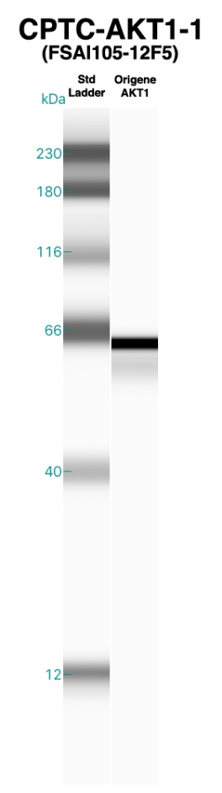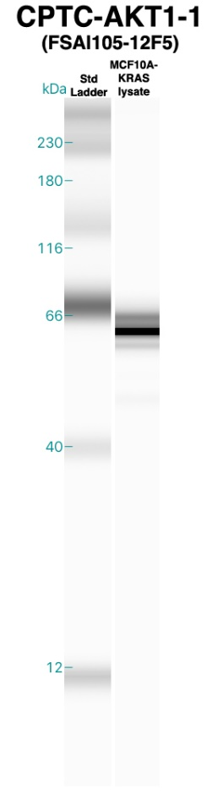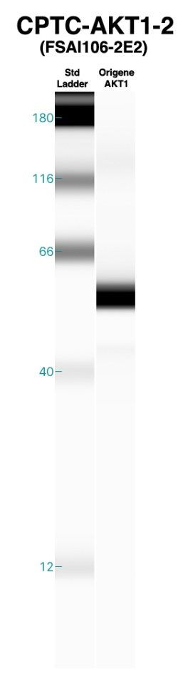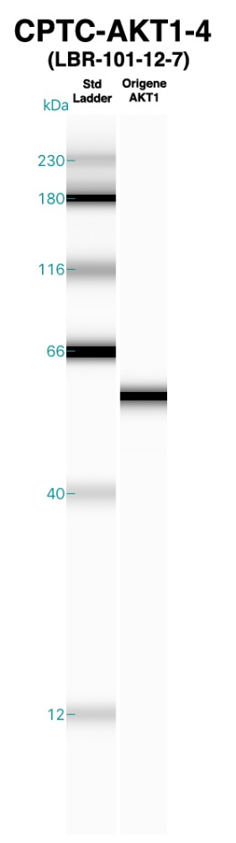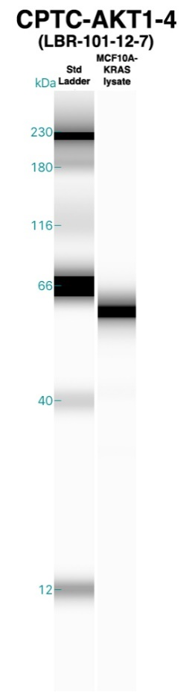
AKT2, THFPQF(pS)YSASIRE (pS473), THFPQFSYSASIRE, THFPQF(pS)YSASIR (pS473), THFPQFSYSASIR, CPTC-AKT2-1

AKT2, THFPQF(pS)YSASIRE (pS473), THFPQFSYSASIRE, THFPQF(pS)YSASIR (pS473), THFPQFSYSASIR, CPTC-AKT2-2

AKT2, THFPQF(pS)YSASIRE (pS473), THFPQFSYSASIRE, THFPQF(pS)YSASIR (pS473), THFPQFSYSASIR; AKT1, RPHFPQFSYSASGTA; AKT3, RPHFPQF(pS)YSASGRE (pS472), RPHFPQFSYSASGRE, RPHFPQF(pS)YSASGR (pS472), RPHFPQFSYSASGR, CPTC-AKT2-6

Expected MW from AKT2 recombinant protein (Origene cat. # TP317733) = 55.6 kDa.

UniProt: Isoform 1 MW = 56 kDa, Isoform 2 MW = 51 kDa.

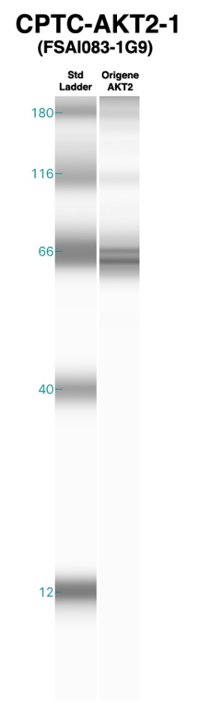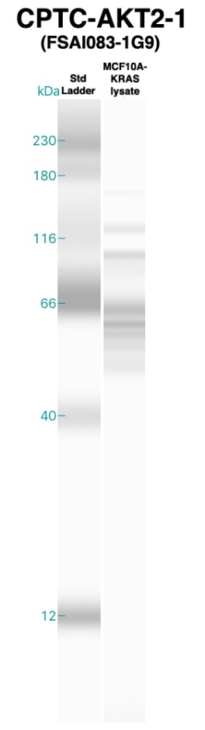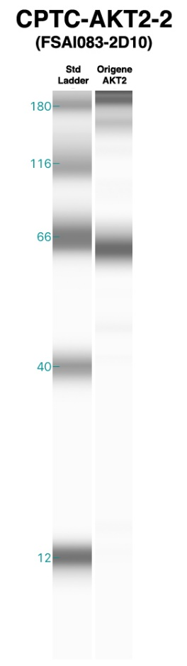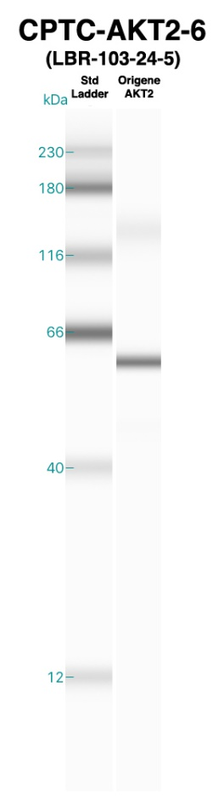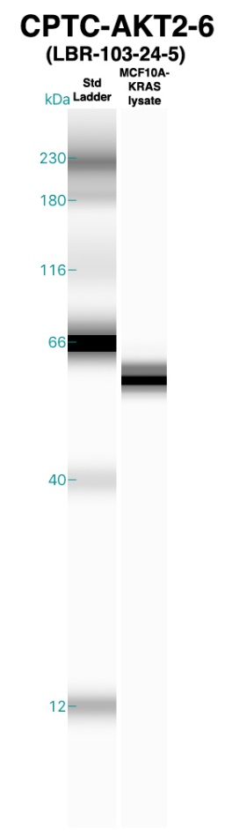

AKT3, DEVAHTLTESR, CPTC-AKT3-7

AKT3, RPHFPQF(pS)YSASGRE (pS472), RPHFPQFSYSASGRE, RPHFPQF(pS)YSASGR (pS472), RPHFPQFSYSASGR; AKT1, RPHFPQF(pS)YSASGTA (pS473), RPHFPQFSYSASGTA, CPTC-AKT3-1

AKT3, RPHFPQF(pS)YSASGRE (pS472), RPHFPQFSYSASGRE, RPHFPQF(pS)YSASGR (pS472), RPHFPQFSYSASGR; AKT1, RPHFPQF(pS)YSASGTA (pS473), RPHFPQFSYSASGTA; AKT2, THFPQF(pS)YSASIRE (pS473), THFPQFSYSASIRE, THFPQF(pS)YSASIR (pS473), THFPQFSYSASIR, CPTC-AKT3-2

Expected MW from AKT3 recombinant protein (Origene cat. # TP321051) = 55.6 kDa.

UniProt: Isoform 1 MW = 56 kDa, Isoform 2 MW = 54 kDa.

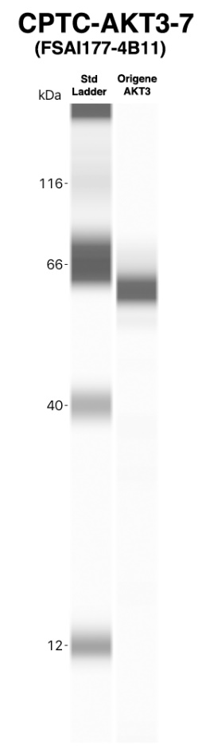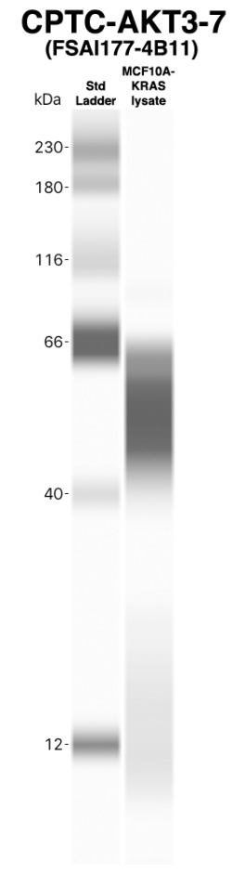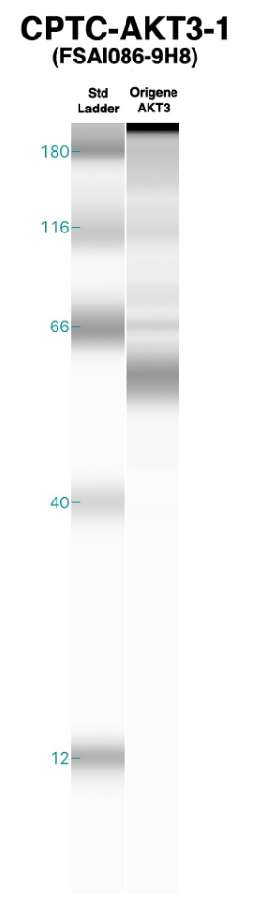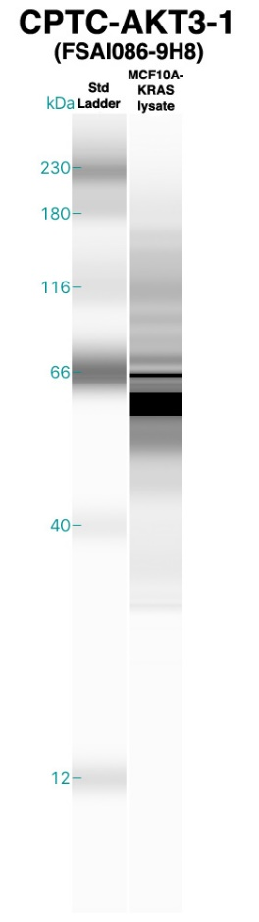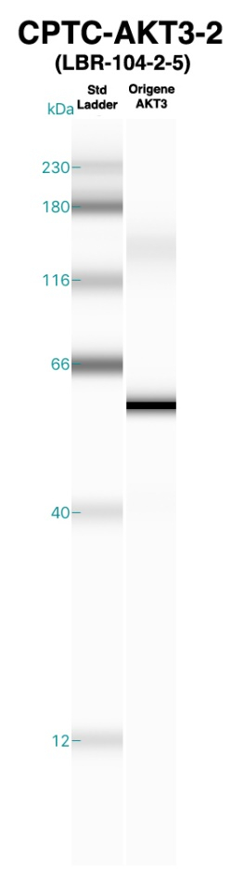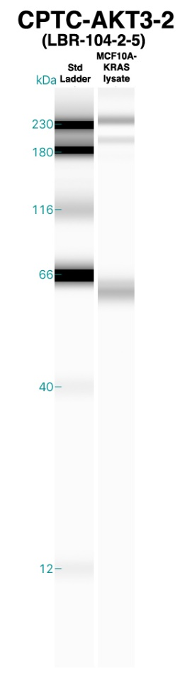

AKT3, RPHFPQF(pS)YSASGRE (pS472), RPHFPQF(pS)YSASGR (pS472); AKT1, RPHFPQF(pS)YSASGTA (pS473); AKT2, THFPQF(pS)YSASIRE (pS473), THFPQF(pS)YSASIR (pS473), CPTC-AKT3-3

AKT3, RPHFPQF(pS)YSASGRE (pS472), RPHFPQFSYSASGRE, RPHFPQF(pS)YSASGR (pS472), RPHFPQFSYSASGR; AKT1, RPHFPQF(pS)YSASGTA (pS473), RPHFPQFSYSASGTA; AKT2, THFPQF(pS)YSASIRE (pS473), THFPQFSYSASIRE, THFPQF(pS)YSASIR (pS473), THFPQFSYSASIR, CPTC-AKT3-4

Expected MW from AKT3 recombinant protein (Origene cat. # TP321051) = 55.6 kDa.

UniProt: Isoform 1 MW = 56 kDa, Isoform 2 MW = 54 kDa.

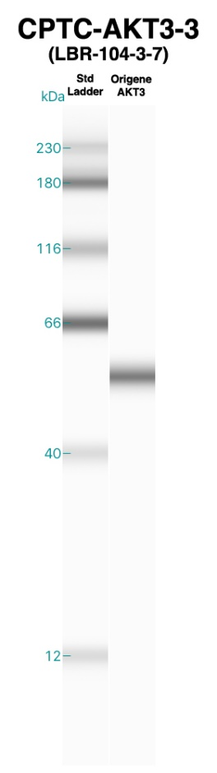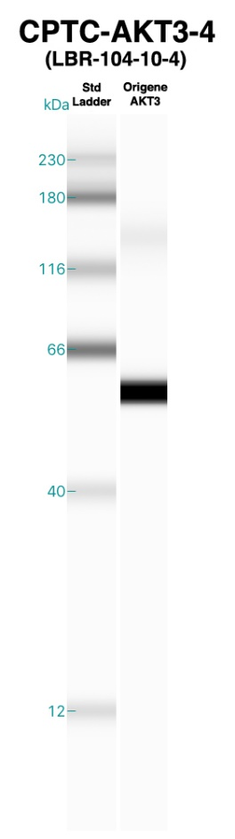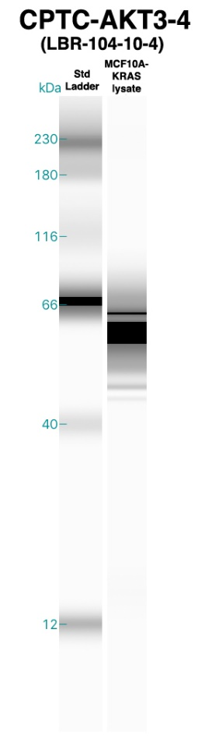
ARAF, D(pS)GYYWEVPPSEVQLLK (pS299), DSGYYWEVPPSEVQLLK, CPTC-ARAF-4

ARAF, IGTGSFGTVFR, CPTC-ARAF-2

ARAF, TQADELPACLLSAAR, CPTC-ARAF-3

Expected MW from ARAF recombinant protein (Origene cat. # TP300737) = 67.4 kDa.

UniProt: Isoform 1 MW = 68 kDa, Isoform 2 MW = 21 kDa.

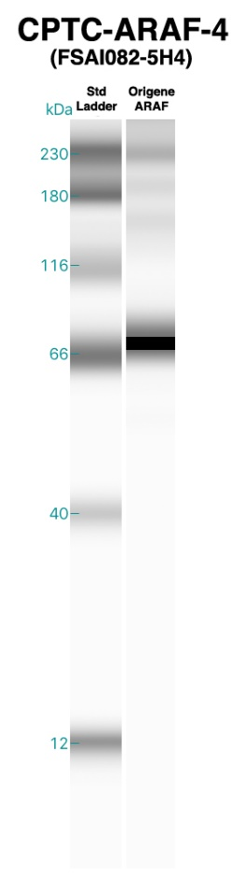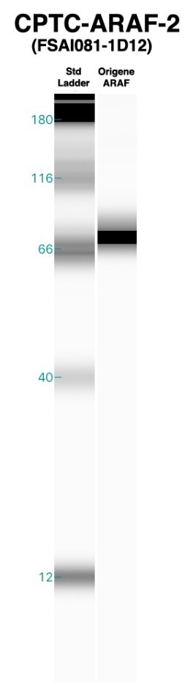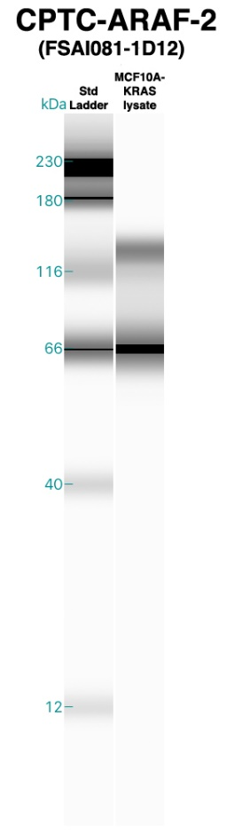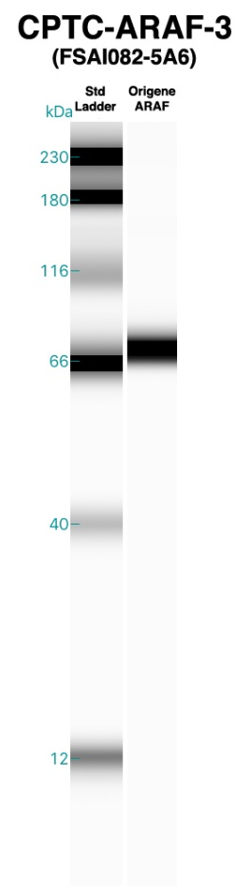
BRAF, AGFQTEDFSLYACASPK, CPTC-BRAF-3

BRAF, GDGGSTTGLSA(pT)PPASLPGSLTNVK (pT401), GDGGSTTGLSATPPASLPGSLTNVK, CPTC-BRAF-6

BRAF, GDGGSTTGLSA(pT)PPASLPGSLTNVK (pT401), GDGGSTTGLSATPPASLPGSLTNVK, CPTC-BRAF-7

Expected MW from BRAF recombinant protein (Origene cat. # TP700051) = 84 kDa.

UniProt: MW = 84 kDa.

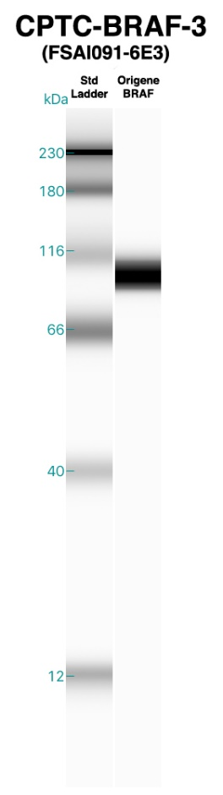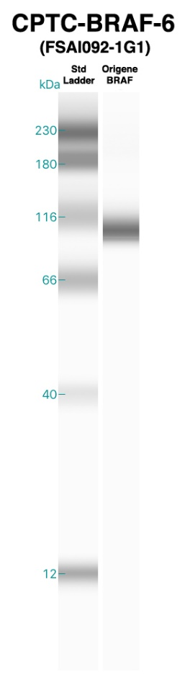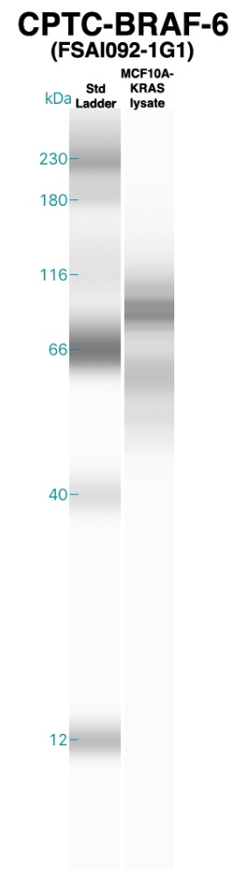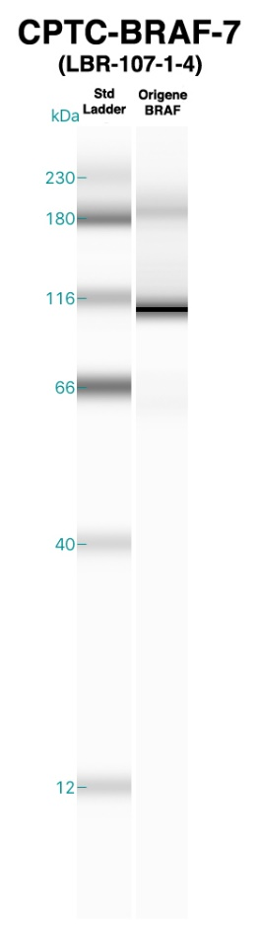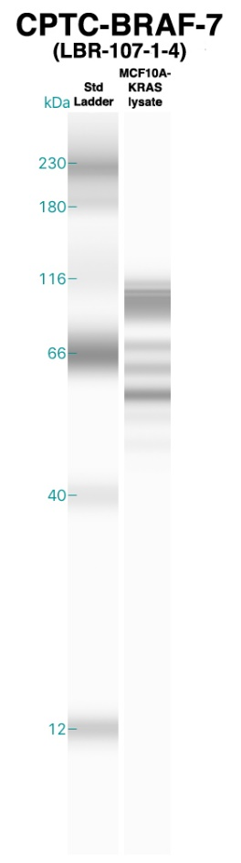
BRAF, RDSSDDWEIPDGQITVGQR, CPTC-BRAF-5

Expected MW from BRAF recombinant protein (Origene cat. # TP700051) = 84 kDa.

UniProt: MW = 84 kDa.

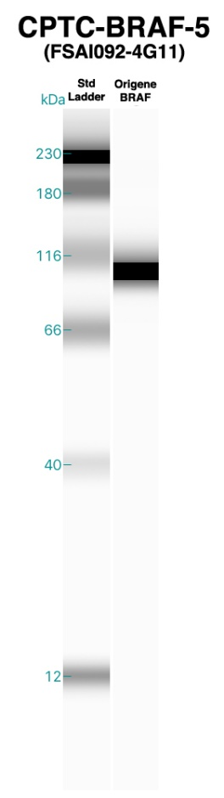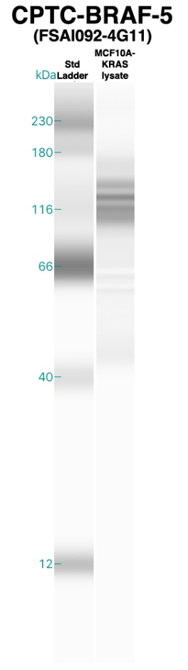
CCND1, AEETCAPSVSYFK, CPTC-CCND1-5

CCND1, AYPDANLLNDR, CPTC-CCND1-3

CCND1, FLSLEPVKK, CPTC-CCND1-1

Expected MW from CCND1 recombinant protein (Origene cat. # TP304957) = 33.5 kDa.

UniProt: MW = 34 kDa.

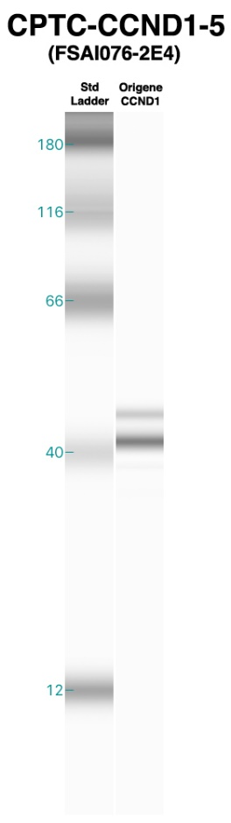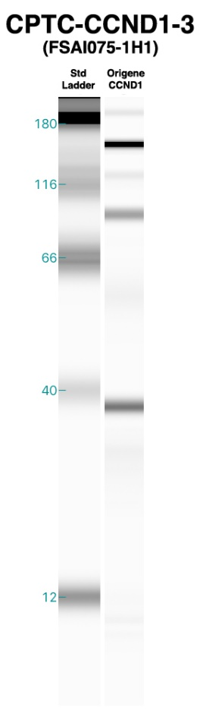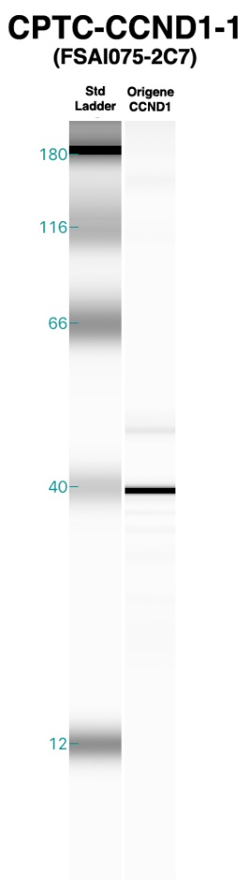
CDH1, GLDARPEVTR, CPTC-CDH1-1

CDH1, GLDARPEVTR, CPTC-CDH1-2

CDH1, GQVPENEANVVITTLK, CPTC-CDH1-3

Expected MW from CDH1 recombinant protein (Origene cat. # TP320731) = 94.8 kDa.

UniProt: Isoform 1 MW = 97 kDa, Isoform 2 MW = 91 kDa.

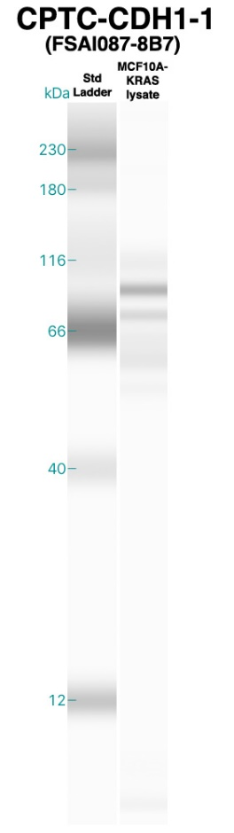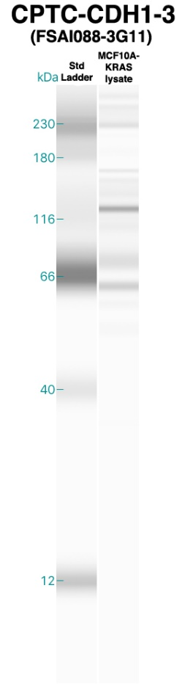
CDH1, GQVPENEANVVITTLK, CPTC-CDH1-4

CDH1, NTGVISVVTTGLDR, CPTC-CDH1-5

Expected MW from CDH1 recombinant protein (Origene cat. # TP320731) = 94.8 kDa.

UniProt: Isoform 1 MW = 97 kDa, Isoform 2 MW = 91 kDa.

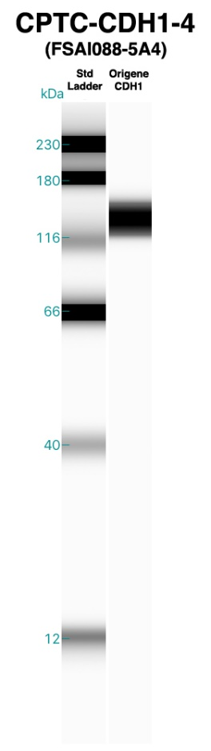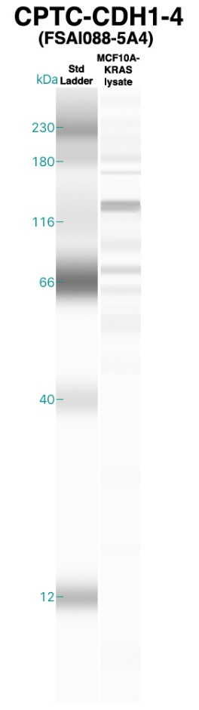
CDH2, SAAPHPGDIGDFINEGLK, CPTC-CDH2-4

Expected MW from CDH2 recombinant protein (Origene cat. # TP307170) = 97.2 kDa.

UniProt: Isoform 1 MW = 100 kDa, Isoform 2 MW = 97 kDa.

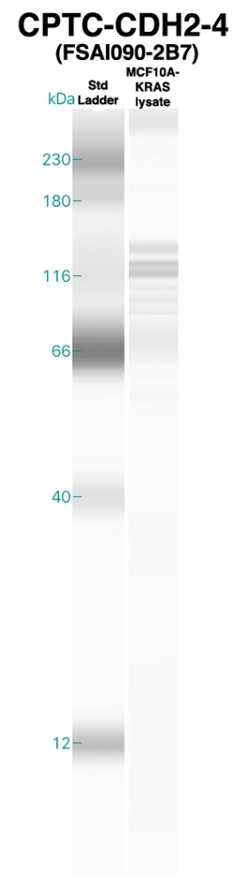
EGFR, IPLENLQIIR, CPTC-EGFR-6

EGFR, NLQEILHGAVR, CPTC-EGFR-7

Expected MW from EGFR recombinant protein (Origene cat. # TP314877) = 42.4 kDa.

UniProt: Isoform 1 MW = 134 kDa, Isoform 2 MW = 45 kDa, Isoform 3 MW = 77 kDa, Isoform 4 MW = 69 kDa.

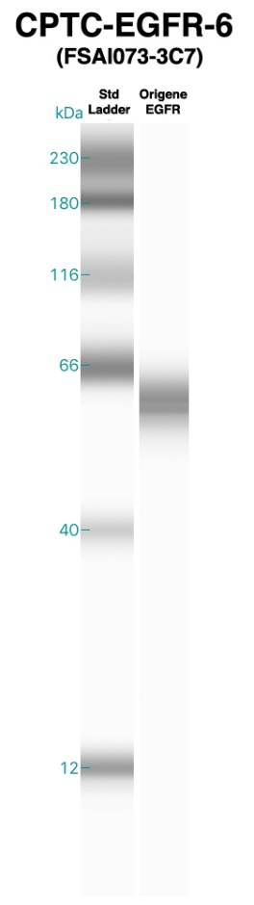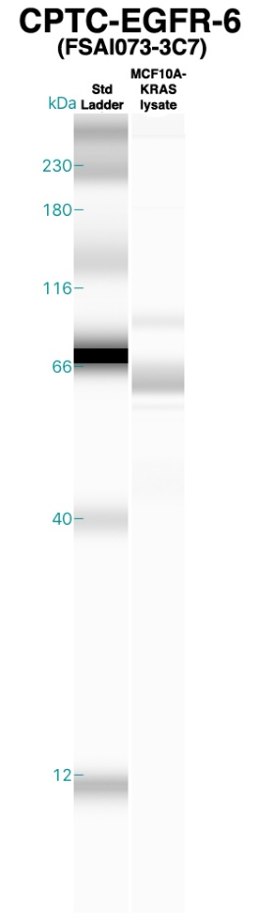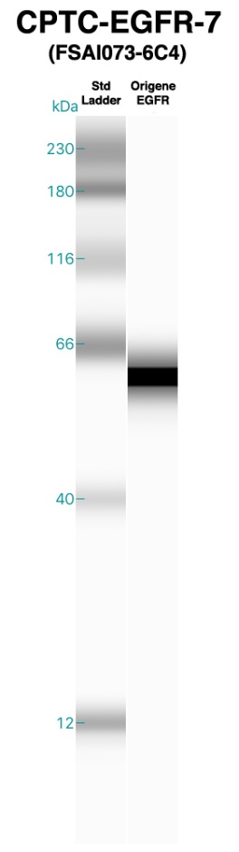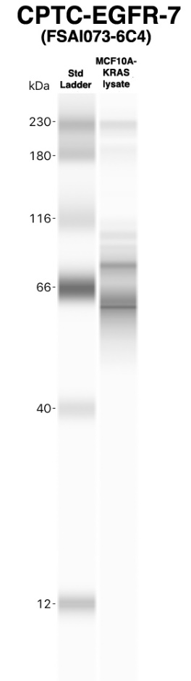
ERBB3, YLERGESIEPLDPSEK, CPTC-ERBB3-3

Expected MW from ERBB3 recombinant protein (Origene cat. # TP309954) = 146 kDa.

UniProt: Isoform 1 MW = 148 kDa, Isoform 2 MW = 20 kDa, Isoform 3 MW = 36 kDa, Isoform 4 MW = 142 kDa, Isoform 5 MW = 77 kDa.

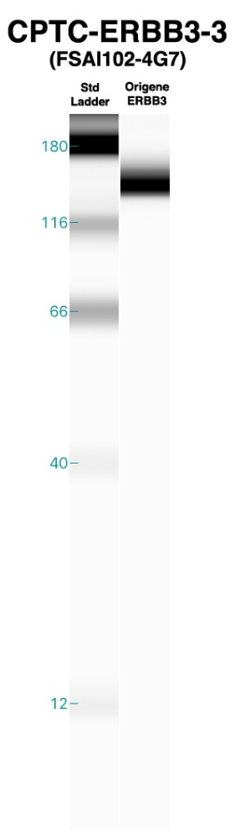
FOS, APHPFGVPAPSAGAYSR, CPTC-FOS-3

FOS, GSSSNEPSSDSLSSPTLLAL, CPTC-FOS-4

FOS, TEPFDDFLFPASSR, CPTC-FOS-1

Expected MW from FOS recombinant protein (Origene cat. # TP760257) = 40.5 kDa.

UniProt: Isoform 1 MW = 41 kDa, Isoform 2 MW = 29 kDa, Isoform 3 MW = 36 kDa.

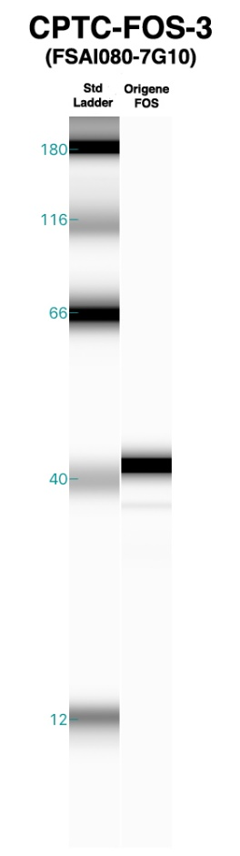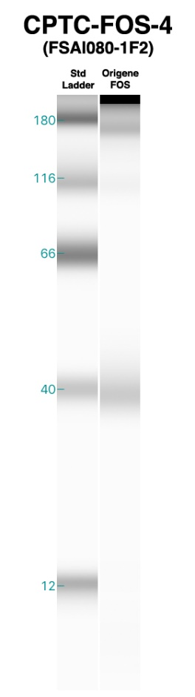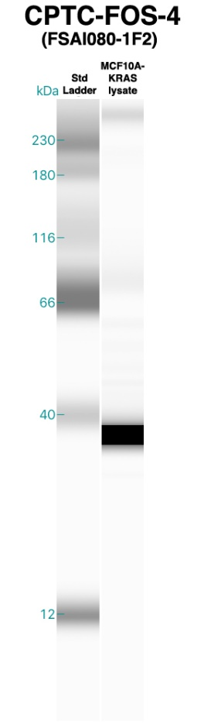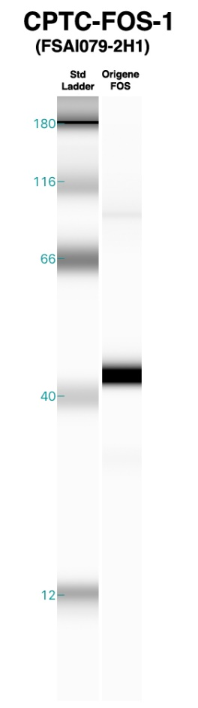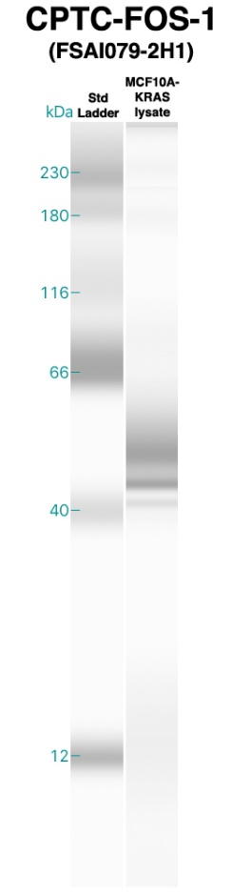
GSK3B, TT(pS)FAESCKPVQQPSAFGSMK (pS9), TTSFAESCKPVQQPSAFGSMK, CPTC-GSK3B-10

GSK3B, TT(pS)FAESCKPVQQPSAFGSMK (pS9), CPTC-GSK3B-9

GSK3B, VIGNGSFGVVYQAK, CPTC-GSK3B-7

Expected MW from GSK3B recombinant protein (Origene cat. # TP300468) = 47.9 kDa.

UniProt: Isoform 1 MW = 47 kDa, Isoform 2 MW = 48 kDa.

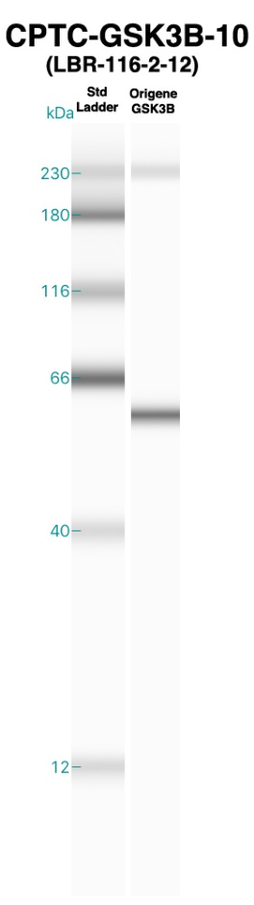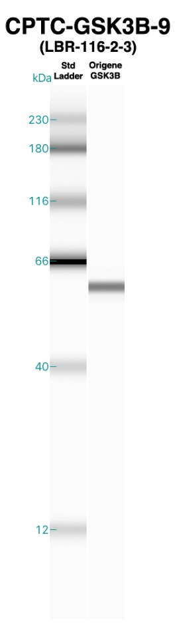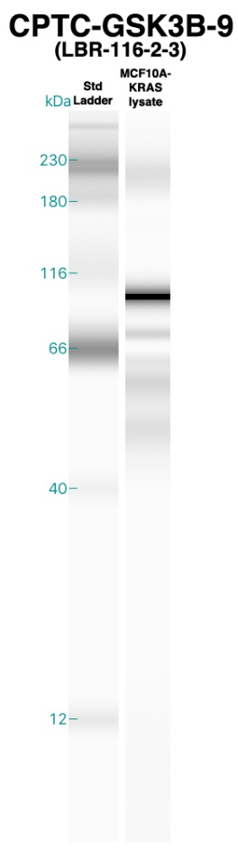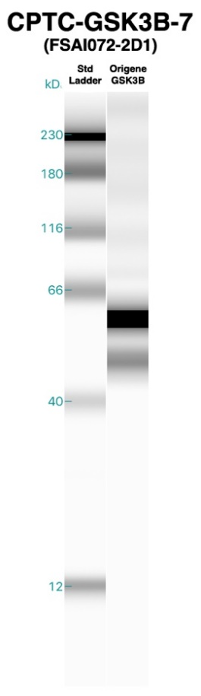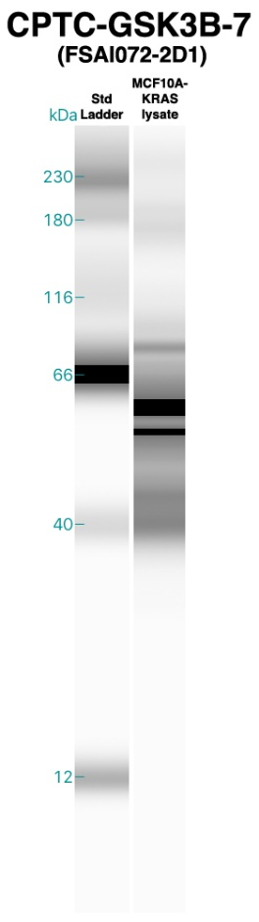
MAP2K1, ISELGAGNGGVVFK, CPTC-MAP2K1-1

Expected MW from MAP2K1 recombinant protein (Origene cat. # TP318460) = 43.3 kDa.

UniProt: Isoform 1 MW = 43 kDa, Isoform 2 MW = 41 kDa.

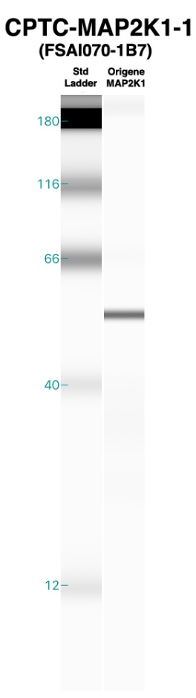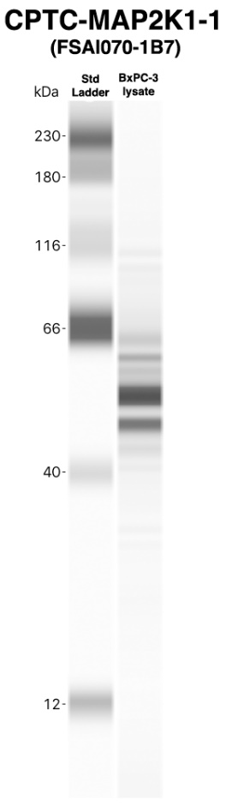
MAPK1, VADPDHDHTGFL(pT)E(pY)VATR (pT185/pY187), VADPDHDHTGFL(pT)EYVATR (pT185), VADPDHDHTGFLTE(pY)VATR (pY187), VADPDHDHTGFLTEYVATR; MAPK3, IADPEHDHTGFL(pT)E(pY)VATR (pT202/pY204), IADPEHDHTGFL(pT)EYVATR (pT202), IADPEHDHTGFLTE(pY)VATR (pY204), IADPEHDHTGFLTEYVATR, CPTC-MAPK1-1

MAPK1, VADPDHDHTGFL(pT)E(pY)VATR (pT185/pY187), VADPDHDHTGFL(pT)EYVATR (pT185); MAPK3, IADPEHDHTGFL(pT)E(pY)VATR (pT202/pY204), IADPEHDHTGFL(pT)EYVATR (pT202), CPTC-MAPK1-3

MAPK1, VADPDHDHTGFLTE(pY)VATR (pY187), VADPDHDHTGFLTEYVATR; MAPK3, IADPEHDHTGFLTE(pY)VATR (pY204), IADPEHDHTGFLTEYVATR, CPTC-MAPK1-4

Expected MW from MAPK1 recombinant protein (Origene cat. # TP310493) = 41.2 kDa.

UniProt: Isoform 1 MW = 41 kDa, Isoform 2 MW = 36 kDa.

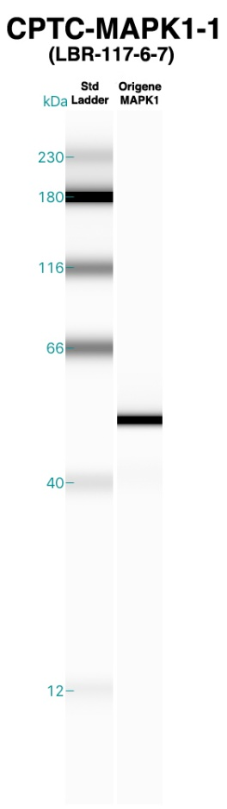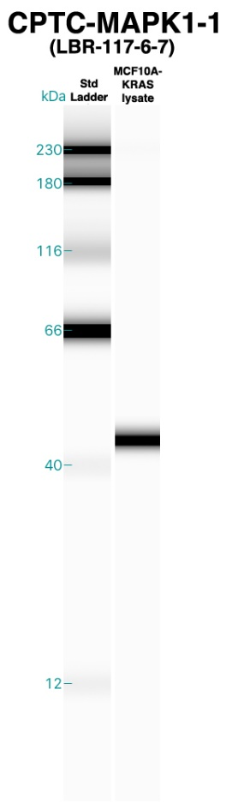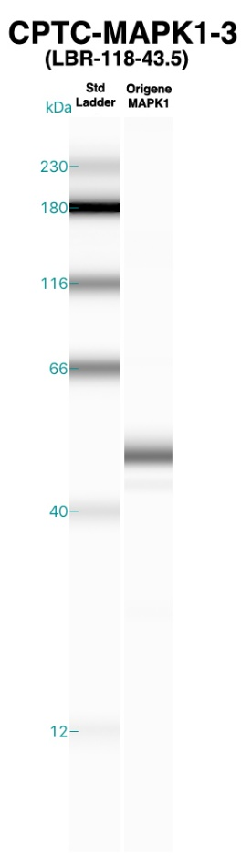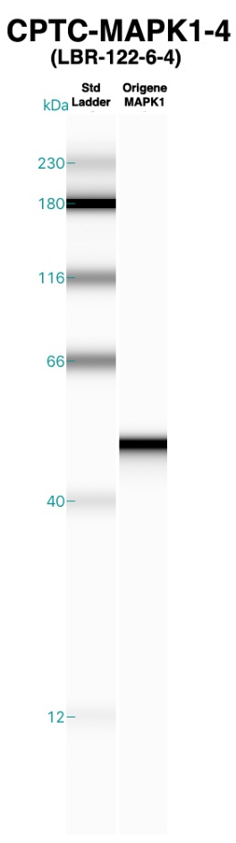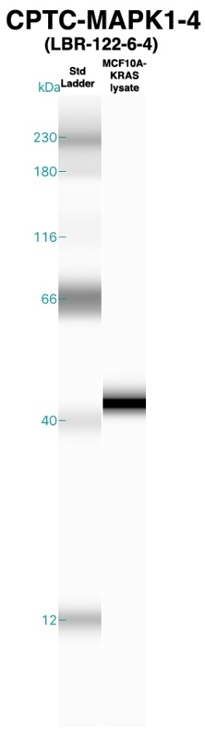
MAPK1, VADPDHDHTGFL(pT)E(pY)VATR (pT185/pY187); MAPK3, IADPEHDHTGFL(pT)E(pY)VATR (pT202/pY204), CPTC-MAPK1-2

Expected MW from MAPK1 recombinant protein (Origene cat. # TP310493) = 41.2 kDa.

UniProt: Isoform 1 MW = 41 kDa, Isoform 2 MW = 36 kDa.

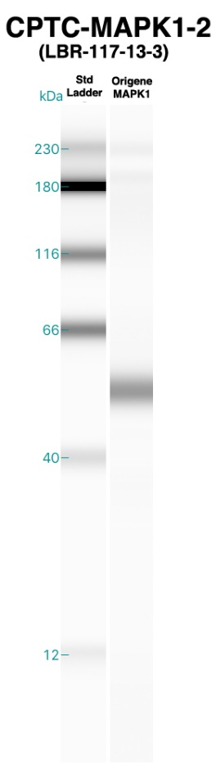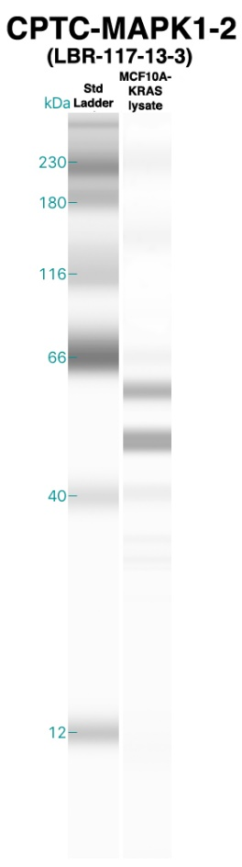
MAPK3, IADPEHDHTGFL(pT)E(pY)VATR (pT202/pY204), IADPEHDHTGFL(pT)EYVATR (pT202), IADPEHDHTGFLTE(pY)VATR (pY204), IADPEHDHTGFLTEYVATR; MAPK1, VADPDHDHTGFL(pT)E(pY)VATR (pT185/pY187), VADPDHDHTGFL(pT)EYVATR (pT185), VADPDHDHTGFLTE(pY)VATR (pY187), VADPDHDHTGFLTEYVATR, CPTC-MAPK3-1

MAPK3, IADPEHDHTGFL(pT)EYVATR (pT202), IADPEHDHTGFLTE(pY)VATR (pY204), IADPEHDHTGFLTEYVATR; MAPK1, VADPDHDHTGFL(pT)EYVATR (pT185), VADPDHDHTGFLTE(pY)VATR (pY187); VADPDHDHTGFLTEYVATR, CPTC-MAPK3-4

MAPK3, IADPEHDHTGFL(pT)EYVATR (pT202), IADPEHDHTGFL(pT)E(pY)VATR (pT202/pY204); MAPK1, VADPDHDHTGFL(pT)EYVATR (pT185); VADPDHDHTGFL(pT)E(pY)VATR (pT185/ pY187), CPTC-MAPK3-5

Expected MW from MAPK3 recombinant protein (Origene cat. # TP304196) = 43 kDa.

UniProt: Isoform 1 MW = 43 kDa, Isoform 2 MW = 38 kDa, Isoform 3 MW = 40 kDa.

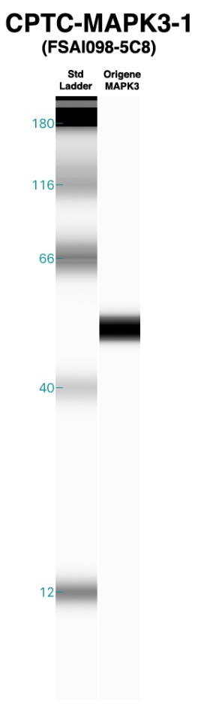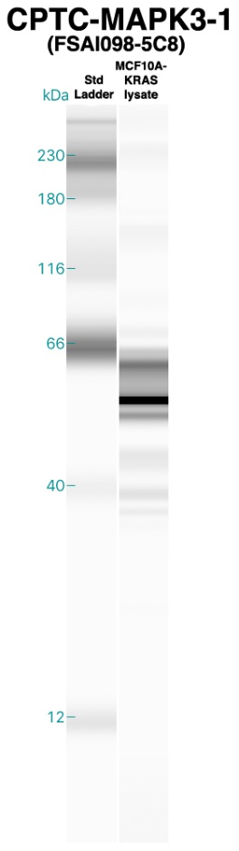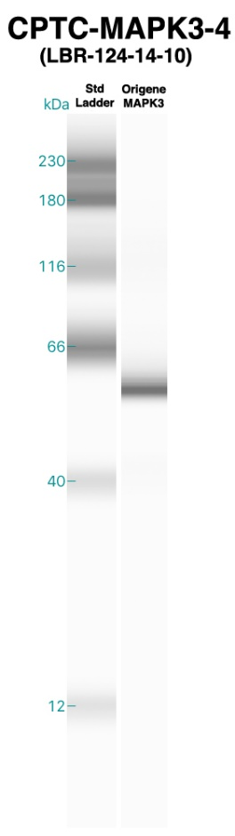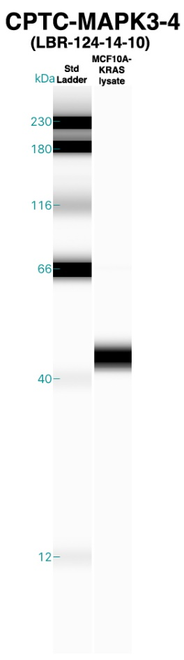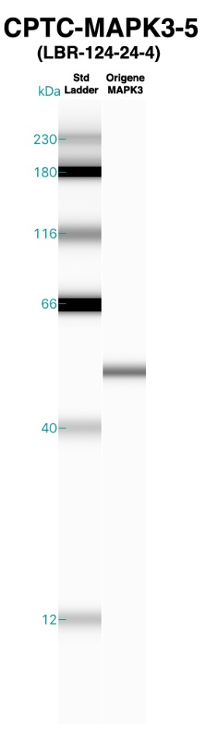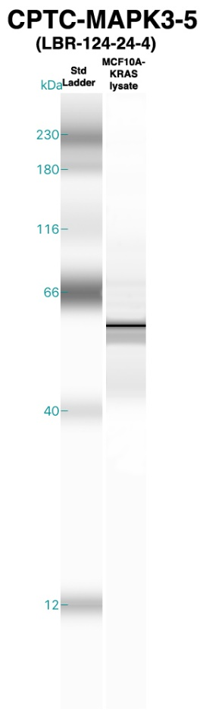
MAPK3, IADPEHDHTGFL(pT)E(pY)VATR (pT202/pY204), IADPEHDHTGFLTE(pY)VATR (pY204); MAPK1, VADPDHDHTGFL(pT)E(pY)VATR (pT185/pY187), VADPDHDHTGFLTE(pY)VATR (pY187), CPTC-MAPK3-6

Expected MW from MAPK3 recombinant protein (Origene cat. # TP304196) = 43 kDa.

UniProt: Isoform 1 MW = 43 kDa, Isoform 2 MW = 38 kDa, Isoform 3 MW = 40 kDa.

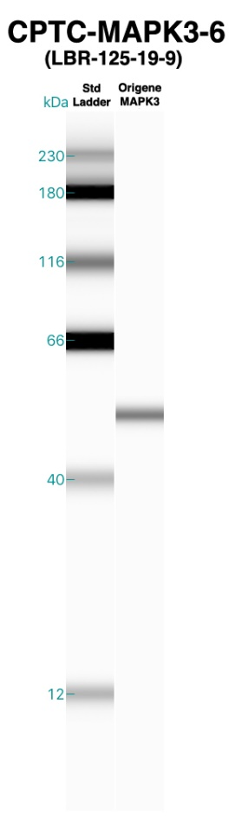
MTOR, DLELAVPGTYDPNQPIIR, CPTC-MTOR-8

MTOR, IQSIAPSLQVITSK, CPTC-MTOR-7

MTOR, LFDAPEAPLPSR, CPTC-MTOR-3

Expected MW from MTOR recombinant protein (Origene cat. # TP320457) = 288.7 kDa.

UniProt: MW = 289 kDa.

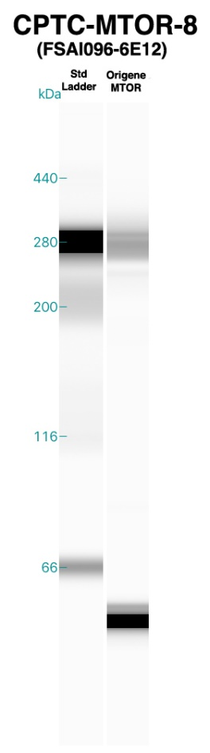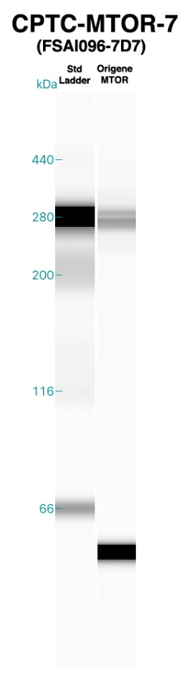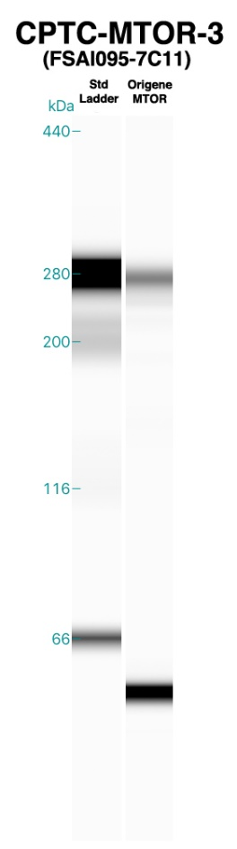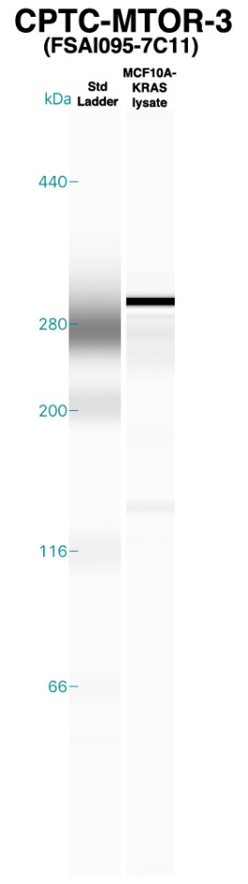
MTOR, LTESLDFTDYASR, CPTC-MTOR-5

MTOR, LTESLDFTDYASR, CPTC-MTOR-6

MTOR, TD(pS)YSAGQSVEILDGVELGEPAHK (pS2448), TDSYSAGQSVEILDGVELGEPAHK, CPTC-MTOR-1

Expected MW from MTOR recombinant protein (Origene cat. # TP320457) = 288.7 kDa.

UniProt: MW = 289 kDa.

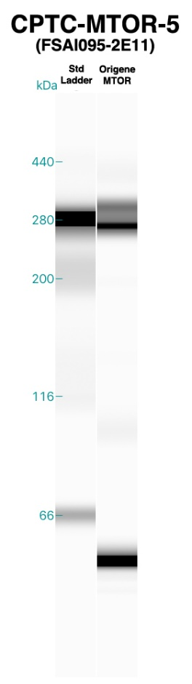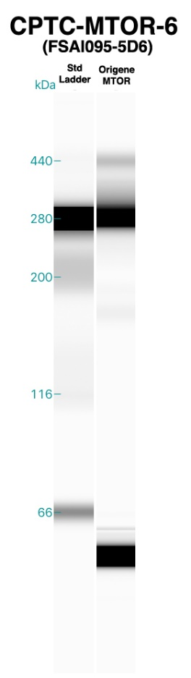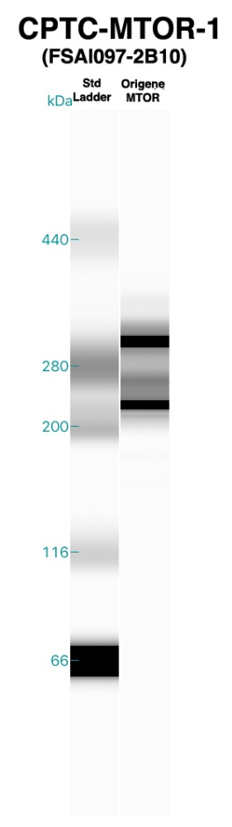
MTOR, TGTTVPESIH(pS)FIGDGLVKPEALNKK (pS2481), TGTTVPESIHSFIGDGLVKPEALNKK, TGTTVPESIH(pS)FIGDGLVKPEALNK (pS2481), TGTTVPESIHSFIGDGLVKPEALNK, CPTC-MTOR-9

MTOR, TGTTVPESIHSFIGDGLVKPEALNK, CPTC-MTOR-2

MTOR, VLGLLGALDPYK, CPTC-MTOR-4

Expected MW from MTOR recombinant protein (Origene cat. # TP320457) = 288.7 kDa.

UniProt: MW = 289 kDa.

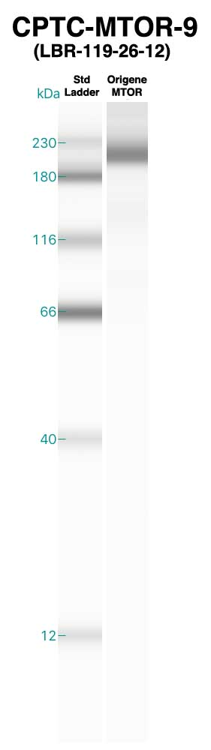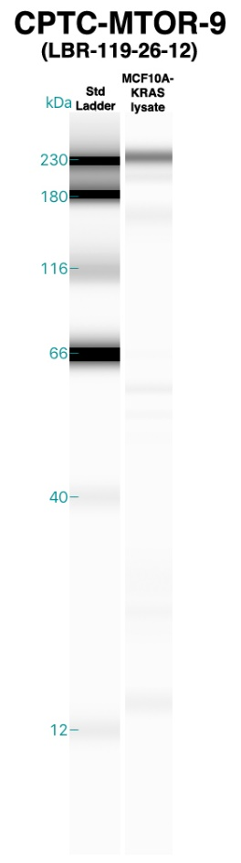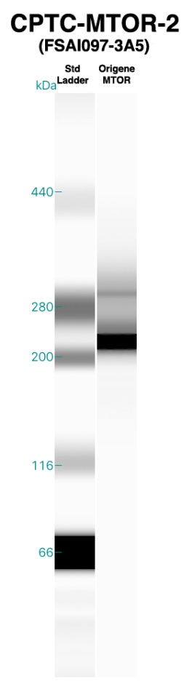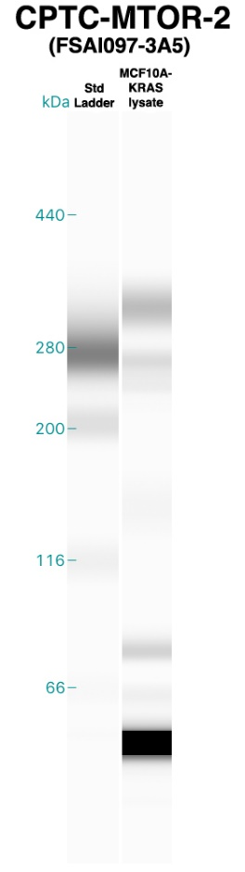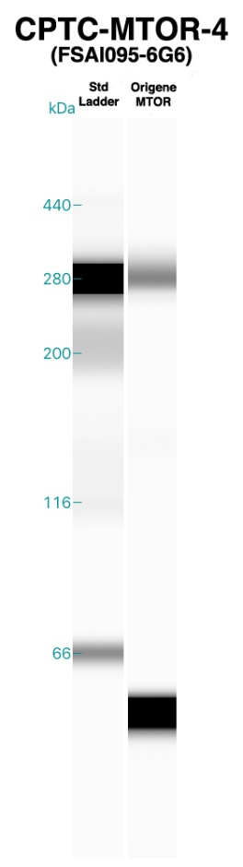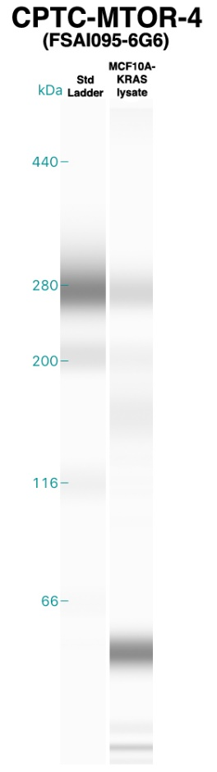
PTEN, AQEALDFYGEVR, CPTC-PTEN-1

PTEN, AQEALDFYGEVR, CPTC-PTEN-5

PTEN, AQEALDFYGEVR, CPTC-PTEN-6

Expected MW from PTEN recombinant protein (Origene cat. # TP302627) = 47 kDa.

UniProt: Isoform 1 MW = 47 kDa, Isoform 2 MW = 65 kDa, Isoform 3 MW = 20 kDa.

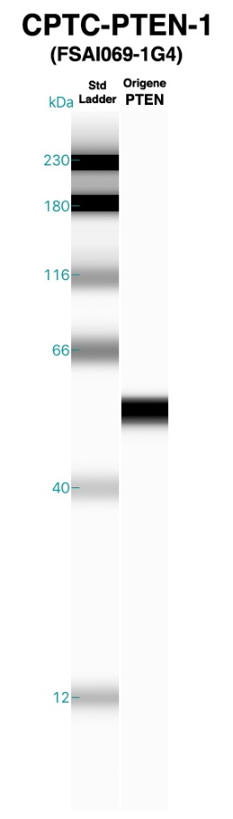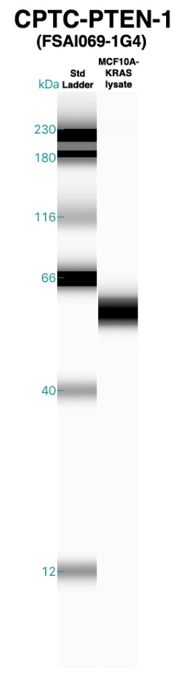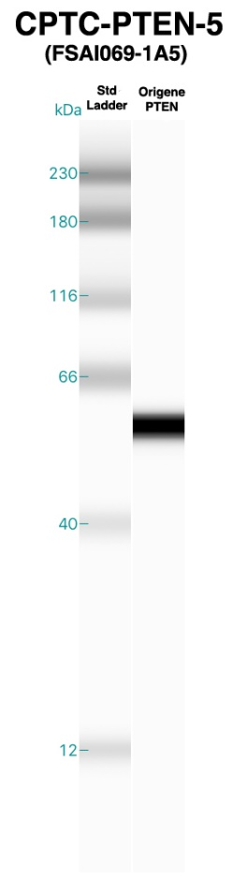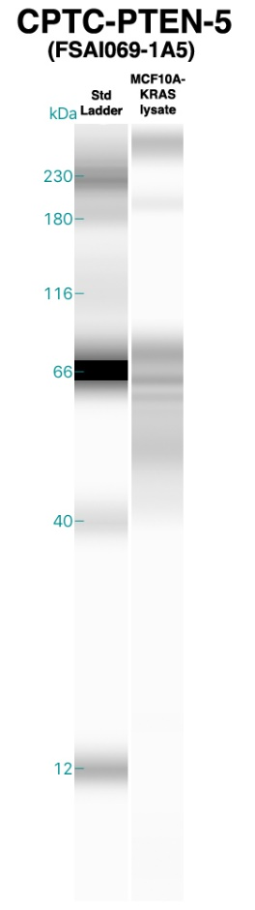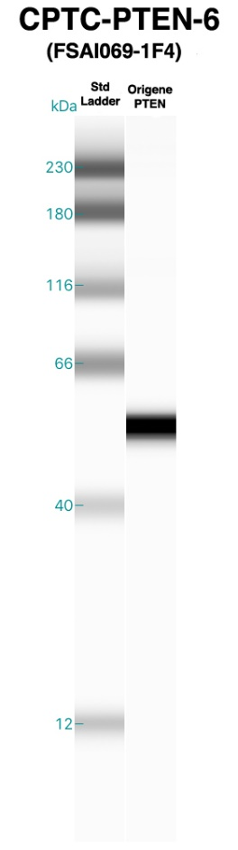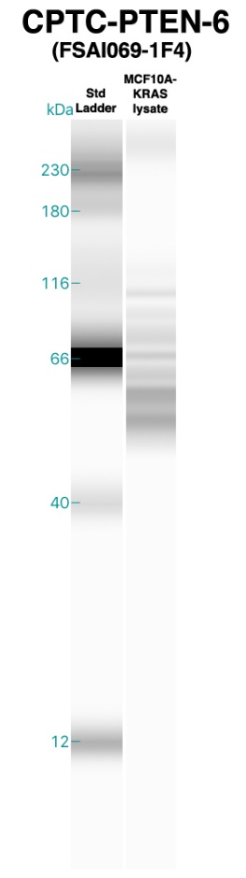
PTEN, AQEALDFYGEVR, CPTC-PTEN-7

PTEN, NHLDYRPVALLFHK, CPTC-PTEN-2

Expected MW from PTEN recombinant protein (Origene cat. # TP302627) = 47 kDa.

UniProt: Isoform 1 MW = 47 kDa, Isoform 2 MW = 65 kDa, Isoform 3 MW = 20 kDa.

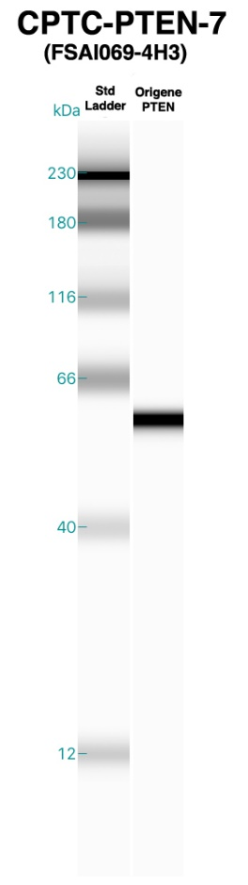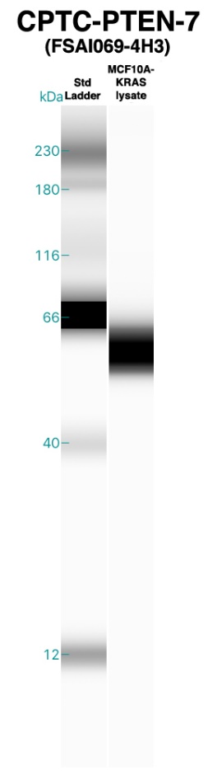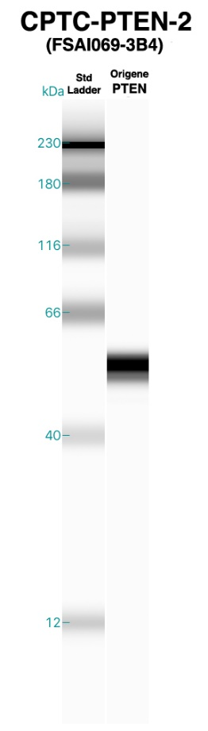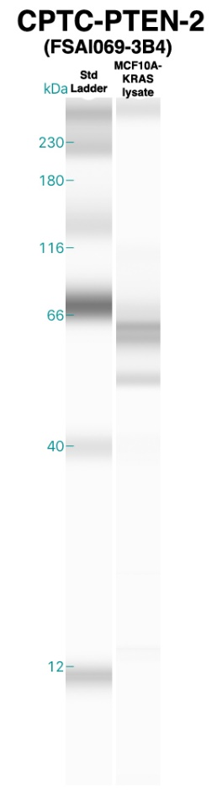
RAF1, ST(pS)TPNVHMVSTTLPVDSR (pS259), CPTC-RAF1-3

RAF1, VVDPTPEQFQAFR, CPTC-RAF1-1

RAF1, VVDPTPEQFQAFR, CPTC-RAF1-2

Expected MW from RAF1 recombinant protein (Origene cat. # TP301983) = 79.2 kDa.

UniProt: Isoform 1 MW = 73 kDa, Isoform 2 MW = 75 kDa.

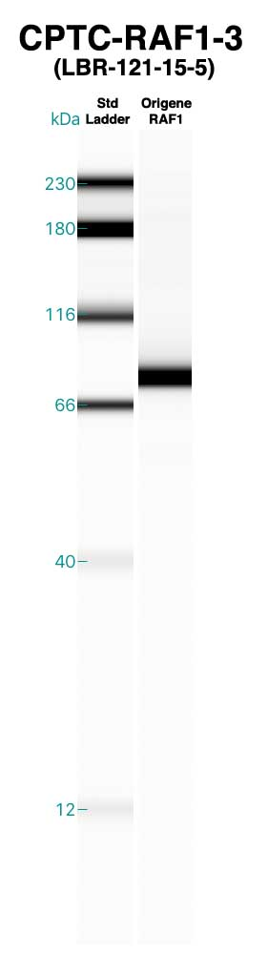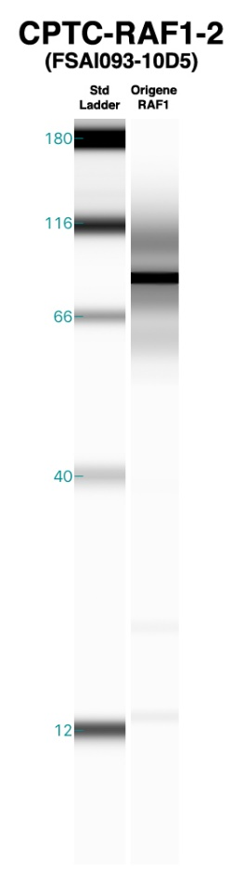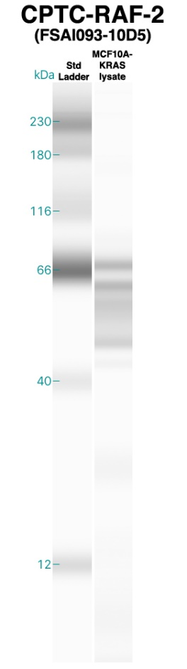
RPTOR, ALETIGANLQK, CPTC-RPTOR-2

Expected MW from RPTOR recombinant protein (Novus cat. # H00057521-P01, GST tagged) = 70 kDa.

UniProt: Isoform 1 MW = 149 kDa, Isoform 2 MW = 43 kDa, Isoform 3 MW = 132 kDa.

