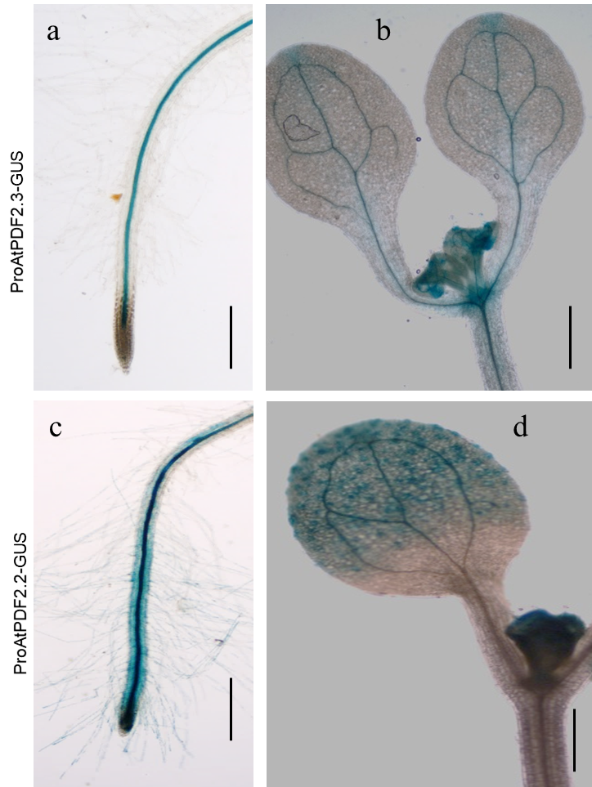
Additional file 7: Figure S7. Histochemical localization of GUS activity in transgenic plants expressing the GUS reporter gene under the control of the proAtPDF2.3 or proAtPDF2.2 promoter.
(a-b) One week old whole-mount ProAtPDF2.3-GUS transgenic seedling root (a) and shoot (b).
(c-d) One week old whole-mount ProAtPDF2.2-GUS transgenic seedling root (c) and shoot (d).
Scale bar = 1mm in (a, c) or 5mm in (b, d).

