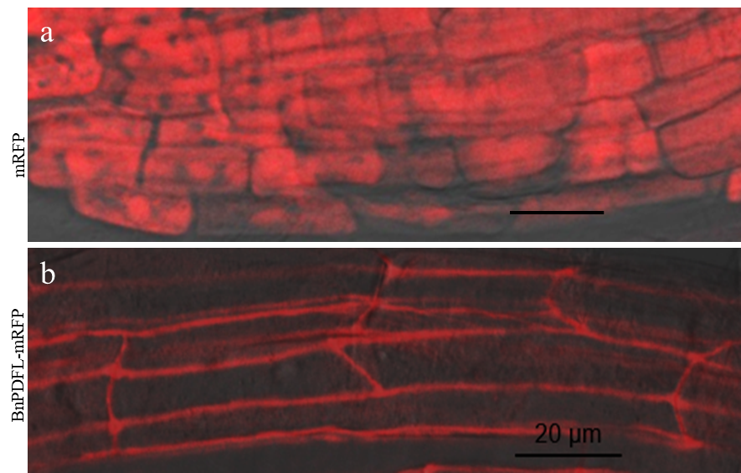
Additional file 6: Figure S6. BnPDFL is a Cell wall localized protein
Subcellular localization of mRFP control or BnPDFL in Arabidopsis plants harboring the construct 35S::mRFP (a) or 35S::BnPDFL -mRFP (b). Root epidermal cells were incubated in 40% sucrose to induce plasmolysis and then imaged by confocal microscopy.

