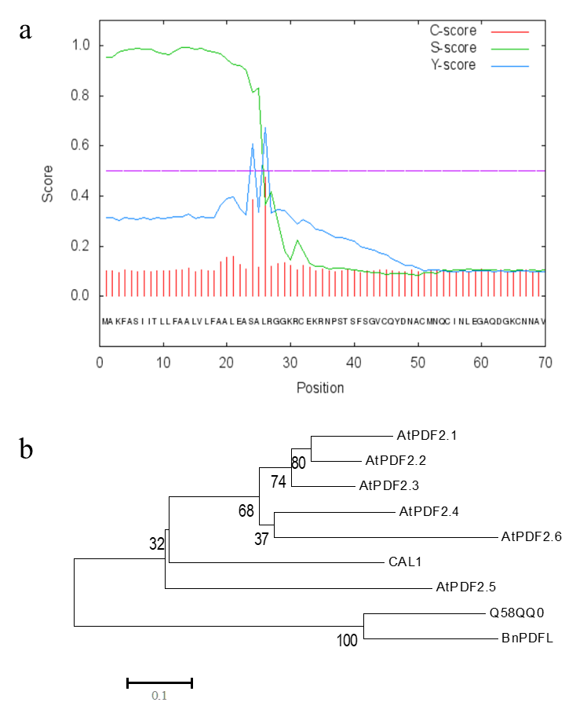
Additional file 5: Figure S5. Bioinformatics analysis of BnPDFL. (a) BnPDFL secretion signal peptide predication by web tool SignaIP 4.0 server. The signal peptide prediction cleavage site is between position 25 and 26 amino acids. (b) Phylogenetic relationship of defensin proteins in rice (CAL1), Arabidopsis thaliana (AtPDF2s) and Brassica napus (BnPDFL, Q58QQ0). The 0.1 scale shows substitution distance.

