Supplementary Tables
Additional file 1: Table S1. Details of parameters for MRI imaging protocols.
Parameters | T1WI |  | T2WI |  | FS-T2WI |  | DWI |  | Contrast-enhanced MRI
Repetition / echo time (msec) |  | 550/10 |  | 4000/83 |  | 8000/83 |  | 2800/81 |  | 4.89/2.38
Echo trains per slice | 44 |  | 19 |  | 19
Sequence | TSE |  | TSE |  | TSE |  | EP2D |  | VIBE
Bandwidth(Hz) | 178 |  | 260 Hz |  | 260 |  | 1250 Hz |  | 400 Hz
Thickness(mm) | 4 |  | 4 |  | 4 |  | 5 |  | 3
Field of view (mm) | 350 |  | 350 |  | 350 |  | 300 |  | 380
Voxel size(mm) | 1.5×1.1×4.0 |  | 1.1×1.1×4.0 |  | 1.4×1.4×4.0 |  | 2.7×1.9×5.0 |  | 1.7×1.2×3.0
Flip angle (degrees) | 150 |  | 144 |  | 150 |  |  |  | 10

 | Additional file 1: Table S2. Statistical difference of ADC measurements in various groups based on clinical and MRI features.
 | Group items | ADC (mean ± S.D.) × 10⁻³s/m² | P value
 | Clinical features
 | CA-125 level(U/L) |  | 0.000
 | <500 | 1105 ± 475
 | >500 | 851 ± 231
 | Maximum diameter(cm) |  | 0.424
 | <10 | 1009 ± 413
 | >10 | 1096 ± 481
 | Ki67 expression |  | 0.000
 | <50% | 1109 ± 453
 | >50% | 795 ± 234
 | FIGO |  | 0.01
 | I and II | 1059 ± 47.8
 | III and IV | 902 ± 29.3
 | Relapse or dead |  | 0.672
 | yes | 1025 ± 376
 | no | 1056 ± 456
 | MRI features
 | Component |  | 0.000
 | solid | 1046 ± 444
 | mixed | 1163 ± 490
 | cystic | 840 ± 323
 | T₁ high signal |  | 0.000
 | present | 1209 ± 437
 | absent | 977 ± 431
 | Septa
 | present | 1213 ± 509 | 0.000
 | absent | 950 ± 370

Figure legends
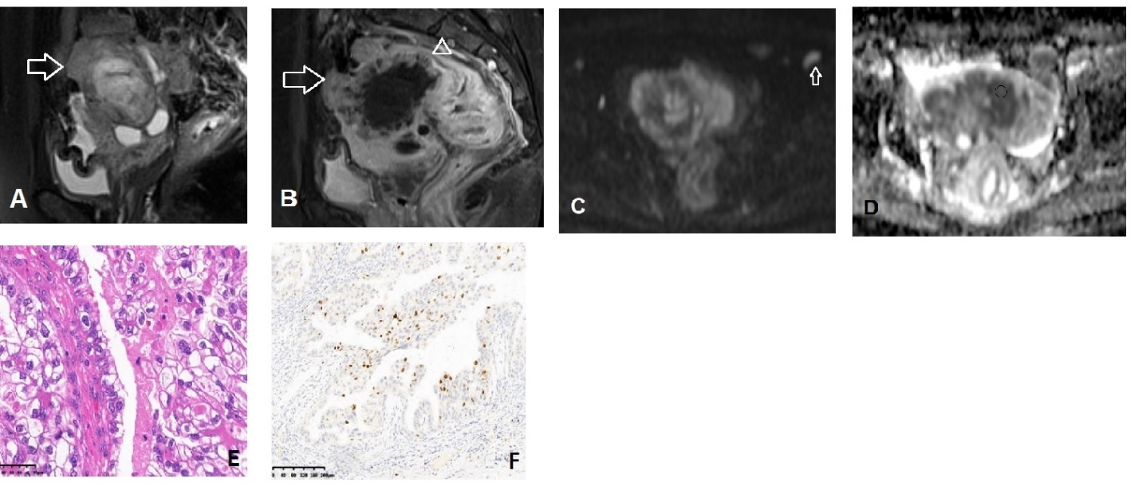
Additional file 1: Figure S1. A 66-years old woman with clear cell tumor (Ic). On sagittal fs-T2WI(A)，the mainly solid tumor (arrow) centrally occupied the pelvisand the mass showed avid enhancement on post-enhanced images(B) and the mass backwardly invaded the anterior wall of rectum(arrow head); On DWI, the solid tumor showed high signal and the corresponding ADC value (D) was 1134(853-1446) ×10⁻³s/m². Note, the enlarged node (arrow) beside the iliac artery. Haematoxylin and eosin staining of tumor (original magnification × 400, E) and Ki-67 stain picture (original magnification × 100, 5% expression in one view field, F).
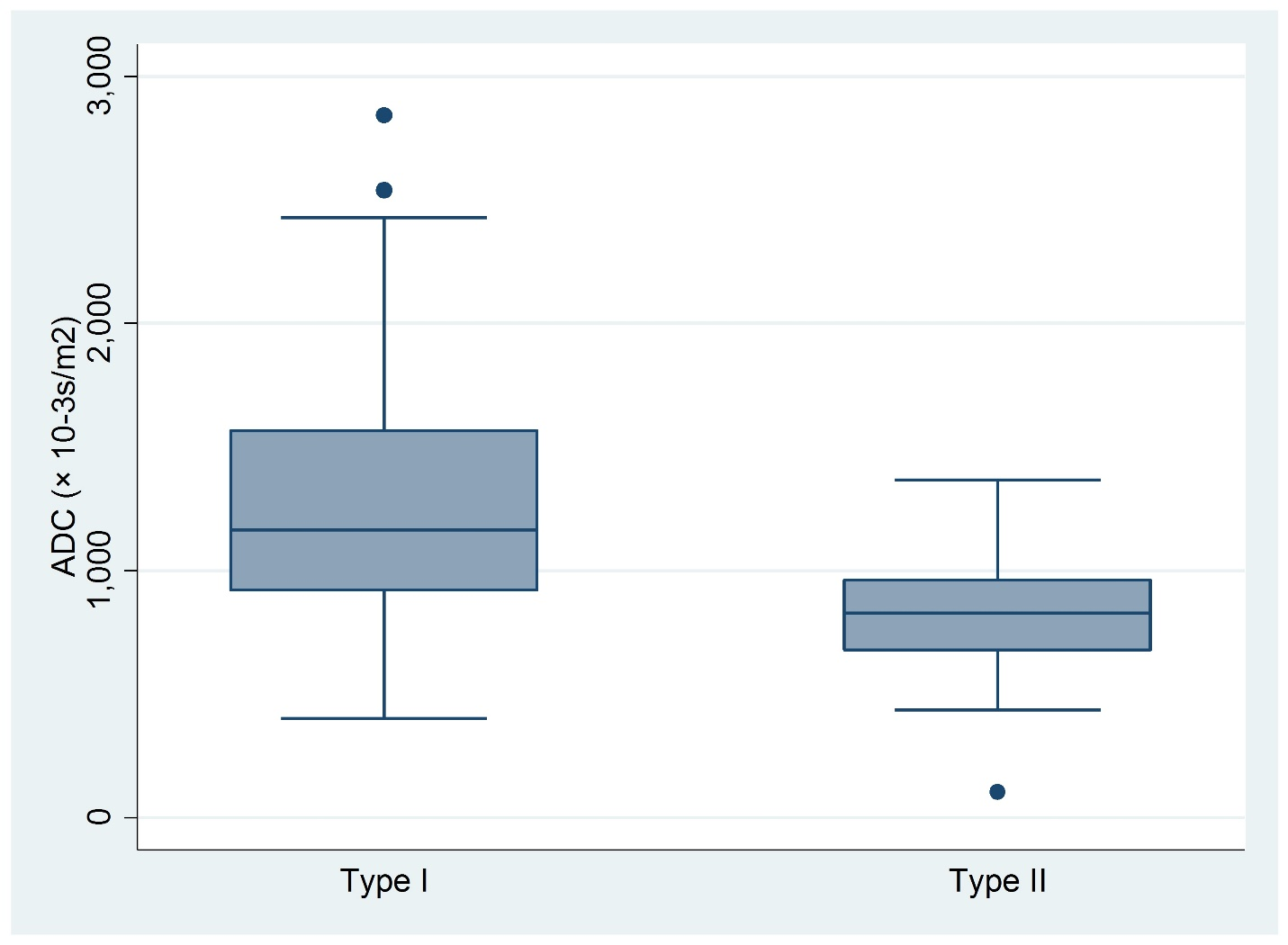Additional file 1: Figure S2. Stem-and-Leaf Plots of the calculated ADC values (10⁻³/mm²/s) within between Type I and Type II cancer group.
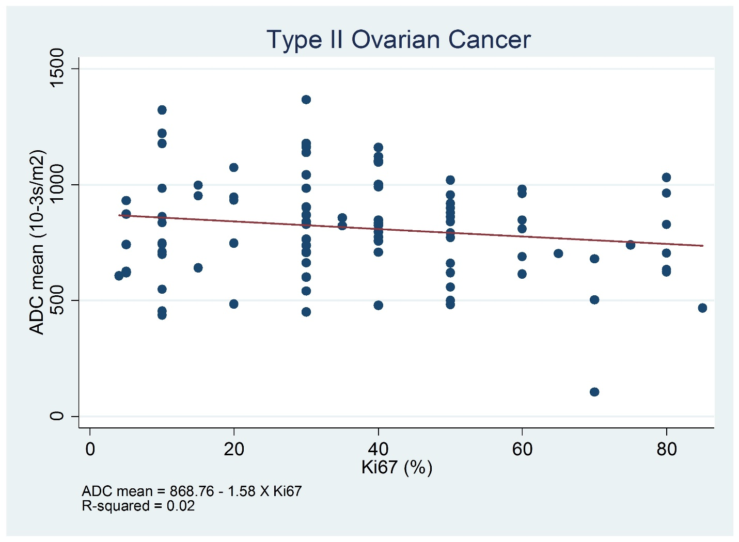Additional file 1: Figure S3. Scatter Plots of Ki-67 expression and the mean ADC value in Type II cancer group.

