Additional file -1

Figure S1. The geo-location of Libyan regions and districts involved in the study

Table S1; Libyan regions, Districts, administrative boundaries and population density
Figure S2; National and Regional trends of HIV infection in Libya 1993 2017

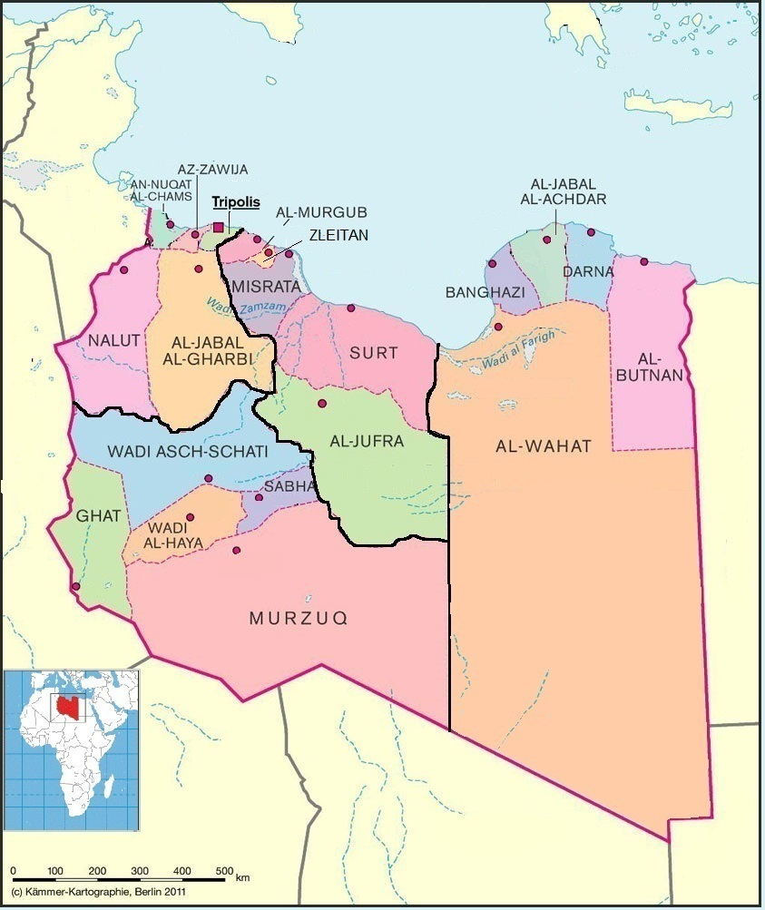
Figure-S1. The geo-location of Libyan regions and districts involved in the study
Table S1; Libyan regions, Districts, administrative boundaries and population density

District (Arabic) | District (English) | Area (km²) | Population | Number
East Region
البطنان | Butnan | 84,996 | 159,536 | 1
درنة | Derna | 31,511 | 163,351 | 2
الجبل الأخضر | Jabal al Akhdar | 11,429 | 203,156 | 3
بنغازي | Benghazi | 11,372 | 856,645 | 4
الواحات | Al Wahat | 539,134 | 227,151 | 5
Central Region
سرت | Sirte | 225,437 | 193,720 | 6
الجفرة | Jufra | 117,410 | 52,342 | 7
مصراتة | Misrata | 29,172 | 550,938 | 8
زليتن | Zleitan | 21,231 | 120,872 | 9
المرقب | Murqub | 6,796 | 432,202 | 10
West Region
طرابلس | Tripoli | 3,501 | 1,5186,13 | 11
الزاوية | Zawiya | 2,753 | 290,993 | 12
النقاط الخمس | Nuqat al Khams | 6,089 | 287,662 | 13
الجبل الغربي | Jabal al Gharbi | 76,717 | 304,159 | 14
نالوت | Nalut | 67,191 | 93,224 | 15
South Region
وادي الشاطئ | Wadi al Shatii | 97,160 | 78,532 | 16
سبها | Sabha | 107,310 | 134,162 | 17
وادي الحياة | Wadi al Hayaa | 31,485 | 76,858 | 18
غات | Ghat | 68,482 | 23,518 | 19
مرزق | Murzuq | 356,308 | 78,621 | 20

Figure S2; National and Regional trends of HIV infection in Libya 1993-2017

