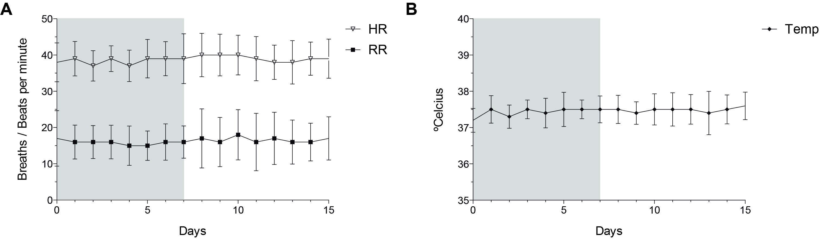Additional file 1: Figure S1 Clinical examination findings in healthy adult horses treated with tamoxifen (0.25 mg/kg, orally, q 24 hours for 7 days) (gray area, days 0-7), with 7 days of follow-up after the treatment period (days 8-15) (n=20). A) Respiratory and heart rates; B) Rectal temperature.

