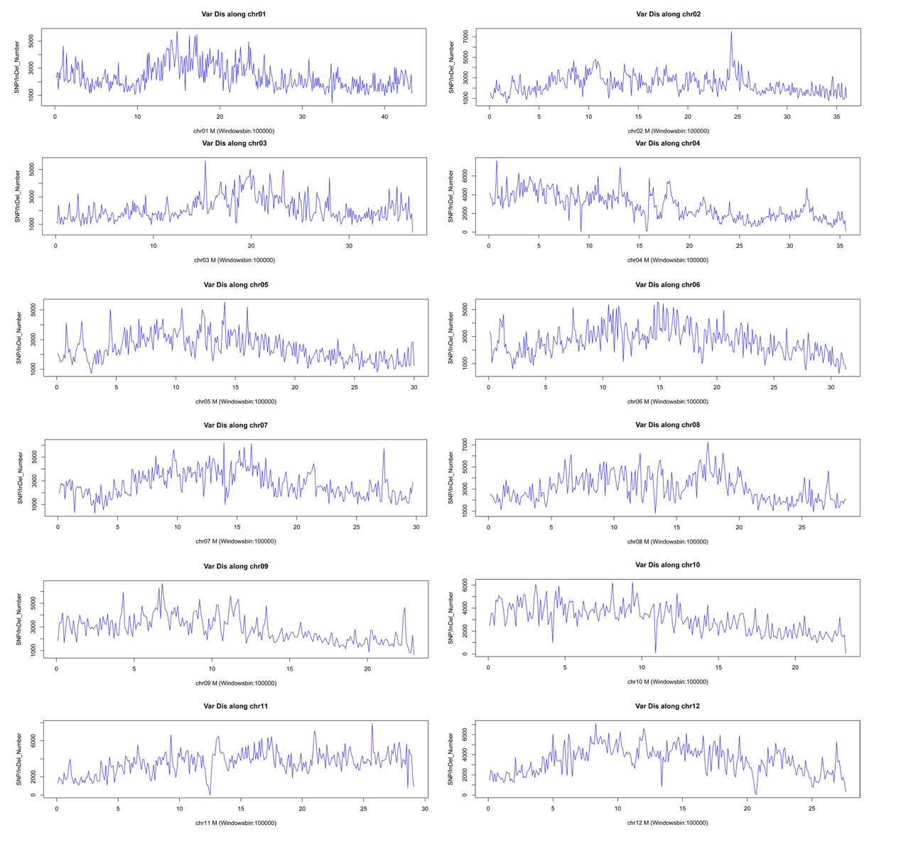Fig. S1 SNP distribution along position in each chromosome.

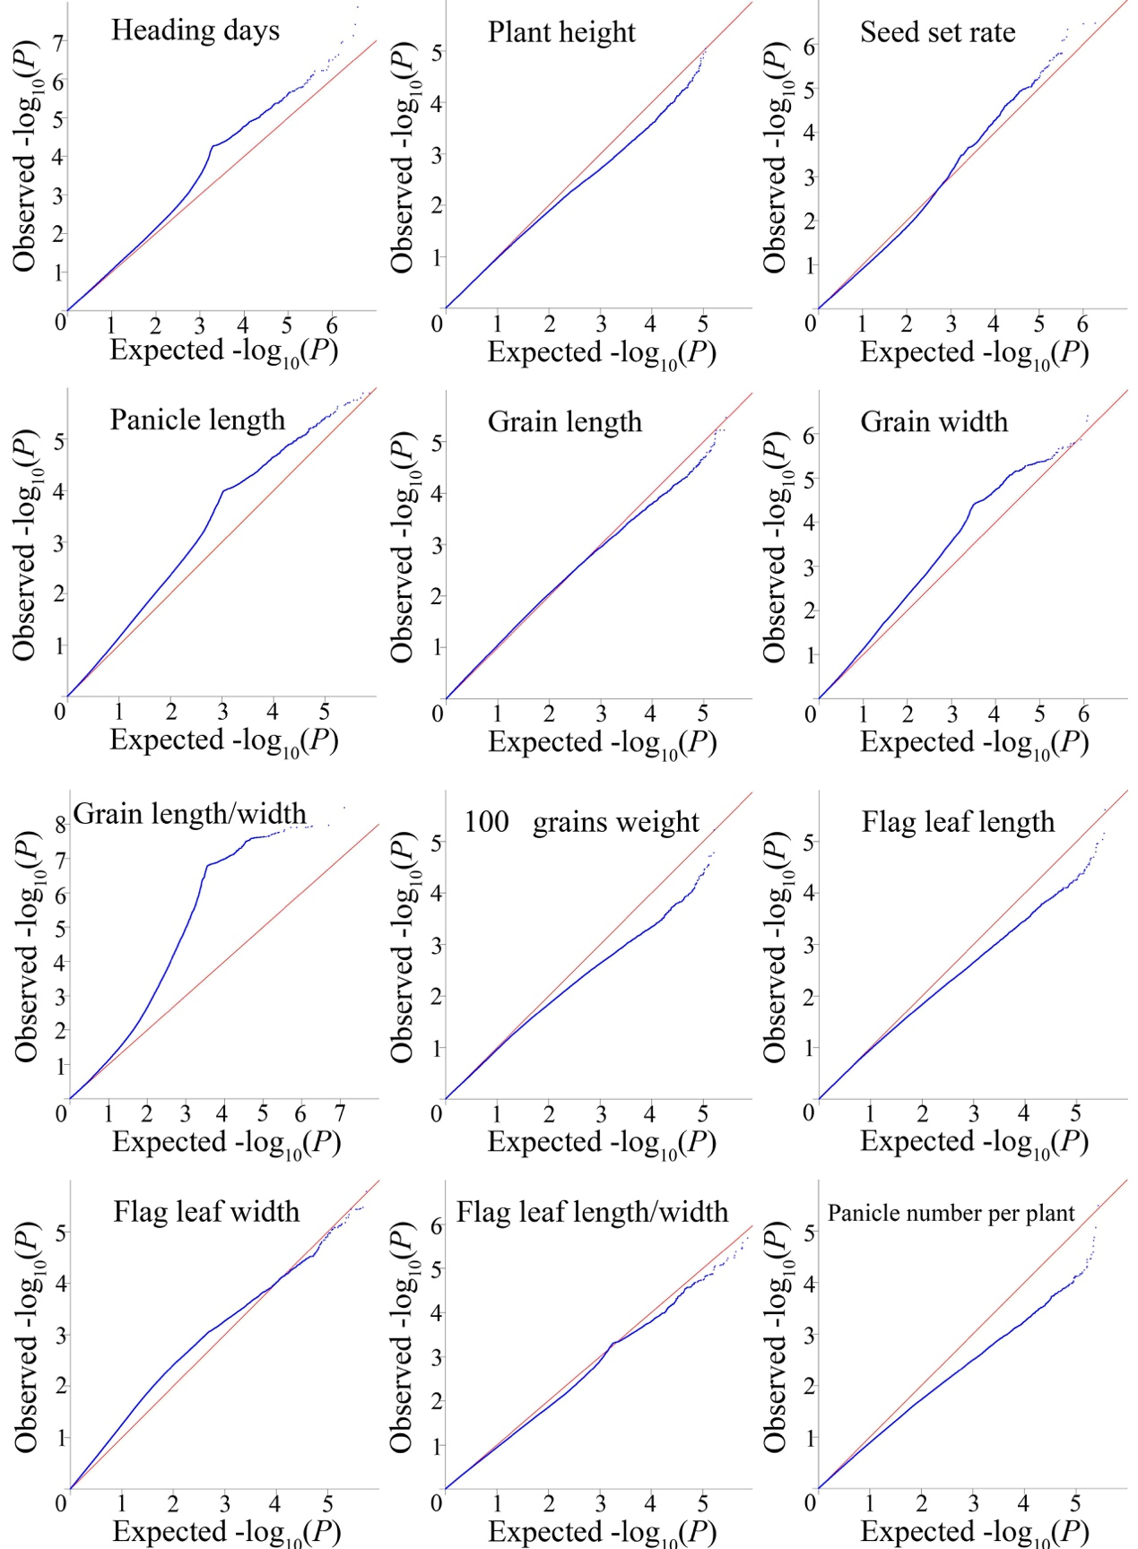
Fig. S2 Genome-wide average LD decay estimated in Ting’s core collection on 12 chromosomes.

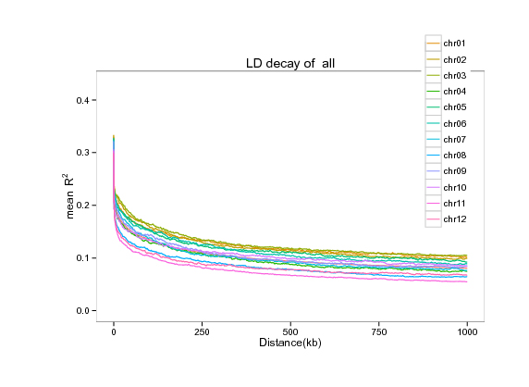
Fig. S3 Distribution of pairwise relative 1 kinship values based on 3.8 million SNPs in Ting’s core collection. The height of blue bar represents the percentage of varieties in different range of kinships.

Fig. S4 Plots of observed versus expected P-values using EMMAX for 12 agronomic traits. Red symbol represents expected P-values, and Blue symbol represents observed P-values.

