Table S1. Knockout strategies suggested by OptGene algorithm for the production of putrescine
Solution | BPCY | Knockout reactions |  | Maximum specific growth rate (h⁻¹) | Putrescine productivity (mmol/gDCW/h)
1 | 0.0024 | GlyA, ACKr |  | 0.0325 | 0.6572
2 | 0.00239 | ACKr, MTHFC |  | 0.0324 | 0.6579
3 | 0.00239 | ACKr, MTHFD |  | 0.0324 | 0.6579
4 | 0.00238 | ACKr, FTHFLi |  | 0.0320 | 0.6603
5 | 0.00237 | ACKr |  | 0.0320 | 0.6607
6 | 0.00199 | NTRIRx, ACKr, CMPA, TPI |  | 0.0461 | 0.3848
7 | 0.00199 | NTRIRx, ACKr, TPI |  | 0.0470 | 0.3762
8 | 0.00171 | MTHFD, NADTRHD, AKGDH |  | 0.0697 | 0.2186
9 | 0.00171 | SUCOAS, NADTRHD |  | 0.0707 | 0.2151
10 | 0.00171 | NADTRHD, AKGDH |  | 0.0709 | 0.2147
11 | 0.00171 | GLYA, PTAr |  | 0.0710 | 0.2142
12 | 0.0017 | GLYA, X5PPKT |  | 0.0731 | 0.2070
13 | 0.0017 | PTAr, FTHFLi |  | 0.0733 | 0.2065
14 | 0.0017 | MTHFD, X5PPKT |  | 0.0733 | 0.2064
15 | 0.0017 | MTHFC, X5PPKT |  | 0.0733 | 0.2064
16 | 0.0017 | NTRIRy, PTAr |  | 0.0736 | 0.2054
17 | 0.0017 | X5PPKT |  | 0.0740 | 0.2042
18 | 0.0017 | GLYA |  | 0.0741 | 0.2036
19 | 0.00169 | MTHFC |  | 0.0743 | 0.2030
20 | 0.00169 | MTHFD |  | 0.0743 | 0.2030

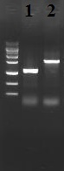
Figure S1. Knockout of speE1 check by PCR using primer outside of the flanking region. Lane 1 is the mutant strain and Lane 2 is the wild-type strain.

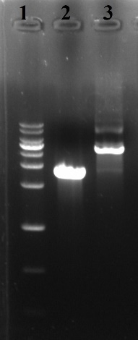
Figure S2. The insertion of pTAC-argDJ into the genome of the engineered strain 20ZE4A. Lane 1 is the 1 kbp marker Enzynomics, Lane 2 is the wild-type strain, and Lane 3 is the engineered strain.

