Influence of particle size and total organic carbon on the distribution of polybrominated diphenyl ethers in landfill soils: Assessment of exposure implications

E. Akortia^{*a, b}, M. Lupankwaª and J.O. Okonkwo^{a,}
ªEnvironmental Chemistry Research Group, Department of Environmental, Water and Earth Sciences, Tshwane University of Technology, Private Bag X680, Pretoria, South Africa.
^{b}Ghana Atomic Energy Commission, Radiation Protection Institute, P. O. Box LG 80, Legon, Accra, Ghana.
*Corresponding author: Email (Sericuk@yahoo.co.uk; eakortia@gmail.com)

List:
Equation 1: Size selection strategy calculations.
Equation 2: Percentage difference in concentrations.

SM 1 TABLES
Table S1: Descriptive statistics of PBDE quantities (ng g⁻¹) in the landfill soils (150‒250 µm fractions).
Table S2: Descriptive statistics of PBDE quantities (ng g⁻¹) in the landfill soils (45‒150 µm fractions).
Table S3: PBDEs load in sieved soil 150‒250 µm.
Table S4: PBDEs load in sieved soil 45‒150 µm.
Table S5: Certified and measured concentrations (ng g⁻¹) of certified reference material (NIST SRM 2585-Organic contaminants in house dust).

SM 2 FIGURES
Figure S1: Particle size distribution in landfill site soils using Microtrac S3500 particle size analyser.

Size selection strategy calculations:
Common size fractions often employed for chemical analysis:
≤250 µm, <150 µm, <75 µm, and <50 µm
Using equation 1: (Refer to main text)
$C_{Est. =}\frac{\sum{C_{f}W_{f}}}{\sum{W_{f}}}$ (1)
For example, for each sample, C_{f} W_{f} refers to the absolute amounts estimated for total PBDE burdens in Tables S3 and S4.
Therefore, C_{Est.} equals to the sum of the respective concentrations for each sample.
≡ C_{Est.}= ∑(C_{f1,} C_{f2}, C_{f3}… C_{f6})
From Tables S3 and S4; C_{Est.} (150‒250 µm) = 49.7 ng g⁻¹ and C_{Est.} (45‒150 µm) = 45.1 ng g⁻¹
For the percentage difference in concentration, we focused on two cases, i.e. A and B corresponding to the soil aggregates evaluated. Using the smallest size fraction as the bench mark (45‒150 µm), it was hypothesised that the ultra-fine particle would be more prone to exposure. Therefore, case A corresponds to 45‒150 µm, whereas case B corresponds to 150‒250 µm aggregates. Thus, the percentage difference in concentration between case A and case B can be estimated as:
$$∁\left(\%\right)=100×\frac{C_{caseA}-C_{caseB}}{C_{caseA}} (2)$$

≡ Case A = 45.1 ng g⁻¹ Case B = 49.7 ng g⁻¹
≡ C (%) = -10.1

≡ Case B exceeded case A (benchmark) by a 10% margin.

SM1 Tables

Table S1 Descriptive statistics of PBDE quantities (ng g⁻¹) in the landfill soils (150‒250 µm fractions).
CONGENERS | Mean | SD | CV | Median | Min | Max
BDE-28 | 0.396 | 0.00182 | 0.00460 | 0.395 | 0.393 | 0.398
BDE-47 | 0.439 | 0.732 | 1.67 | 0.0659 | 0.000 | 1.84
BDE-100 | 1.12 | 0.506 | 0.451 | 0.922 | 0.787 | 2.11
BDE-99 | 1.14 | 0.682 | 0.597 | 0.795 | 0.787 | 2.50
BDE-154 | 1.58 | 0.00728 | 0.00460 | 1.58 | 1.57 | 1.59
BDE-153 | 1.60 | 0.0537 | 0.0334 | 1.58 | 1.57 | 1.71
BDE-183 | 2.00 | 0.0538 | 0.0269 | 1.98 | 1.97 | 2.11
∑₇BDEs | 8.28 | 2.04 | 2.79 | 7.32 | 7.08 | 12.3
SD=Standard deviation; CV=Coefficient of variation; Min=Minimum; Max=Maximum
Table S2 Descriptive statistics of PBDE quantities (ng g⁻¹) in the landfill soils (45‒150 µm fractions).
CONGENERS | Mean | SD | CV | Median | Min | Max
BDE-28 | 0.397 | 0.000974 | 0.00245 | 0.397 | 0.396 | 0.399
BDE-47 | 0.0443 | 0.108 | 2.45 | 0.000 | 0.000 | 0.266
BDE-100 | 1.10 | 0.482 | 0.436 | 0.861 | 0.792 | 1.99
BDE-99 | 0.816 | 0.100 | 0.123 | 0.795 | 0.661 | 0.930
BDE-154 | 1.59 | 0.00389 | 0.00245 | 1.59 | 1.58 | 1.59
BDE-153 | 1.59 | 0.00389 | 0.00245 | 1.59 | 1.58 | 1.59
BDE-183 | 1.99 | 0.00487 | 0.00245 | 1.98 | 1.98 | 1.99
∑₇BDEs | 7.52 | 0.704 | 3.02 | 7.21 | 7.00 | 8.77
SD=Standard deviation; CV=Coefficient of variation; Min=Minimum; Max=Maximum

Table S3 PBDEs load in sieved soil 150‒250 µm
Soil (n=6) | Mass (g) | Conc. (ng g˗¹) | Absolute amounts | Percent contribution
S1 | 5.09 | 7.08 | 36 | 14.3
S2 | 5.02 | 7.57 | 38 | 15.1
S3 | 5.06 | 7.12 | 36 | 14.3
S4 | 5.07 | 10.8 | 54.7 | 21.8
S5 | 5.06 | 9.22 | 46.7 | 18.6
S6 | 5.04 | 7.93 | 40 | 15.9
C(est.) |  | 49.7 | 251
C(est.)= Sum concentration of PBDEs in each sample

Table S4 PBDEs load in sieved soil 45‒150 µm
Soil (n=6) | Mass (g) | Conc. (ng g˗¹) | Absolute amounts | Percent contribution
S1 | 5.04 | 7.01 | 35.3 | 15.5
S2 | 5.04 | 7.68 | 38.7 | 17.0
S3 | 5.05 | 7.13 | 36 | 15.8
S4 | 5.03 | 7.29 | 36.7 | 16.1
S5 | 5.02 | 8.77 | 44 | 19.4
S6 | 5.04 | 7.27 | 36.7 | 16.1
C (est.) |  | 45.1 | 227
C(est.)= Sum concentration of PBDEs in each sample

Table S5 Certified and measured concentrations (ng g⁻¹) of certified reference material (NIST SRM 2585-Organic contaminants in house dust)
Congener | Measured (n=3) | Certified | Recovery (%)
BDE-17 | 104 ± 4.1 | 115 ± 1.2 | 90
BDE-28 | 40 ± 1.0 | 46.9 ± 4.4 | 85
BDE-47 | 463 ± 9.0 | 497 ± 46 | 93
BDE-100 | 146 ± 3.5 | 145 ± 11 | 101
BDE-99 | 628 ± 0.08 | 892 ± 53 | 70
BDE-154 | 73.3 ± 0.7 | 84 ± 2 | 88
BDE-153 | 85.3 ± 0.8 | 119 ± 1 | 72
BDE-183 | 47.6 ± 4.5 | 43 ± 3.5 | 111
BDE-209 | 2082 ± 11 | 2510 ± 190 | 83

SM 2 Figures

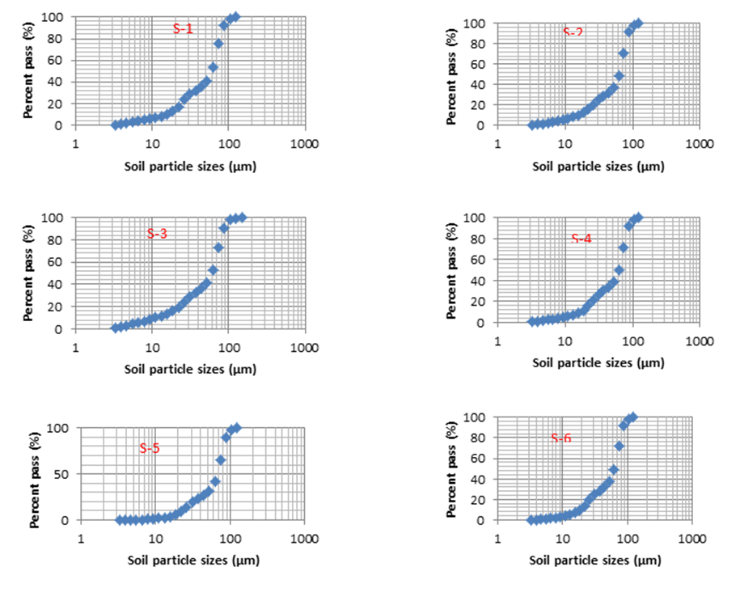
Figure S1 Particle size distribution in landfill site soils using Microtrac S3500 particle size analyser.

