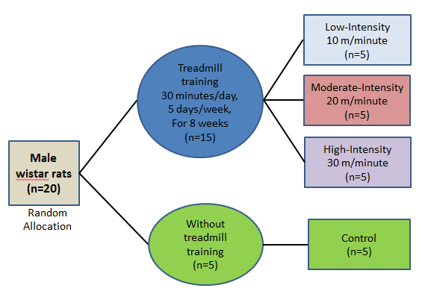
Additional file 1: Figure S1
Experimental Design of the Research. Animals were randomly allocated to 4 groups upon arrival. Three treadmill training intensities (Low-Intensity/LI, Moderate-Intensity/MI, and High-Intensity/HI) and one group without treadmill training/Control, were compared.

