Additional file 3:
Fig S1. Study flowchart. HCC, hepatocellular carcinoma; LASSO, Least Absolute Shrinkage and Selector Operation; ICPI, immune-clinical prognostic index.
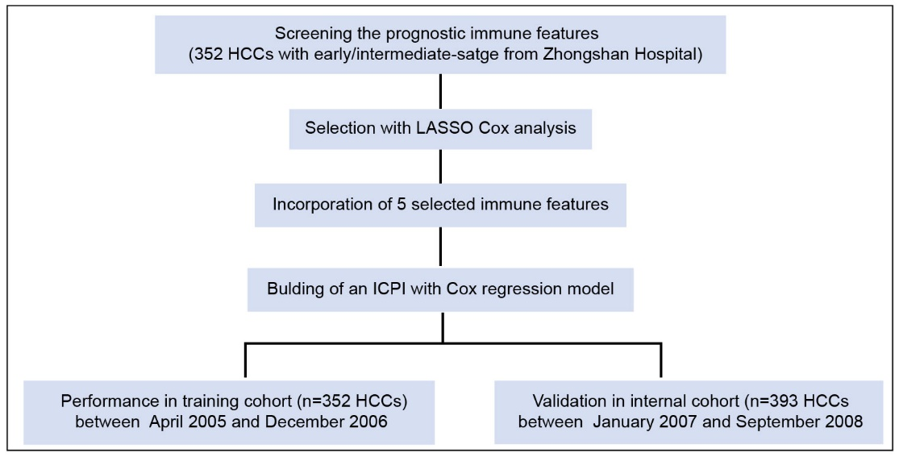

Fig S2. Digital image analyzed using the image software (Image-pro plus 6.0), with tissue represented in yellow and stained cells represented in red. Bar, 100 μm.
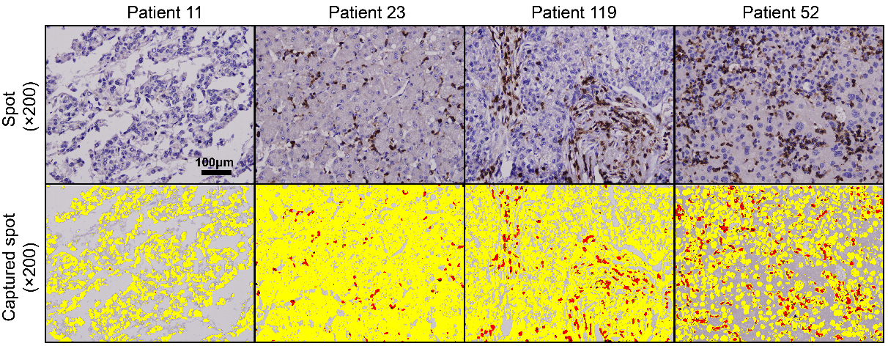

Fig S3. Immunohistochemistry expression pattern of 14 immune infiltrations in tumor and adjacent liver tissues, including CD3, CD4, CD8, CD14, CD20, CD27, CD45RA, CD45RO, CD57, CD66b, CD68, CD103, CXCR5 and PD1. Bar, 20 μm.
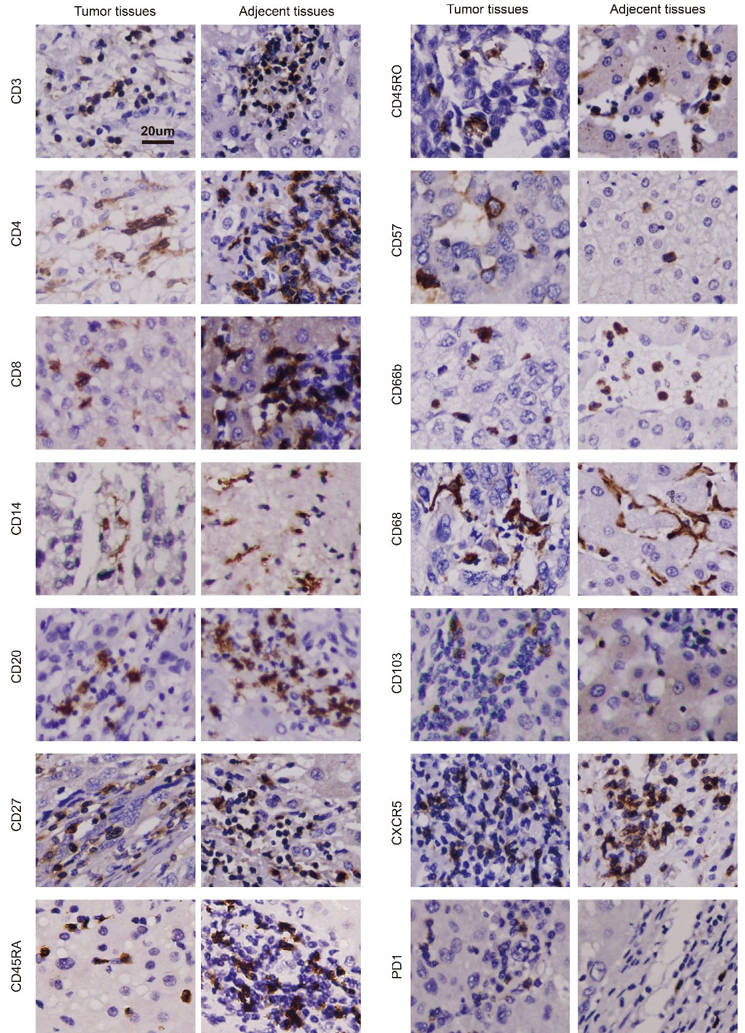

Fig S4. X-tile plots of ICPI in the training cohort automatically selecting the optimum cut point according to the highest χ²-value defined by Kaplan-Meier survival analysis and log-rank test.
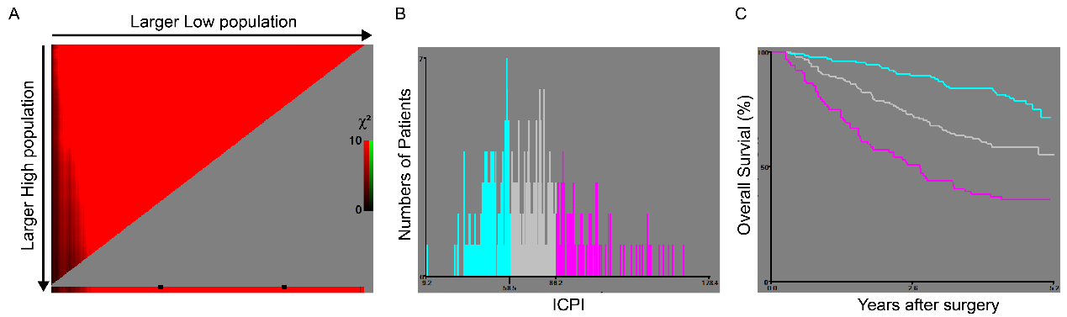

Fig S5. Kaplan-Meier survival curves of the training cohort categorized by different staging systems [(A) Stratified ICPI; (B) BCLC; (C) CLIP; (D) JIS; (E) LCSGJ; (F) Okuda; (G) AJCC 7th edition; (H) AJCC 8th edition)].
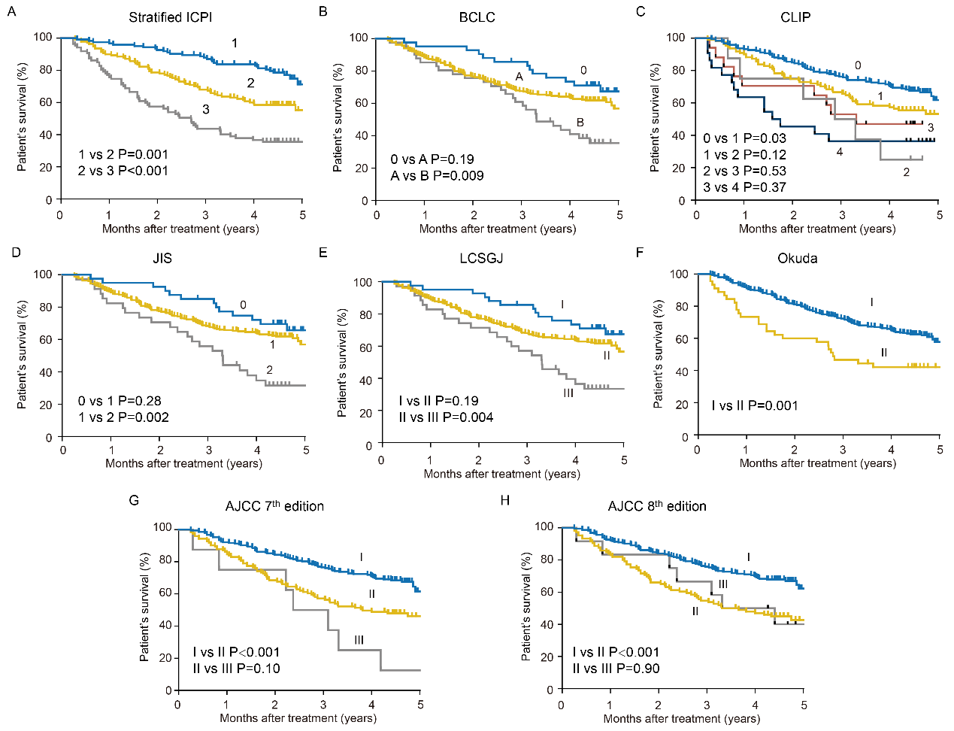

Fig S6. (A) Nomogram for predicting the survival probability in HCC patients. (B) Calibration of the predictive models at 1-, 3- and 5- year in the derivation and validation cohorts. Nomogram-predicted probability of overall survival (OS) is plotted on the x-axis; actual OS is plotted on the y-axis.
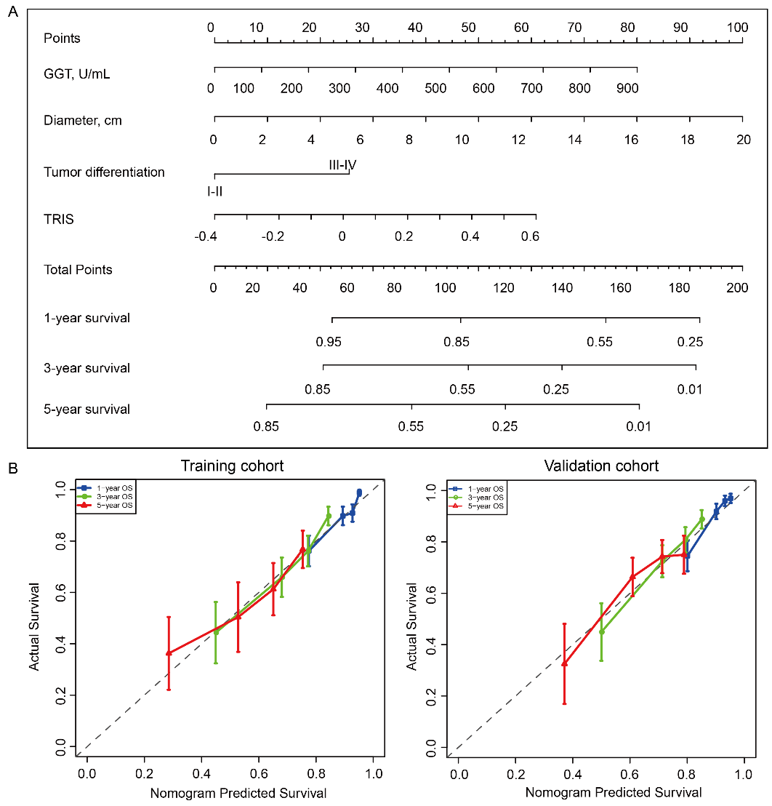

Fig S7. The correlation between TRIS and the density of intratumoral immune features, including CD4⁺, CD20⁺, CD45RO⁺, and CD45RA⁺ cells.
