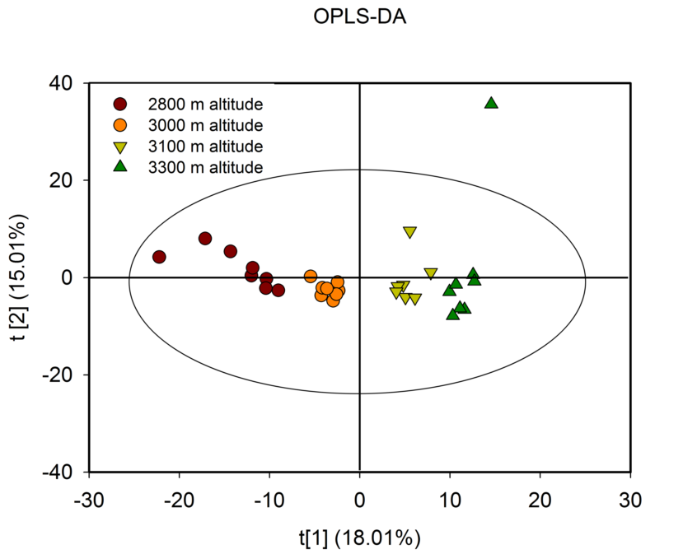
Figure S2 Orthogonal projections to latent structures discriminant analysis (OPLS-DA) score scatter plot derived from the GC-MS data set for leaves of Herpetospermum pedunculosum (Ser.) Baill. Each point represents the metabolic profile of eight replicates of samples collected at four altitudes. Brown circle indicted samples collected in 2800 m altitude; orange circle indicted samples collected in 3000 m altitude; yellow down-triangle indicated samples collected in 3100 m altitude; D: green up-triangle indicated samples collected in 3300 m altitude.

