**Figure. S1. Results of sanger and clone sequencing of the thirteen indels.**

The RS indicates the reference sequence; Ins and Del represent the sequence with insertion/deletion identified in this study, respectively.

rs381714237 ss2137349053

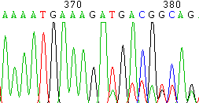

RS

Ins

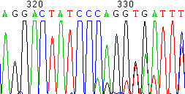

Ins

RS

rs385060942 ss2137349051

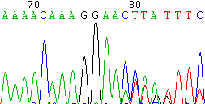

Ins

RS

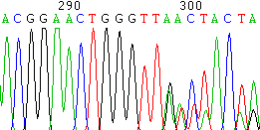

Ins

RS

rs453960300 rs378415122

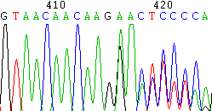

Del

RS

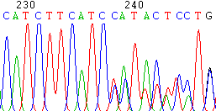

RS

Del

rs134985825 rs377943075

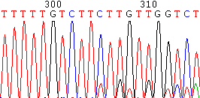

RS

Ins

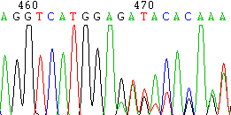

Del

RS

rs136639319 rs379188781

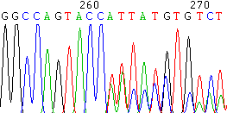

RS

Del

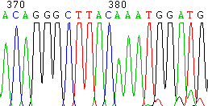

RS

Del



rs134444531 ss2137349058

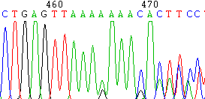

Del

RS

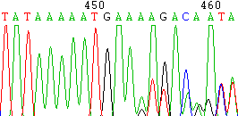

RS

Del

ss2019489562

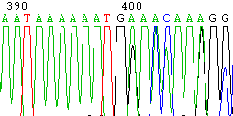

RS

Ins