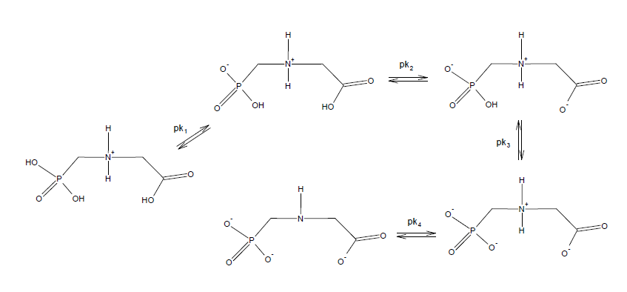
Figure S1. Molecular structures of glyphosate at different pHs. pk₁=2.0; pk₂ =2.6;pk₃ =5.6;pk₄ =10.6 [62].

