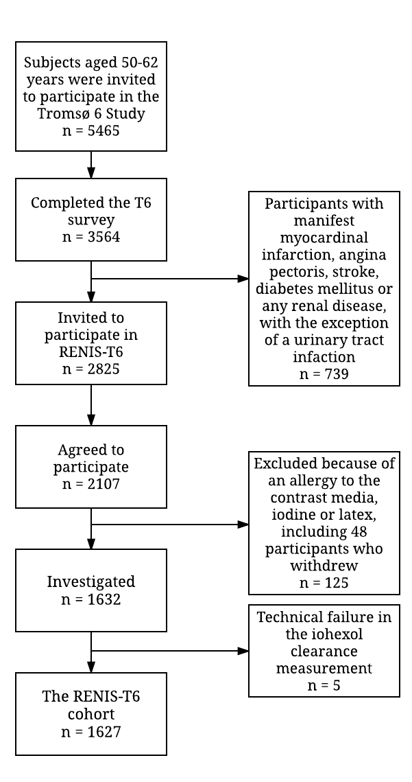
Figure 1. Inclusion of participants in the Renal Iohexol Clearance Survey in Tromsø 6 (RENIS-T6). Refer to the text for details.

