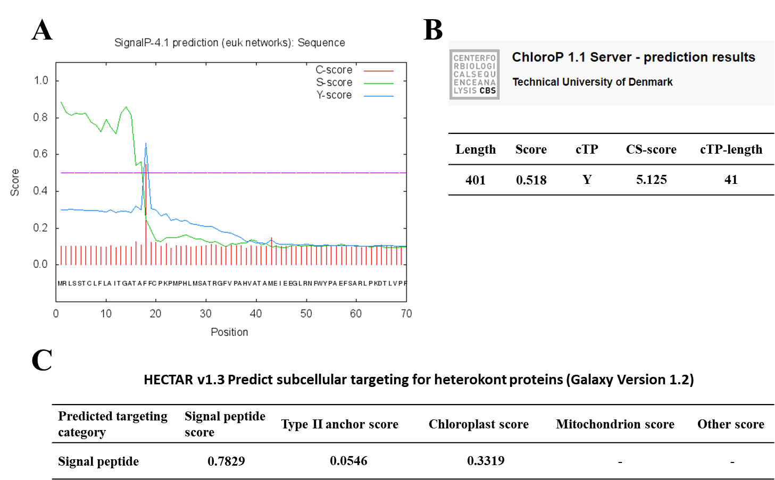

Figure S2. The prediction of leader sequence and localization by computational method. The signal peptide and transit peptide in chloroplast GCSL in N. salina were predicted by SignalP 4.1 (A) and ChloroP1.1 (B), respectively. Localization of the chimeric CrCAO protein linked to the signal and transit peptide of N. salina was predicted to be localized in the chloroplast by HECTAR v1.3 (C).

