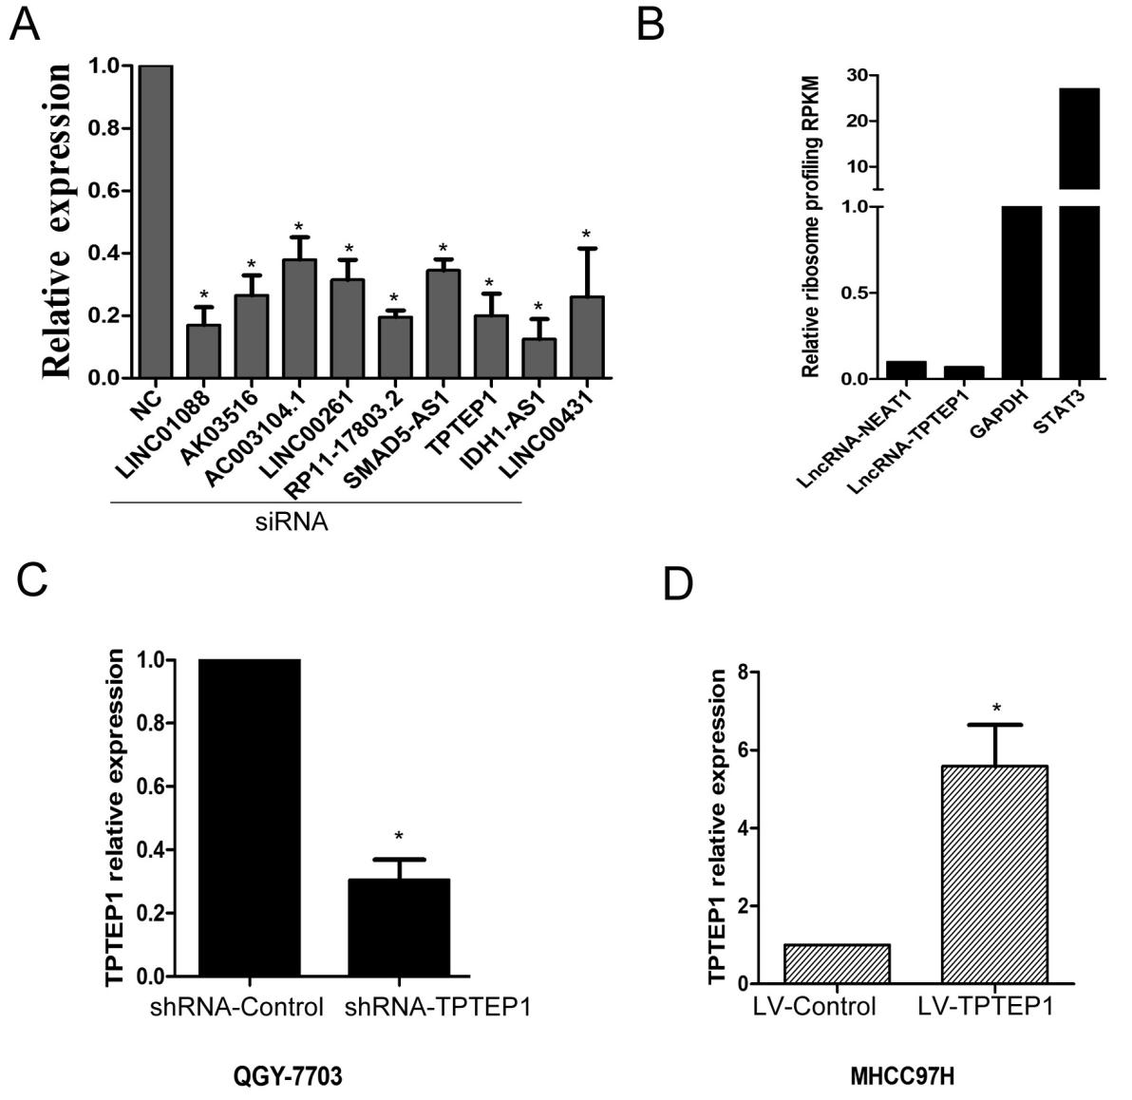

Supplementary Fig. 1. (A) QGY-7703 cells were transfected with the indicated siRNAs for 24 h and then the relative Long-non coding RNAs expressions were detected by qRT-PCR. (B) Ratio of RPKM (reads per kilobase per million mapped reads) value from ribosomal profiling of each indicated gene in QGY-7703. QGY-7703 cells were cultured in DMEM medium with 10% fetal bovine serum (Gibco), and then stimulated with IL-6 12 h. Cycloheximide was added into cell culture medium to a final concentration of 100 μg/ml and mixed well just before cell lysis. For cell lysis, cells were washed with ice-cold PBS and then lysed with ice-cold lysis buffer. The cell lysis was scraped down and then triturated ten times through a 26-G needle. Then footprint fragment purification was performed according to previous study (N. T. Ingolia, G. A. Brar, S. Rouskin, A. M. McGeachy, J. S. Weissman, The ribosome profiling strategy for monitoring translation in vivo by deep sequencing of ribosome-protected mRNA fragments. Nat. Protoc. 7, 1534–1550 (2012). doi:10.1038/nprot.2012.086 Medline). RNA was harvested using TRIzol reagent and Q-PCR was performed.(C) Relative RNA levels of TPTEP1 in QGY-7703 cells infected with the lentivirus expressing shRNA against TPTEP1 (shRNA-TPTEP1) or the control (shRNA-Control). (D) Relative RNA levels of TPTEP1 in MHCC97H cells infected with the lentivirus expressing TPTEP1 (LV-TPTEP1) or the control (LV-Control). Data are represented as means ± SD (n=3; *represents P < 0.05).

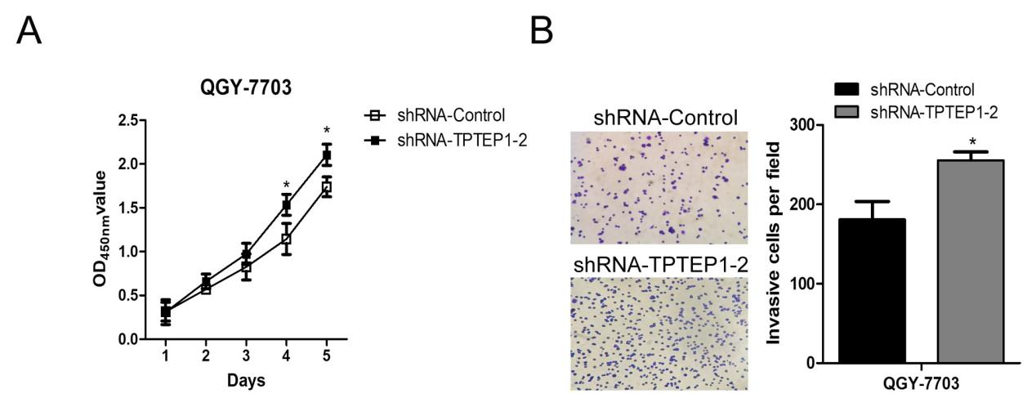

Supplementary Fig. 2. (A) Cell proliferation was examined by MTT assays in shRNA-Control QGY-7703 cells and TPTEP1-knockdowned QGY-7703 cells (shRNA-TPTEP1-2, another TPTEP1 shRNA used to avoid off-target effects) at the indicated time points. (B) Cell invasive ability was examined by transwell invasion assays in shRNA-Control QGY-7703 cells and TPTEP1-knockdowned QGY-7703 cells (shRNA-TPTEP1-2). Data are represented as means ± SD (n=3; *represents P < 0.05).

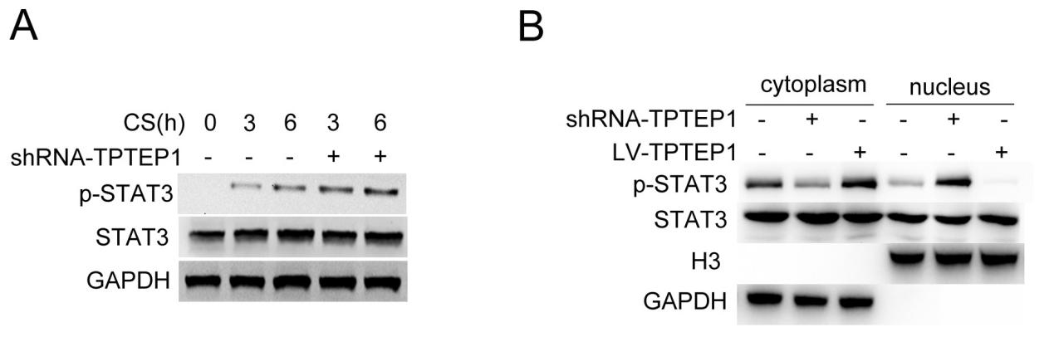
Supplementary Fig. 3. (A) QGY-7703 cells were infected with lentivirus carrying shRNA against TPTEP1 (ShRNA-TPTEP1) or not for 48h, and then treated with 30ug/ml cisplatinum (CS) or not for the indicated hours. The protein expression levels of GAPDH, STAT3 and phosphorylated STAT3 (p-STAT3) were detected by Western blotting. (B) QGY-7703 cells were infected with lentivirus carrying shRNA against TPTEP1 (ShRNA-TPTEP1) or lentivirus carrying TPTEP1 gene (LV-TPTEP1) for 48h, and then stimulated with IL-6 for 6 h. The protein expression levels of STAT3 and p-STAT3 in the cytoplasmic and nuclear fractions were detected by Western blotting (GAPDH as the cytoplasmic maker, and Histone H3 as the nuclear maker).
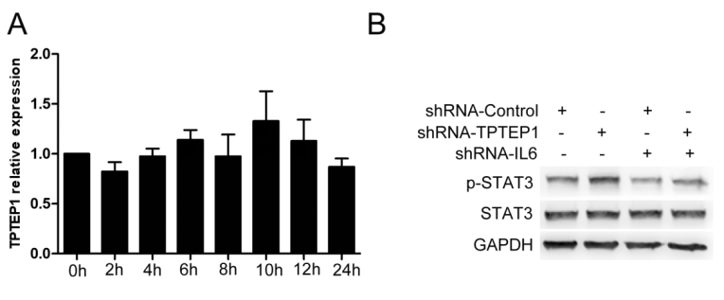
Supplementary Fig. 4. (A) QGY-7703 cells were stimulated with IL-6 (30 ng/ml) for the indicated times. TPTEP1 expressions were detected by qRT-PCR. (B) TPTEP1-knockdowned QGY-7703 cells or Control QGY-7703 cells (shRNA-Control) were transfected with shRNA-IL6 or not for 24 hours and then stimulated with IL-6 (30 ng/ml) for 30 min. The protein expression levels of STAT3 and phosphorylated STAT3 (p-STAT3) were detected by Western blotting (GAPDH as loading control).
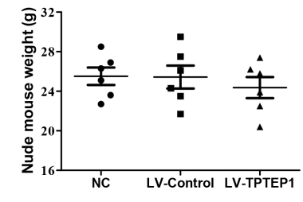
Supplementary Fig. 5. Eighteen 4-week-old male BALB/c nude mice were divided into 3 groups randomly. Each group was composed of 6 mice that were injected with MHCC97H cells (NC), control MHCC97H cells (LV-Control) or TPTEP1-overexpressed cells (LV-TPTEP1). Five weeks later, the body weights of mice were monitored. Data are represented as means ± SD (n=6; *represents P < 0.05).

Clinical variables | Case number
TPTEP1(lower vs. higher) | 24/8
Sex (male vs. female) | 17/15
Age (≥55 years vs. <55 years) | 22/10
Cirrhosis (yes vs. no) | 16/16
Tumor size (≥5 cm vs. <5 cm) | 11/21
Tumor number (>1 vs. 1) | 17/15
ALT (>75 versus <75 U/L) | 23/9

Supplementary Table 1. Clinicopathological Characteristics of the human samples used in this study.
ALT: alanine aminotransferase.

 | Sequence | Names
siRNAs against LncRNAs
 | ACUGAGAAAGAAACGGUUCGAACCGUUUCUUUCUCAGU | siRNA-LINC01088
 | GCAGGAGCUAAGCGUUUCAUGAAACGCUUAGCUCCUGC | siRNA-AK03516
 | GAGGCACUCCAAUUGAGCCAUGGCUCAAUUGGAGUGCCUC | siRNA-AC003104.1
 | CGAACCAGCAGGGUCGUGUACACGACCCUGCUGGUUCG | siRNA-LINC00261
 | CCUUGACUUUCAGUGACCAUGGUCACUGAAAGUCAAGG | siRNA-RP11-17803.2
 | GUGAGUUGCCAUCAACCAAUUGGUUGAUGGCAACUCAC | siRNA-SMDA5-AS1
 | ACAGCAUCGAAGUAAGAGAUCUCUUACUUCGAUGCUGU | siRNA-TPTEP1
 | UGACGUGGACCAAGAGCAGCUGCUCUUGGUCCACGUCA | siRNA-IDH1-AS1
 | CGGGACUGGGUAGCUAUCAUGAUAGCUACCCAGUCCCG | siRNA-LINC00341
Primers for TPTEP1 constructs
TPTEP1 (full legnth) F | 5’-GTGAATTCCTCGAGACTAGTTCTGCCTCTCCCGGTACCTGCT-3’ | pcDNA3.1-TPTEP1 (full legnth)
TPTEP1 (full legnth) R | 5’GGATCCGCGGCCGCTCTAGCACTAGTTTTTGATGGAATTTTTAGTTT-3’
TPTEP1-2 F | 5’-GTGAATTCCTCGAGACTAGTTCTGCCTCTCCCGGTACCTGCT-3’ | pcDNA3.1-TPTEP1-2
TPTEP1-2 R | 5’-GGATCCGCGGCCGCTCTAGCACTAGTGAAGGCAGTAAAGAAATGAGC-3’
TPTEP1-3 F | 5’-GTGAATTCCTCGAGACTAGTTCTCTCAGACCGACCAGCCCAAGAAAC-3’ | pcDNA3.1-TPTEP1-3
TPTEP1-3 R | 5’-GGATCCGCGGCCGCTCTAGCACTAGTTTTTGATGGAATTAAAAAGTTTACT-3’
TPTEP1-4 F | 5’-GTGAATTCCTCGAGACTAGTTCTGCCTCTCCCGGTACCTGCT-3’ | pcDNA3.1-TPTEP1-4
TPTEP1-4 R | 5’-GGATCCGCGGCCGCTCTAGCACTAGTGACCTGAGGTCGTAGGTGGATC-3’
Primers for STAT3 constructs
STAT3 (full legnth) F | 5’-GCCATGGAGGCCCGAATCGGATGGCCCAATGGAATCAGCT-3’ | pCMV-Flag-STAT3 (full length)
STAT3 (full legnth) R | 5’-GGCCGCGGTACCTCGAGTCACATGGGGGAGGTAGCGC-3’
STAT3 (NTD) F | 5’-GCCATGGAGGCCCGAATCGGATGGCCCAATGGAATCAGCT-3’ | pCMV-Flag-STAT3 (NTD)
STAT3 (NTD) R | 5’-GGCCGCGGTACCTCGAGTGGTTGGCCTGGCCCCCTTG-3’
STAT3 (NTD+CC+DBD) F | 5’-GCCATGGAGGCCCGAATCGGATGGCCCAATGGAATCAGCT-3’ | pCMV-Flag-STAT3 (NTD+CC+DBD)
STAT3 (NTD+CC+DBD) R | 5’-GGCCGCGGTACCTCGAGGTGGTGGAGGAGAACTGCCA-3’
STAT3 △DBD F | 5’-GCCATGGAGGCCCGAATT CGGATGGCCCAATGGAATCAGCTACAGC-3’ | pCMV-Flag-STAT3 △DBD
 | 5’-CCAACAACGGCAGCCTCTCTACCACCAAGCGAGGACTGAGC-3’
STAT3 △DBD R | 5’-GGCCGCGGTACCTCGAG TCACATGGGG GAGGTAGCGC-3’
 | 5’-GCTCAGTCCTCGCTTGGTGGTCGAGAGGCTGCCGTTGTTGG-3’
STAT3 (DBD+LK+SH2+TA) F | 5’-GCCATGGAGGCCCGAATTCGGCTTTGGAACGAAGGGTACAT-3’ | pCMV-Flag-STAT3 (DBD+LK+SH2+TA)
STAT3 (DBD+LK+SH2+TA) R | 5’-GGCCGCGGTACCTCGAGTCACATGGGGGAGGTAGCGC-3’
STAT3 (DBD) F | 5’-GCCATGGAGGCCCGAATTCGGCTTTGGAACGAAGGGTACAT-3’ | pCMV-Flag-STAT3 (DBD)
STAT3 (DBD) R | 5’-GGCCGCGGTACCTCGAGGTGGTGGAGGAGAACTGCCA-3’
Primers for qRT-PCR
TPTEP1 F | 5’-CTGGGAGAAGTGCCCTTGC-3’
TPTEP1 R | 5’-CACCTCATCAGTCATTTGCTCA-3’
NEAT1 F | 5’-CAGTTAGTTTATCAGTTCTCCCATCCA-3’
NEAT1 R | 5’-GTTGTTGTCGTCACCTTTCAACTCT-3’
TfⅡb F | 5’-ACTACAGAGCCGGTGATATGAT-3’
TfⅡb R | 5’-GTTGCTTTGTCATTGCTGAAAGT-3’
MCL1 F | 5’-TGCTTCGGAAACTGGACATCA-3’
MCL1 R | 5’-TAGCCACAAAGGCACCAAAAG-3’
Cyclin D1 F | 5’-GCTGCGAAGTGGAAACCATC-3’
Cyclin D1 R | 5’-CCTCCTTCTGCACACATTTGAA-3’
Bcl-xl F | 5’-GAGCTGGTGGTTGACTTTCTC-3’
Bcl-xl R | 5’-TCCATCTCCGATTCAGTCCCT-3’
IL6 F | 5’-ACTCACCTCTTCAGAACGAATTG-3’
IL6 R | 5’-CCATCTTTGGAAGGTTCAGGTTG-3’
GAPDH F | 5’-TCAACAGCAACTCCCACTCTTCCA-3’
GAPDH R | 5’-ACCCTGTTGCTGTAGCCGTATTCA-3’
Primers for STAT3 response element
STAT3 response element F | 5’-CCGACAGTCTGGTCGCATT-3’ | pGL3-basic-STAT3 response element
STAT3 response element R | 5’-A GGCTCCATGGGGGTCGTAT G-3’
Primers used for RIP
TPTEP1 F | 5’-CTGGGAGAAGTGCCCTTGC-3’
TPTEP1 R | 5’-CACCTCATCAGTCATTTGCTCA-3’
Supplementary Table 2. Primers used in this study.
F: forward primer; R: reverse primer.

