Additional File 1 – Confusion Matrix and classification statistics
This file displays the confusion matrix for 24 types motions as performed by 11 participants in 11 trials. The actual motion performed is viewed in the x axis (Target) while the motion predicted by the classifier is displayed in the corresponding row. The colour map also indicates the relative score of each cell, on a scale from 0 to 110. Since 11 participants performed each motion 10 times each, a perfect score for that motion would be observed as a value of 110 in the diagonal of this matrix.
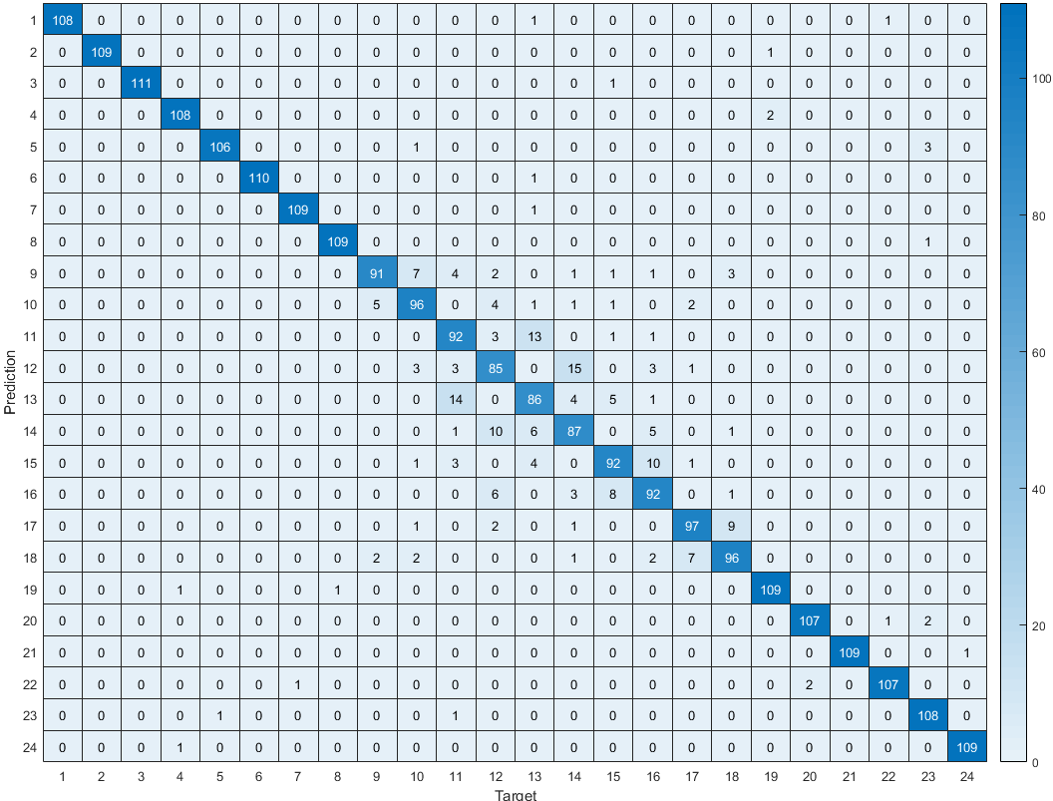

The table below shows additional statistics associated with the classifier performance for each of the 24 motions. Please note the following acronyms: TP = True positive, FP = False positive, TN = True negative, FN = False negative. True positive (TP) represents the number of true predictions when the Target is true, and matches the values in the diagonal of the confusion matrix. Accuracy is calculated as (true positive + true negative)/total. Precision is calculated as (TP)/(TP + FP). Sensitivity or True Positive Rate (TPR) is calculated as (TP)/(TP + FN). False Positive Rate (FPR) is calculated as (FP)/(FP + TN).
Please also note that motions 9-18 correspond to table-based reaching motions. Since performance was lower for these motions, average performance statistics were computed separately for this group.
Motion # | True Positive | Accuracy | Precision | Sensitivity, or True Positive Rate | False Positive Rate
1 | 108 | 0.9992 | 1.0000 | 0.9818 | 0
2 | 109 | 0.9996 | 1.0000 | 0.9909 | 0
3 | 111 | 0.9996 | 1.0000 | 0.9911 | 0
4 | 108 | 0.9985 | 0.9818 | 0.9818 | 0.0008
5 | 106 | 0.9981 | 0.9907 | 0.9636 | 0.0004
6 | 110 | 0.9996 | 1.0000 | 0.9910 | 0
7 | 109 | 0.9992 | 0.9909 | 0.9909 | 0.0004
8 | 109 | 0.9992 | 0.9909 | 0.9909 | 0.0004
9 | 91 | 0.9902 | 0.9286 | 0.8273 | 0.0028
10 | 96 | 0.9890 | 0.8649 | 0.8727 | 0.0059
11 | 92 | 0.9834 | 0.7797 | 0.8364 | 0.0103
12 | 85 | 0.9803 | 0.7589 | 0.7727 | 0.0107
13 | 86 | 0.9807 | 0.7611 | 0.7818 | 0.0107
14 | 87 | 0.9815 | 0.7699 | 0.7909 | 0.0103
15 | 92 | 0.9864 | 0.8440 | 0.8288 | 0.0067
16 | 92 | 0.9845 | 0.8000 | 0.8364 | 0.0091
17 | 97 | 0.9909 | 0.8981 | 0.8818 | 0.0043
18 | 96 | 0.9894 | 0.8727 | 0.8727 | 0.0055
19 | 109 | 0.9981 | 0.9732 | 0.9820 | 0.0012
20 | 107 | 0.9981 | 0.9817 | 0.9727 | 0.0008
21 | 109 | 0.9996 | 1.0000 | 0.9909 | 0
22 | 107 | 0.9981 | 0.9817 | 0.9727 | 0.0008
23 | 108 | 0.9970 | 0.9474 | 0.9818 | 0.0024
24 | 109 | 0.9992 | 0.9909 | 0.9909 | 0.0004
Mean, overall | 101 | 0.9933 | 0.9211 | 0.9198 | 0.0035
Mean, motions 9-18 | 91 | 0.9856 | 0.8278 | 0.8302 | 0.0076
Mean, motions 1-8 and 19-24 | 109 | 0.9988 | 0.9878 | 0.9838 | 0.0005

