Annex- 1
Workflow in the data collection by phase of asylum procedure from the arrival of immigrants to the second instance decision.

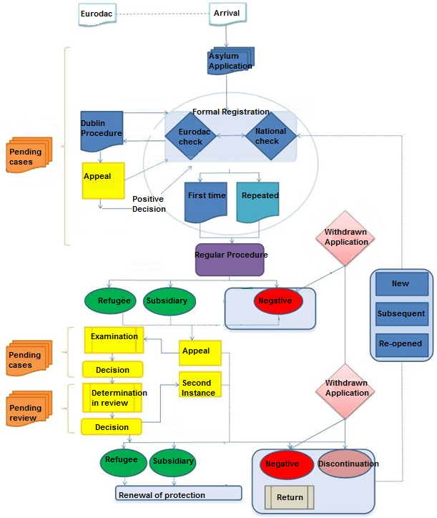

Asylum-related data collections in Italy

