Additional file 1
Figure S1: CFLAR_{L} protein level positively correlated with GMEB1 and USP40 protein levels in NSCLC cell lines. Relative amounts of GMEB1, CFLAR_{L} and USP40 normalized to ACTB in NSCLC cell lines were quantified using Photoshop CS6. The pearson correlation coefficient for the protein expression levels of CFLAR_{L} versus GMEB1 (A) or USP40 (B) and USP40 versus GMEB1 (C) were shown in the picture. (D, E) SAHA treatment was conducted in A549 and Calu-1 cells and cells were then prepared for western analysis.

Figure S2: CFLAR_{L} directly interact with GMEB1. The schematic diagram of CFLAR_{L} (A) and GMEB1 (D). (B) FLAG tagged CFLAR_{L} domains and HA-GMEB1 were co-transfected in HEK293FT cells for co-IP assay. (C) CFLAR_{L} domain deletion mutation plasmids were co-transfected with HA-GMEB1 for co-IP assay. (E) FLAG tagged CFLAR_{L} and HA tagged GMEB1 domains were co-transfected in HEK293FT cells for co-IP assay. (F) HA-GMEB1-325-573 and HA-GMEB1-WT plasmids were transfected in A549 cells for western blot analysis.

Figure S3: USP40 interacted with GMEB1 and CFLAR_{L}. (A, B) HIS-USP40 and HA-GMEB1 were co-transfected in HEK293FT cells co-IP assay analysis. (C, D) HIS-USP40 and FLAG-CFLAR_{L} were co-transfected in HEK293FT cells for co-IP assay analysis. (E) Calu-1 cells were fixed and subjected to indirect immunofluorescence staining with anti-FLIP_{L} (Santa Cruz, US) and USP40 (Santa Cruz, US). The red signal (CFLAR_{L}) was obtained with anti-rabbit IgG Alexa 568-conjugated secondary Ab, and the green signals (USP40) were obtained with anti-mouse IgG Alexa 488-conjugated secondary Ab. Nuclei were stained with DAPI. (F) FLAG tagged CFLAR_{L} domains and HIS-USP40 were co-transfected in HEK293FT cells. HIS-USP40 and pcDNA3.1 were co-transfected as control. Cells were harvested for co-IP assay. (G) CFLAR_{L} domain deletion mutation plasmids were co-transfected with HIS-USP40 for co-IP assay.

Figure S4: USP40 targeted CFLAR_{L} for de-ubiquitination. (A) The schematic diagram of USP40-C62A. (B) USP40-C62A and USP40-WT were transfected in A549 cells for western blot analysis. (C) FLAG-CFLAR_{L} was co-transfected with HIS-USP40-WT and HIS-USP40-C62A for co-IP assay. (D) GST pull down assay was conducted using GST-CFLAR_{L}, HA-Ub, HIS-USP40-WT and HIS-USP40-C62A plasmids in HEK293FT cells. (E) HA-GMEB1 plasmid was transfected in HEK293FT cells for co-IP assay.

Figure S5: GMEB1 inhibited apoptosis via CFLAR_{L}. (A) A549 cells were seeded in 6-well plates. GMEB1 siRNA and FLAG-CFLAR_{L} were transfected for 48h. Cells were treated with TRAIL for 6h. Cells were harvested for western blot analysis. (B, C) A549 cells were seeded in 6-well plates. GMEB1 siRNA were transfected for 48h. Cells were treated with TRAIL for 24h. Cells were collected for Flow Cytometry analysis. (D, E) A549 cells were seeded in 6-well plates. GMEB1 siRNA and FLAG-CFLAR_{L} plasmid were co-transfected for 48h. Then cells were treated with TRAIL for 24h. Cells were collected for Flow Cytometry analysis.
Figure S1
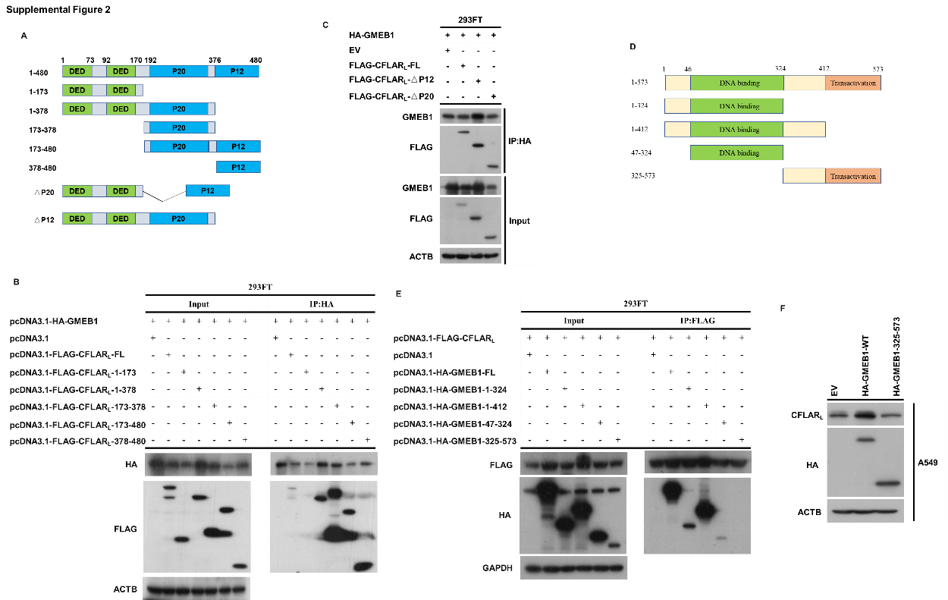
Figure S2

Figure S3
Figure S4

Figure S5

