Additional file 1: Figure S1 Illustration of the influence of logistic model parameters on curve, and the model fitted to a CKC. From left to right: α defines the asymmetry of the logistic model, τ the steepness of the curve and k influences the terminal slope. The regression curve fitted to a given CKC for a malignant (blue) and a benign lesion (green).
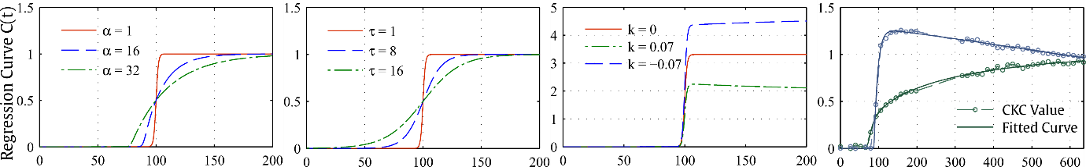
Figure S2 Boxplot of automatic segmentation performance in terms of Dice similarity coefficient (DSC). DWI, diffusion-weighted imaging; GI, Gini Importance; mRMR, minimum-Redundancy-Maximum-Relevance; PET, positron emission tomography; w/o, without
Table S1 Definitions of morphologic features.
Morphological feature | Definition | Note
Number of voxels in the lesion ($n$) = Volume of lesion ($V$) | $n=|x_{l}|$ | Number of voxels and volume were the same in this case since a voxel had a volume of 1 mm$^{3}$.
Centroid ($\overline{c}$) | $\overline{c}=\frac{1}{n}\sum_{n}{‍}x_{i}$, with $x_{i}∈x_{l}$
Maximum radial distance ($r$) | $r=\max_{x_{i}∈x_{l}}(||x_{i}-\overline{c}||)$
Normalized radial length ($nrl$) | $nrl_{i}=\frac{||x_{i}-\overline{c}||}{r}$, with $x_{i}∈x_{l}$
Area of enclosing surface ($A$) | $|voxel surface faces|$
Volume Overlap Ratio ($VOR$) | $\frac{V}{4/3π r^{3}}$ | Ratio of lesion volume to circumscribing sphere.
Elliptic Volume Overlap Ratio ($EllVOR$) | $\frac{V}{4/3π a b c}$ | Ratio of lesion volume to inertia ellipsoid. $a,b,c$...ellipsoid radii. The inertia ellipsoid is obtained by PCA of $x_{l}$.
Discrete Compactness ($C_{d}$) ⁵² | $\frac{n-A/6}{n-(\sqrt[3]{n})^{2}}$
Irregularity ($Irr$) | $1-\frac{π*d_{e}^{2}}{A}$, with $d_{e}=2\sqrt[3]{\frac{3V}{4π}}$ | Deviation of lesion surface $A$ from a sphere surface with the same volume.
Sphericity ($S$) | $\frac{\min_{x_{i}∈x_{l}}(||x_{i}-\overline{c}||)}{r}$ | Ratio of inscribing sphere radius to circumscribing sphere.
NRL mean ($μ_{nrl}$) | $1/n\sum_{n}{‍}nrl_{i}$
NRL variance ($σ_{nrl}^{2}$) | $$1/n\sum_{n}{‍}(nrl_{i}-μ_{nrl})^{2}$$
NRL sphericity ($S_{nrl}$) | $\frac{μ_{nrl_{i}}}{σ_{nrl}^{2}}$

