Precision and Recall of Classification
Precision
The performance of matching patients with different prototypes was used to assess the IC methods, CS methods and SS methods. The precision is shown below.
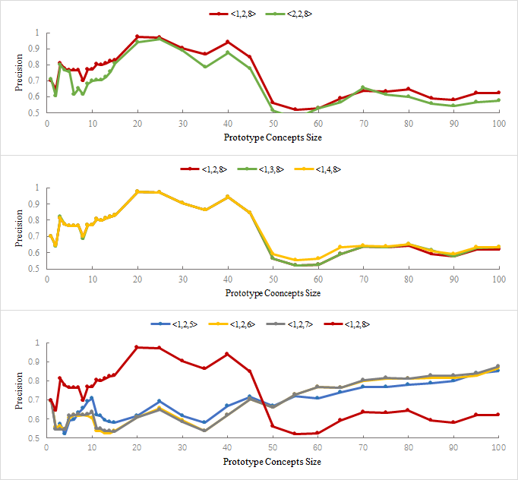
Supplemental Figure 2 The precision of the performance of classification.

Recall
The performance of matching patients with different prototypes was used to assess the IC methods, CS methods and SS methods. The recall is shown below.
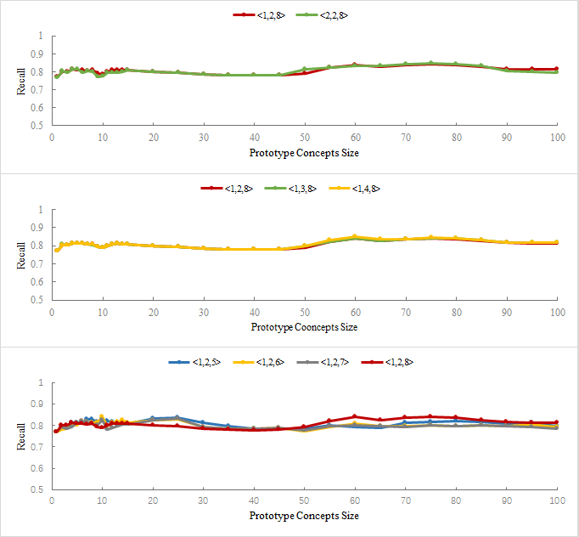
Supplemental Figure 3 The recall of the performance of classification.

Performance of Combinations with Taxonomy-based IC
When IC is computed based on taxonomy (IC#2 Formula), the performance of matching patients with different prototypes and predicting HLOS length is as shown below. Thess results also confirmed the result shown in the main text.
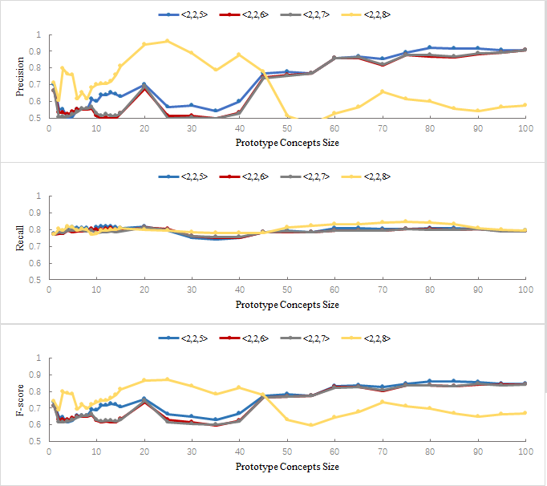
Supplemental Figure 4 Performance of Combinations using Taxonomy-based IC

