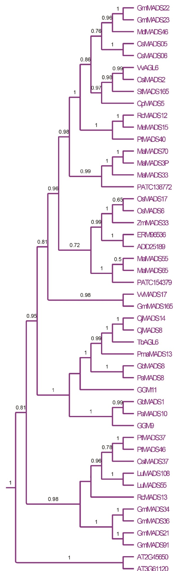
Additional file 7: The AGL6 /AGL13 genes in Bayesian tree and the Bayesian posterior probability values in tree.

