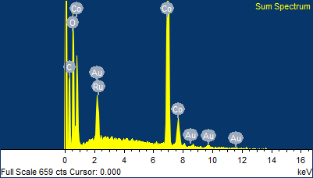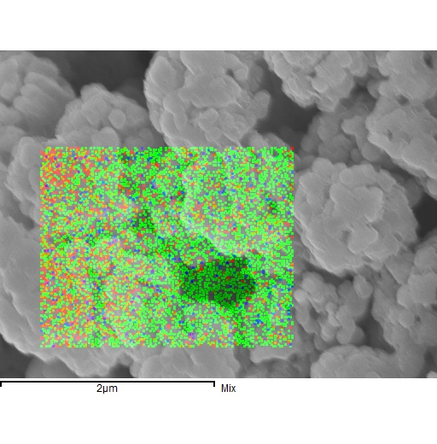

Spectrum processing :

No peaks omitted

Processing option : All elements analyzed (Normalised)

Number of iterations = 3

Standard :

C CaCO3 1-Jun-1999 12:00 AM

O SiO2 1-Jun-1999 12:00 AM

Co Co 1-Jun-1999 12:00 AM

Ru Ru 1-Jun-1999 12:00 AM

Au Au 1-Jun-1999 12:00 AM

|  |  |  |  |
| --- | --- | --- | --- |
| Element | Weight% | Atomic% |  |
|  |  |  |  |
| C K | 14.91 | 40.17 |  |
| O K | 10.69 | 21.63 |  |
| Co K | 67.46 | 37.04 |  |
| Ru L | 0.13 | 0.04 |  |
| Au M | 6.81 | 1.12 |  |
|  |  |  |  |
| Totals | 100.00 |  |  |

Comment:

3/23/2018 5:58:56 PM

S6

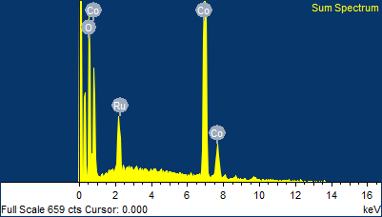

Spectrum processing :

Peaks possibly omitted : 8.030, 9.680 keV

Processing option : All elements analyzed (Normalised)

Number of iterations = 3

Standard :

O SiO2 1-Jun-1999 12:00 AM

Co Co 1-Jun-1999 12:00 AM

Ru Ru 1-Jun-1999 12:00 AM

|  |  |  |  |
| --- | --- | --- | --- |
| Element | Weight% | Atomic% |  |
|  |  |  |  |
| O K | 10.67 | 30.57 |  |
| Co K | 89.22 | 69.38 |  |
| Ru L | 0.11 | 0.05 |  |
|  |  |  |  |
| Totals | 100.00 |  |  |

Comment:

3/23/2018 5:59:39 PM

S6