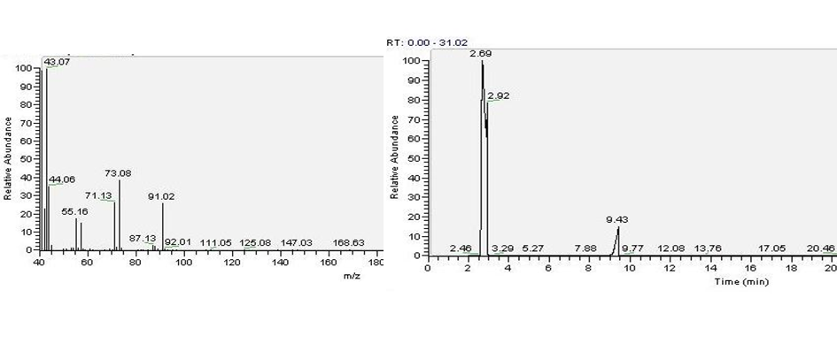
Fig. S1. Chromatograph of 1,4-butanediol standard.

