Combining directed evolution of pathway enzymes and dynamic pathway regulation using a quorum-sensing circuit to improve the production of 4-hydroxyphenylacetic acid in Escherichia coli
Yu-Ping Shen, Lai San Fong, Zhi-Bo Yan, Jian-Zhong Liu*

Institute of Synthetic Biology, Biomedical Center, Guangdong Province Key Laboratory of Improved Variety Reproduction in Aquatic Economic Animals and South China Sea Bio-Resource Exploitation and Utilization Collaborative Innovation Center, School of Life Sciences, Sun Yat-sen University, Guangzhou 510275, China

*Corresponding author: Institute of Synthetic Biology, School of Life Science, Sun Yat-Sen University, Guangzhou 510275, P.R. China. Phone: +86-20-84110115. Fax: +86-20-84036461. E-mail address: lssljz@mail.sysu.edu.cn (J. Z. Liu)

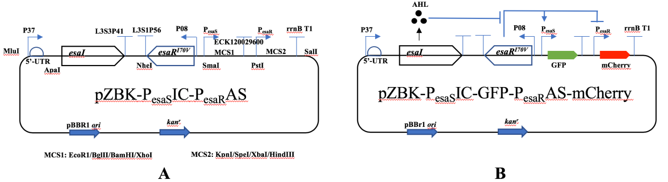
Figure S1. (A) Esa quorum-sensing (QS) plasmid. (B) Activation and repression of genes using quorum-sensing circuit. The QS signaling molecule (3-oxohexanoyl-homoserine lactone, AHL) is produced by the AHL synthase encoded by esaI. In the absence of AHL or at low AHL concentration, the transcriptional regulator EsaR^{I70V} binds the P_{esaS}/or P_{esaR} promoter and activates the transcription of GFP, and/or represses the transcription of mCherry. As cell density increases, AHLs accumulate, resulting in disruption of EsaR^{I70V} binding and repressing of the transcription of GFP, and/or activating of the transcription of mCherry. (C) Gene expression from P_{esaS}/or P_{esaR} promoter in the Esa quorum-sensing circuit. As cell growth, the transcription level of GFP driven by the P_{esaS} promoter decreased, and the transcription level of mCherry driven by the P_{esaR} promoter increased.
Table S1. Mutations on the evolved gene
Plasmid | gene | Base mutation | Amino acid mutaion
2E1 | ARO10 | C1869T | No
 | feaB | T72G, T1195C, A1491T | I24M
4F3 | ARO10 | A1682G, A1842G | No
 | feaB | C165G, A609T, T1296 | N55K
6D5 | ARO10 | T412C, A653G, T948C, A1815T | F138L, D218G
9F5 | ARO10 | T695C, A1599G, A1776G | No
10A3 | ARO10 | T989C, G1351A, A1638G | V451I
10G5 | ARO10 | C1722T | No

Table S2. The sequence of the TIGR
GCCTAGCAAGATCTCCTGATCCCGGTGCGCGACCACCCGGACATCTGCATAGTCTGGGCCAGTCTGAGGACTGGCGGATCAGGGCCTTGAATTTACAGTATTTTAGTGGCCTTACGCTATACTATTCGGTCACCTTATCCGCTCAAGACATGCACTCGGAACGCATCTAGGGTACCGCAGATACTGTATCC

