Additional file 1

Table 2: Volume of antibiotics DDD per 1,000 person-years from 2006 to 2015 according to sex and age groups
 | Overall |  |  |  |  |  | Female |  |  |  |  |  | Male
År | 15-39 | 40-64 | 65-84 | +85 | Overall |  | 15-39 | 40-64 | 65-84 | +85 | Overall |  | 15-39 | 40-64 | 65-84 | +85 | Overall
2006 | 3,837.7 | 4,286.5 | 8,178.3 | 18,979.6 | 5,041.9 |  | 4,936.7 | 5,092.8 | 8,906.1 | 20,640.2 | 6,141.3 |  | 2,776.8 | 3,498.2 | 7,312.4 | 15,367.2 | 3,920.5
2007 | 4,051.1 | 4,551.3 | 8,509.7 | 20,268.7 | 5,333.4 |  | 5,213.6 | 5,427.4 | 9,254.6 | 21,933.2 | 6,497.9 |  | 2,929.4 | 3,695.4 | 7,635.5 | 16,616.9 | 4,147.7
2008 | 3,876.5 | 4,508.0 | 8,414.5 | 21,438.6 | 5,271.0 |  | 5,057.8 | 5,324.8 | 9,256.4 | 23,239.8 | 6,447.8 |  | 2,739.2 | 3,710.2 | 7,439.2 | 17,485.1 | 4,075.8
2009 | 3,816.4 | 4,491.6 | 8,737.1 | 22,213.1 | 5,328.6 |  | 5,016.4 | 5,313.4 | 9,684.5 | 24,156.5 | 6,544.0 |  | 2,659.7 | 3,687.8 | 7,653.1 | 17,983.8 | 4,094.6
2010 | 3,946.9 | 4,696.6 | 8,907.9 | 22,095.8 | 5,518.7 |  | 5,201.5 | 5,568.4 | 9,866.7 | 24,004.4 | 6,772.6 |  | 2,735.8 | 3,841.7 | 7,825.3 | 17,946.5 | 4,245.0
2011 | 3,964.1 | 4,749.1 | 8,955.7 | 22,205.7 | 5,588.8 |  | 5,258.1 | 5,660.7 | 9,997.9 | 23,980.7 | 6,881.5 |  | 2,714.6 | 3,853.6 | 7,795.2 | 18,399.4 | 4,276.7
2012 | 3,581.4 | 4,470.6 | 8,970.6 | 22,724.7 | 5,374.5 |  | 4,829.9 | 5,322.0 | 10,004.5 | 24,269.5 | 6,623.4 |  | 2,379.7 | 3,633.5 | 7,829.0 | 19,499.4 | 4,109.4
2013 | 3,249.7 | 4,321.0 | 9,016.8 | 23,432.6 | 5,236.6 |  | 4,442.9 | 5,155.8 | 10,050.7 | 25,151.5 | 6,470.5 |  | 2,103.9 | 3,497.9 | 7,883.2 | 19,889.0 | 3,987.6
2014 | 3,175.2 | 4,174.2 | 8,722.4 | 23,042.1 | 5,113.4 |  | 4,343.3 | 4,997.8 | 9,714.5 | 25,239.6 | 6,332.6 |  | 2,057.3 | 3,359.9 | 7,639.3 | 18,664.2 | 3,880.3
2015 | 2,741.4 | 3,802.8 | 8,240.7 | 22,332.2 | 4,709.1 |  | 3,806.0 | 4,626.0 | 9,242.9 | 24,439.4 | 5,883.3 |  | 1,726.9 | 2,988.7 | 7,152.3 | 18,233.1 | 3,524.5

Table 3: Volume of narrow- and broad-spectrum antibiotics DDD per 1,000 person-years from 2006 to 2015, stratified by sex and age group
 |  |  | Overall |  |  |  |  |  | Female |  |  |  |  |  | Male
Broad-spectrum  antibiotics | År |  | 15-39 | 40-64 | 65-84 | +85 | Overall |  | 15-39 | 40-64 | 65-84 | +85 | Overall |  | 15-39 | 40-64 | 65-84 | +85 | Overall
 | 2006 |  | 1,038.8 | 1,419.0 | 3,210.6 | 5,937.0 | 1,647.9 |  | 1,548.2 | 1,824.4 | 3,516.6 | 6,199.2 | 2,133.6 |  | 547.0 | 1,022.7 | 2,846.6 | 5,366.6 | 1,152.3
 | 2007 |  | 1,135.8 | 1,561.1 | 3,501.1 | 6,322.9 | 1,807.5 |  | 1,687.0 | 2,030.4 | 3,860.1 | 6,550.6 | 2,346.8 |  | 604.1 | 1,102.6 | 3,079.7 | 5,823.2 | 1,258.3
 | 2008 |  | 1,168.4 | 1,582.2 | 3,564.1 | 6,723.0 | 1,855.1 |  | 1,774.2 | 2,048.7 | 3,950.2 | 6,961.2 | 2,421.2 |  | 585.2 | 1,126.6 | 3,116.8 | 6,200.2 | 1,280.0
 | 2009 |  | 1,188.9 | 1,647.4 | 3,828.2 | 7,258.4 | 1,954.6 |  | 1,811.5 | 2,143.3 | 4,266.2 | 7,390.5 | 2,549.2 |  | 588.8 | 1,162.5 | 3,327.1 | 6,970.9 | 1,350.9
 | 2010 |  | 1,275.6 | 1,833.0 | 4,128.9 | 7,689.3 | 2,139.8 |  | 1,925.1 | 2,377.9 | 4,624.6 | 7,878.0 | 2,778.9 |  | 648.7 | 1,298.7 | 3,569.2 | 7,279.0 | 1,490.7
 | 2011 |  | 1,344.3 | 1,953.7 | 4,364.0 | 8,262.9 | 2,287.0 |  | 2,029.3 | 2,547.7 | 4,914.8 | 8,355.9 | 2,969.0 |  | 682.8 | 1,370.1 | 3,750.6 | 8,063.4 | 1,594.7
 | 2012 |  | 1,246.9 | 1,895.5 | 4,483.7 | 8,863.0 | 2,279.2 |  | 1,931.8 | 2,477.0 | 5,068.8 | 8,961.9 | 2,967.9 |  | 587.7 | 1,323.8 | 3,837.6 | 8,656.5 | 1,581.5
 | 2013 |  | 1,202.0 | 1,873.4 | 4,611.4 | 9,609.2 | 2,308.8 |  | 1,886.8 | 2,477.2 | 5,203.9 | 9,763.5 | 3,015.4 |  | 544.4 | 1,277.9 | 3,961.7 | 9,290.9 | 1,593.4
 | 2014 |  | 1,205.5 | 1,821.6 | 4,440.8 | 9,628.1 | 2,273.3 |  | 1,894.8 | 2,442.3 | 5,057.6 | 10,065.1 | 2,999.2 |  | 545.7 | 1,207.9 | 3,767.5 | 8,757.4 | 1,539.2
Narrow-spectrum  antibiotics | 2015 |  | 1,139.0 | 1,769.5 | 4,385.4 | 9,584.9 | 2,226.6 |  | 1,787.8 | 2,364.2 | 5,016.8 | 9,959.4 | 2,926.9 |  | 520.8 | 1,181.4 | 3,699.6 | 8,856.2 | 1,520.2
 | 2006 |  | 2,402.1 | 2,364.3 | 2,773.0 | 3,641.6 | 2,471.6 |  | 2,790.5 | 2,556.1 | 2,703.9 | 3,405.3 | 2,697.4 |  | 2,027.2 | 2,176.8 | 2,855.1 | 4,155.6 | 2,241.3
 | 2007 |  | 2,516.0 | 2,480.5 | 2,893.1 | 3,961.7 | 2,593.1 |  | 2,934.2 | 2,695.4 | 2,806.8 | 3,783.9 | 2,839.2 |  | 2,112.6 | 2,270.6 | 2,994.4 | 4,351.9 | 2,342.5
 | 2008 |  | 2,318.2 | 2,403.6 | 2,802.8 | 3,943.3 | 2,469.1 |  | 2,715.2 | 2,559.1 | 2,747.4 | 3,709.1 | 2,686.5 |  | 1,936.0 | 2,251.7 | 2,866.9 | 4,457.5 | 2,248.3
 | 2009 |  | 2,198.5 | 2,307.4 | 2,760.1 | 3,949.8 | 2,376.6 |  | 2,588.4 | 2,458.0 | 2,705.2 | 3,740.7 | 2,590.5 |  | 1,822.7 | 2,160.2 | 2,822.9 | 4,405.0 | 2,159.4
 | 2010 |  | 2,252.2 | 2,327.4 | 2,712.2 | 3,796.5 | 2,397.1 |  | 2,666.6 | 2,476.0 | 2,652.3 | 3,552.8 | 2,613.7 |  | 1,852.2 | 2,181.7 | 2,779.9 | 4,326.3 | 2,177.1
 | 2011 |  | 2,226.1 | 2,272.4 | 2,626.7 | 3,679.9 | 2,349.4 |  | 2,653.2 | 2,416.1 | 2,587.7 | 3,531.4 | 2,572.7 |  | 1,813.6 | 2,131.1 | 2,670.1 | 3,998.3 | 2,122.7
 | 2012 |  | 1,962.1 | 2,045.3 | 2,482.3 | 3,624.6 | 2,129.7 |  | 2,339.4 | 2,144.6 | 2,401.3 | 3,450.5 | 2,307.9 |  | 1,599.0 | 1,947.7 | 2,571.8 | 3,988.0 | 1,949.3
 | 2013 |  | 1,688.0 | 1,927.9 | 2,440.8 | 3,655.9 | 1,972.2 |  | 2,008.4 | 1,996.6 | 2,348.6 | 3,494.9 | 2,116.7 |  | 1,380.4 | 1,860.1 | 2,541.8 | 3,987.7 | 1,825.9
 | 2014 |  | 1,655.7 | 1,832.3 | 2,296.2 | 3,424.9 | 1,891.6 |  | 1,958.9 | 1,871.2 | 2,152.4 | 3,284.6 | 2,004.5 |  | 1,365.5 | 1,793.9 | 2,453.1 | 3,704.5 | 1,777.3
 | 2015 |  | 1,317.6 | 1,524.6 | 1,913.3 | 2,897.1 | 1,554.4 |  | 1,561.8 | 1,566.4 | 1,808.4 | 2,799.4 | 1,652.7 |  | 1,084.8 | 1,483.2 | 2,027.1 | 3,087.1 | 1,455.1

Figure 7: Prescribing rates of antibiotic subgroup DDD per 1,000 person-years from 2006 to 2015, stratified by sex and age group
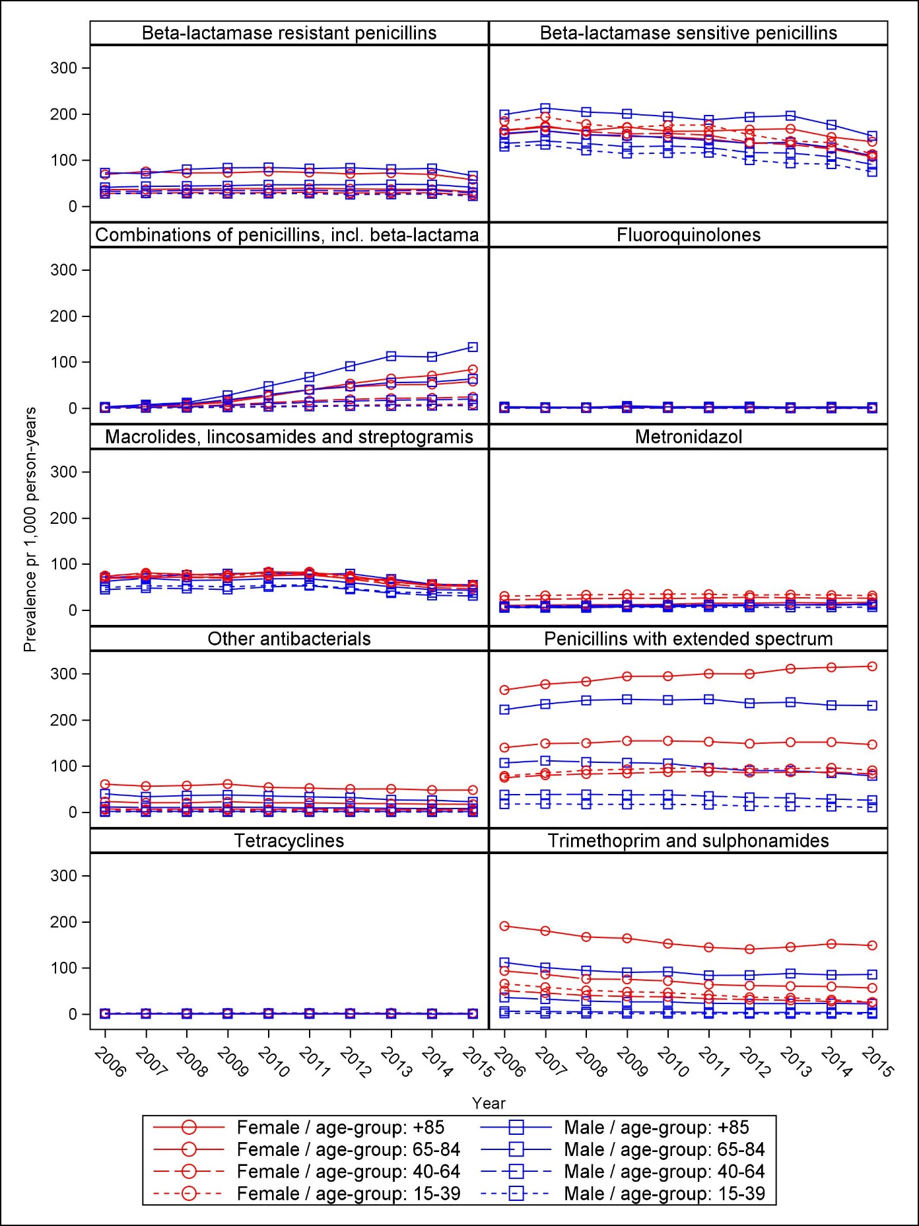
Prescribing rates of antibiotic use per 1,000 person-years
Figure 8: Volume of antibiotic subgroup DDD per 1,000 person-years from 2006 to 2015, stratified by sex and age group
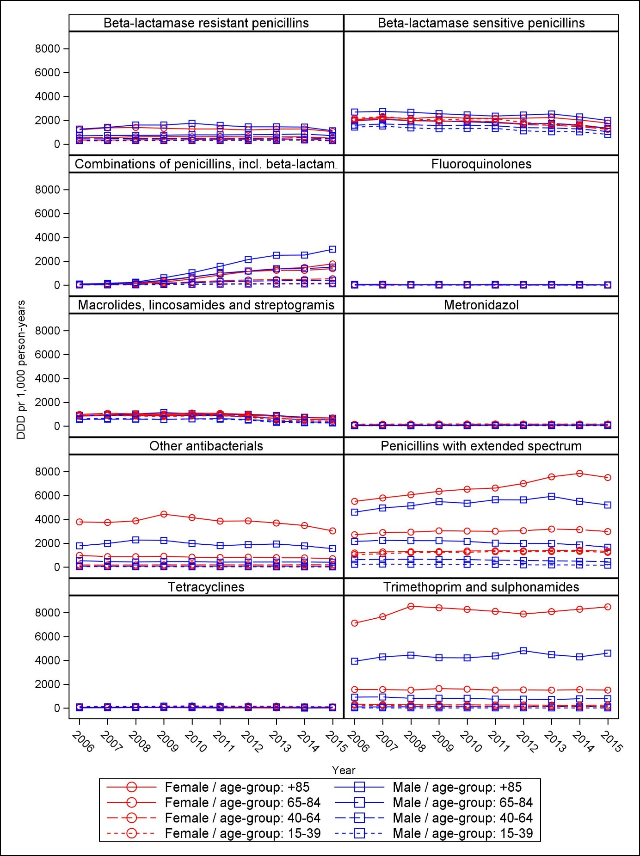

Table 4: Age and sex standardized volume of subgroup of antibiotics, stratified by the municipalities in Central Denmark Region in 2015

Group | Favrskov | Hedensted | Herning | Holstebro | Horsens | Ikast-  Brande | Lemvig | Norddjurs | Odder | Randers | Ringkøbing-  Skjern | Samsø | Silkeborg | Skander-  borg | Skive | Struer | Syddjurs | Viborg | Århus
Overall | 4,428.1 | 4,983.3 | 4,872.0 | 4,679.9 | 4,963.4 | 4,788.7 | 5,073.4 | 5,210.7 | 4,193.9 | 4,790.3 | 4,655.1 | 3,724.5 | 4,534.1 | 4,584.3 | 5,604.8 | 5,237.0 | 4,478.7 | 4,677.1 | 4,602.8
Tetracyclines | 63.0 | 48.1 | 113.5 | 55.2 | 83.2 | 155.6 | 60.4 | 107.8 | 48.3 | 34.7 | 87.6 | 0.0 | 62.1 | 42.0 | 41.3 | 55.6 | 123.9 | 62.4 | 56.0
Penicillins with extended spectrum | 1,326.1 | 1,097.6 | 1,252.5 | 1,221.6 | 1,240.7 | 1,311.6 | 1,365.9 | 1,301.9 | 904.3 | 1,278.5 | 1,018.8 | 635.7 | 1,273.2 | 1,224.0 | 1,607.3 | 1,224.1 | 1,097.1 | 1,247.2 | 1,244.4
Beta-lactamase sensitive penicillins | 1,091.4 | 1,354.1 | 1,090.3 | 1,219.8 | 1,285.4 | 1,185.1 | 1,334.7 | 1,164.0 | 1,238.7 | 1,250.7 | 1,250.1 | 944.9 | 1,049.8 | 1,213.1 | 1,270.0 | 1,244.4 | 1,130.4 | 1,128.8 | 1,087.4
Beta-lactamase resistant penicillins | 431.4 | 409.1 | 390.1 | 379.0 | 363.5 | 370.0 | 438.9 | 482.4 | 400.9 | 371.8 | 385.7 | 473.1 | 413.3 | 407.4 | 496.4 | 433.2 | 428.3 | 432.1 | 384.0
Combinations of penicillins, incl. beta-lactamase inhibitors | 579.1 | 618.7 | 507.0 | 484.4 | 628.3 | 474.2 | 528.7 | 633.6 | 550.4 | 671.4 | 458.1 | 832.2 | 556.2 | 525.3 | 614.2 | 463.5 | 595.0 | 614.3 | 572.4
Trimethoprim and sulphonamides | 340.2 | 431.9 | 802.2 | 560.3 | 404.2 | 659.1 | 509.6 | 531.1 | 346.7 | 383.6 | 647.0 | 132.2 | 483.7 | 463.7 | 633.2 | 903.9 | 358.2 | 339.5 | 463.1
Macrolides, lincosamides and streptogramis | 350.4 | 591.9 | 393.3 | 476.6 | 508.1 | 323.0 | 464.4 | 428.4 | 302.1 | 397.2 | 461.9 | 305.9 | 357.0 | 315.8 | 648.9 | 652.1 | 367.4 | 489.0 | 403.1
Fluoroquinolones | 11.0 | 6.6 | 3.5 | 5.6 | 8.6 | 7.5 | 8.7 | 5.6 | 1.8 | 4.6 | 6.3 | 5.0 | 4.7 | 5.9 | 5.0 | 6.4 | 7.2 | 5.6 | 5.0
Metronidazol | 106.4 | 97.3 | 92.5 | 107.9 | 89.5 | 84.7 | 99.9 | 128.1 | 102.5 | 150.8 | 76.9 | 79.2 | 125.7 | 106.8 | 98.4 | 112.4 | 92.9 | 109.6 | 107.9
Other antibacterials | 113.1 | 307.4 | 210.9 | 136.1 | 330.0 | 207.6 | 255.2 | 393.4 | 246.7 | 220.5 | 223.7 | 306.9 | 188.2 | 274.7 | 180.4 | 118.1 | 273.3 | 235.6 | 263.8

