Supplementary Material
Personalized risk for clinical progression in cognitively normal subjects – the ABIDE project
I.S. van Maurik^{1,2*}, R.E.R. Slot, MD¹, S.C.J. Verfaillie¹, M.D. Zwan, PhD¹, F.H. Bouwman, MD, PhD¹, N.D. Prins, MD, PhD^{1,3}, C.E. Teunissen, PhD⁴, P. Scheltens, MD, PhD ¹, F. Barkhof, MD, PhD^{5,6}, M.P. Wattjes, MD, PhD⁵, J.L. Molinuevo, MD, PhD⁷ , L. Rami, MD, PhD⁷, S. Wolfsgruber, PhD⁸, O. Peters, MD, PhD⁹, F. Jessen, MD, PhD¹⁰, J. Berkhof, PhD², W.M. van der Flier, PhD^{1,2}, for the Alzheimer’s Disease Neuroimaging Initiativeᶧ
Supplementary eFigure 1. Flowchart patient selection
Supplementary eFigure 2. Kaplan-Meier based on CSF risk group
Supplementary eTable 1. Demographic characteristics and baseline survival for complete cases and incomplete cases
Supplementary eTable 2. Baseline Patient characteristics validation cohort
Supplementary eTable 3. Regression coefficient of CSF model including p-tau
Supplementary eTable 4. Reclassification table based on the demographic and CSF model
Supplementary eTable 5. Model development by internal cross validation
Supplementary eTable 6. Model development in the validation cohort

Supplementary eFigure 1. Flowchart patient selection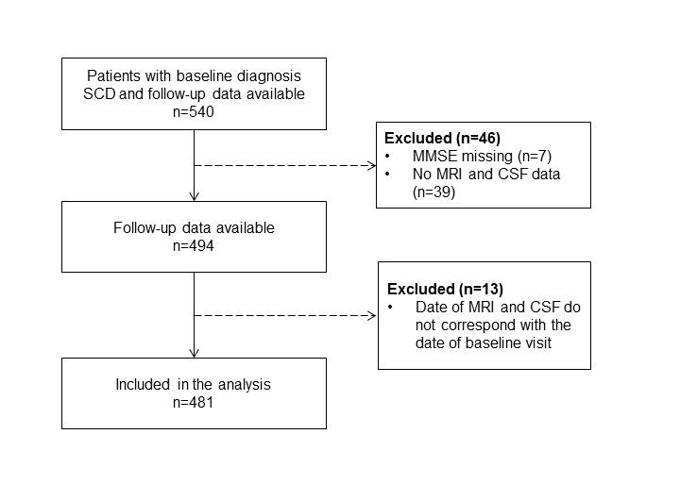

Supplementary eFigure 2. Kaplan-Meier based on CSF risk group
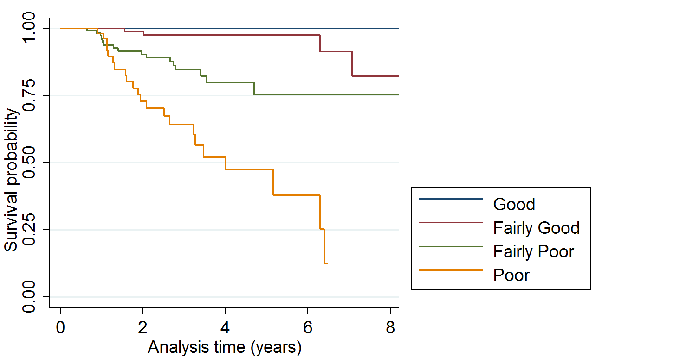
Risk groups were based on the 16th, 50th and 84th percentile of the prognostic index based on the CSF model, resulting in a Good, Fairly Good, Fairly Poor and Poor risk group.
Supplementary eTable 1. Demographic characteristics and baseline survival for complete cases and incomplete cases
 | Complete data | Only MRI data | Only CSF data | p-value
Age | 61±9 | 64±10 | 61±10 | 0.005
Gender, No. females | 120 (41) | 72 (52) | 19 (40) | NS
MMSE | 28±2 | 28±2 | 28±2 | NS
No. with clinical progression (%) | 41 (14) | 24 (17) | 5 (11) | NS
Baseline Survival function | 0.90 | 0.91 | 0.92 | NS
Data are mean±SD, unless otherwise specified. MMSE: mini-mental state examination

Supplementary eTable 2. Baseline Patient characteristics validation cohort
 | ADC  n=481 | ADNI  n=92 | DCN  n=86 | Barcelona  n=41
No. with clinical progression (%)ᶧ | 70 (15%) | 9 (10%) | 33 (38%) | 5 (12%)
Ageᶧ | 62±9 | 72±6 | 65±8 | 66±7
Gender, No. femalesᶧ | 211(44%) | 55 (60%) | 25(29%) | 32 (78%)
MMSE | 28±2 | 29±1 | 28±2 | 28±2
Follow-up durationᶧ | 3±2 | 2±1 | 2±1 | 4±2
Amyloid β1-42* | 879±260 | 1249±443 | 778±314 | 754±220
Total Tau* | 298±196 | 238±93 | 347±225 | 372±322
Data are mean±SD, unless otherwise specified. MMSE: mini-mental state examination, MRI=magnetic resonance imaging, CSF=cerebrospinal fluid. *measured with Elecsys for ADNI, measured with Innotest for DCN and EUROSCD. Differences between cohorts were mearured with chi-square and ANOVA where applicable. Due to difference in measurement levels, CSF values were logtransformed and centered. ᶧ indicates p<0.001.

Supplementary eTable 3. Regression coefficient of CSF model including p-tau
 | MCI/Dementia |  |  |  |  | MCI/AD-dementia
 | Coëfficient | Standard Error | P-value | Harrell's C |  | Coëfficient | Standard Error | P-value | Harrell's C
CSF  (n=344) |  |  |  |  | CSF  (n=344)
Aβ | -1.1592 | 0.3746 | <.01 | 0.80 | Aβ | -1.5333 | 0.4296 | <.001 | 0.83
p-tau | 1.0945 | 0.4073 | <.01 |  | p-tau | 1.2253 | 0.4785 | <.01
Age | 0.0650 | 0.0228 | <.01 |  | Age | 0.0603 | 0.0269 | <.05
Gender | -0.6027 | 0.3346 | <.10 |  | MMSE | -0.2240 | 0.0966 | <.05
MMSE | -0.2762 | 0.0772 | <.001 |  | p-tau*age | -0.1096 | 0.0580 | <.10
p-tau*Age | -0.1251 | 0.0504 | <.05
CSF biomarkers (Aβ and p-tau) are log-transformed and centered. MMSE: mini-mental state examination, p-tau*Age: interaction between age and p-tau.

Supplementary eTable 4. Reclassification table based on the demographic and CSF model
 |  | Demographic model
 |  | low | intermediate | high
CSF model | low | 278 (93%) | 22 (49%) | 0 (0) | 300
 | intermediate | 17 (6%) | 19 (42%) | 0 (0) | 36
 | high | 3 (1%) | 4 (9%) | 1 (100%) | 8
 |  | 298 | 45 | 1
Reclassification of individuals based on the demographic model and CSF model. Low risk: 0-35%, intermediate risk: 35-65%, high risk: 65-100%.
Supplementary eTable 5. Model development by internal cross validation

 |  | Demographic only |  | CSF
Outcome | Set | c | best fit model | c | best fit model
MCI/Dementia | 1 | 0.75 | Age, MMSE | 0.82 | Abeta, Tau, Age, MMSE, Tau*Age
 | 2 | 0.70 | Age, MMSE | 0.75 | Abeta, Tau, Age, MMSE, Tau*Age, Tau*MMSE
 | 3 | 0.77 | Age, MMSE | 0.90 | Abeta, Tau, Age, Sex, MMSE Tau*Age
 | 4 | 0.69 | Age, MMSE | 0.77 | Abeta, Tau, Age, MMSE, Tau*Age, Tau*MMSE
 | 5 | 0.63 | Age, MMSE | 0.77 | Abeta, Tau, Age, Sex, MMSE, Tau*Age, Tau*MMSE
Cross validation was performed with a fivefold cross validated Harrell’s concordance index. The dataset was randomly split up in five groups, models were constructed via backward selection on the training set (four out of five subsets) and validated on the test set that was left out. The process was repeated five times.

Supplementary eTable 6. Model development in validation cohort
 | Coefficient | Standard Error | P-value | Harrell's C in validation cohort | Harrell's C in ADC
Demographic
Age | 0.0469 | 0.0140 | 0.001 | 0.62 | 0.70
MMSE | -0.1264 | 0.0590 | <0.05
MRI model
HCV (cm3) | -0.7546 | 0.2284 | 0.001 | 0.74 | 0.55
NWBV (cm3) | 0.0077 | 0.0020 | <0.001
Age | 0.0278 | 0.0379 | 0.463
HCV*Age | -0.0422 | 0.0249 | 0.090
CSF model
Abeta | -0.7744 | 0.3523 | <0.05 | 0.68 | 0.75
Tau | 0.4970 | 0.2345 | <0.05
Gender | -0.9761 | 0.3182 | <0.01
MMSE | -0.1889 | 0.0831 | <0.05
Combined model
Abeta | -0.5333 | 0.5514 | 0.333 | 0.76 | 0.53
NWBV | 0.0073 | 0.0020 | <0.001
HCV | -0.8122 | 0.2463 | 0.001
Age | 0.0139 | 0.0403 | 0.731
MMSE | -0.0086 | 0.1409 | 0.952
Abeta*MMSE | 0.4924 | 0.2799 | 0.078
HCV*Age | -0.0444 | 0.0264 | 0.093
Models were developed in the validation cohort and validated in ADC. CSF biomarkers (Abeta and Tau) are log-transformed and centered. MMSE: mini-mental state examination, Abeta*MMSE: interaction between Abeta and MMSE.

