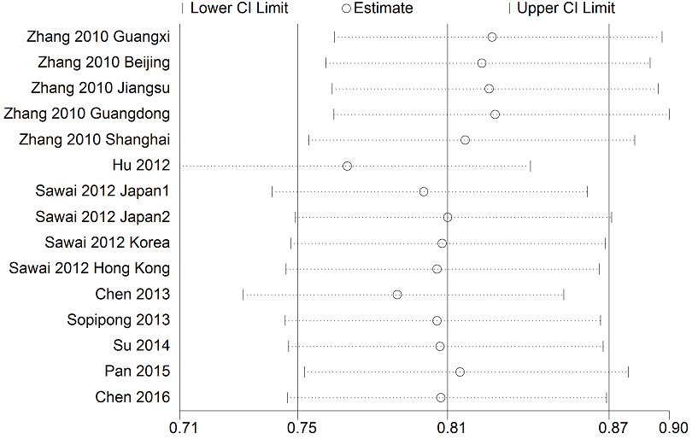
Figure S3 Sensitivity analysis of association between KIF1B polymorphism and HCC susceptibility under the co-dominant genotype model AG vs AA

