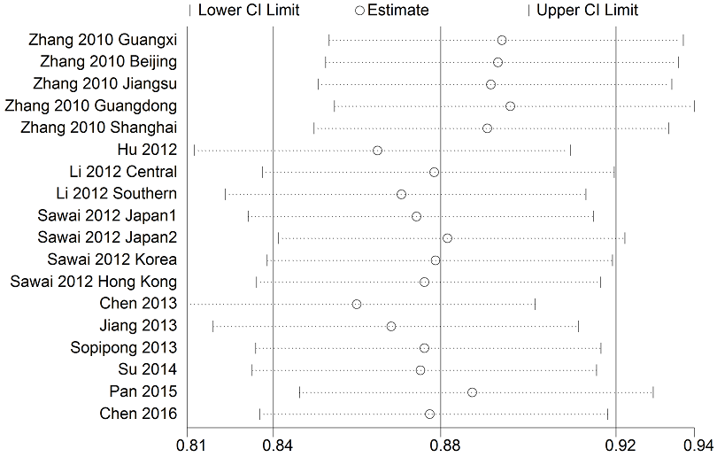

Figure S1 Sensitivity analysis of association between KIF1B polymorphism and HCC susceptibility under the allelic model G-allele vs A-allele

