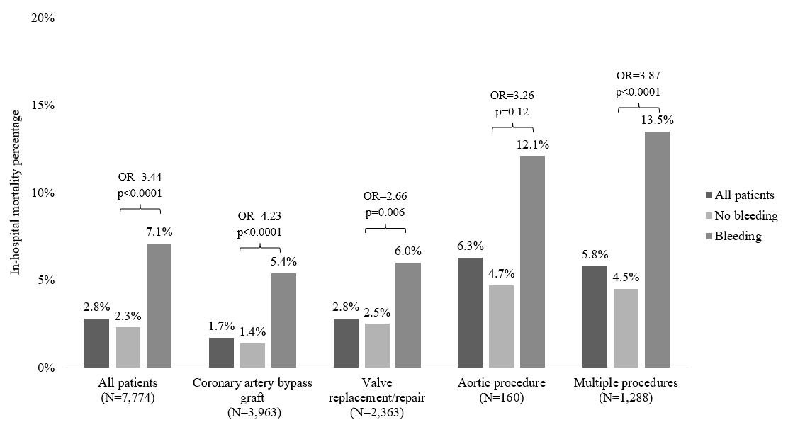
Percentages reflect unadjusted mortality rates (for all patients unstratified by bleeding status) and multivariable-adjusted mortaltiy rates for patients with and without in-hospital bleeding (narrowly defined). Multivariable adjusted odds ratios (ORs) and p-values reflecting the difference in mortality by bleeding status are provided for the entire cohort and for individual procedure types.

