Supplemental Fig. 1. Scatter plot demonstrating the correlation of the I-score with the total cell-free DNA concentration.

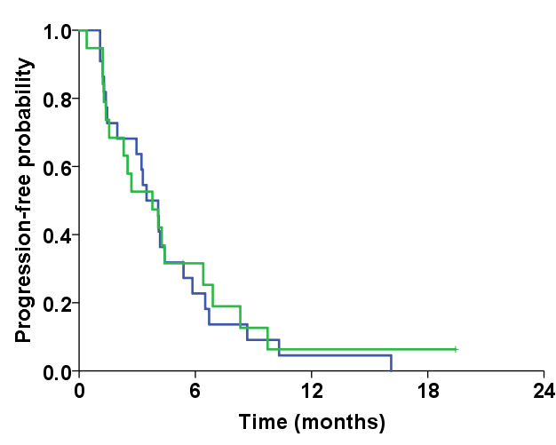
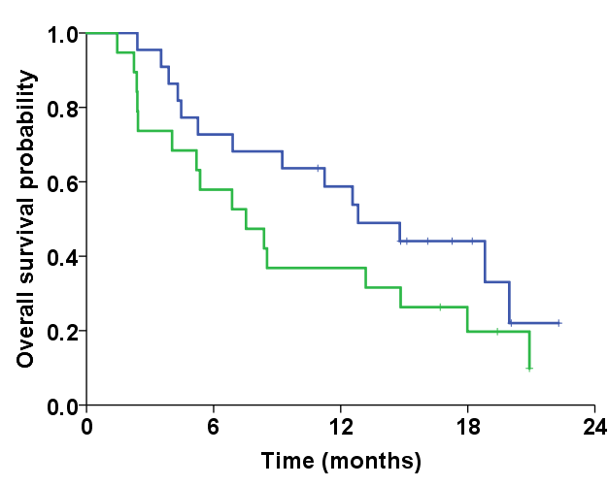
A
B
p = 0.781
p = 0.180
VEGFA ratio-low (≤median)
VEGFA ratio-high (>median)
VEGFA ratio-low (≤median)
VEGFA ratio-high (>median)

Supplemental Fig. 2. Kaplan-Meier curves for (A) time to progression and (B) overall survival according to the VEGFA ratio. VEGFA, vascular endothelial growth factor-A.

