Figure S1
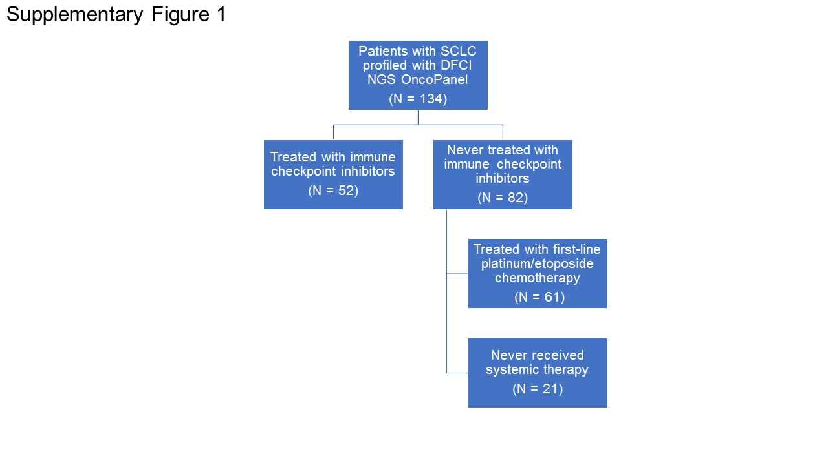Figure S1. Diagram of patients with SCLC who underwent successful next generation sequencing who either did or did not receive treatment with immune checkpoint inhibitors. Patients who never received any systemic therapy for their disease are indicated.

