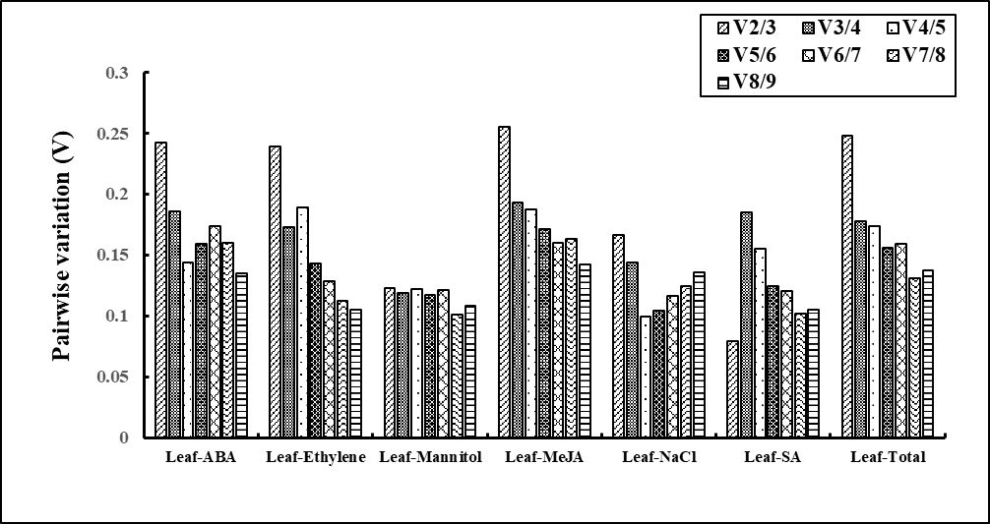

**A**

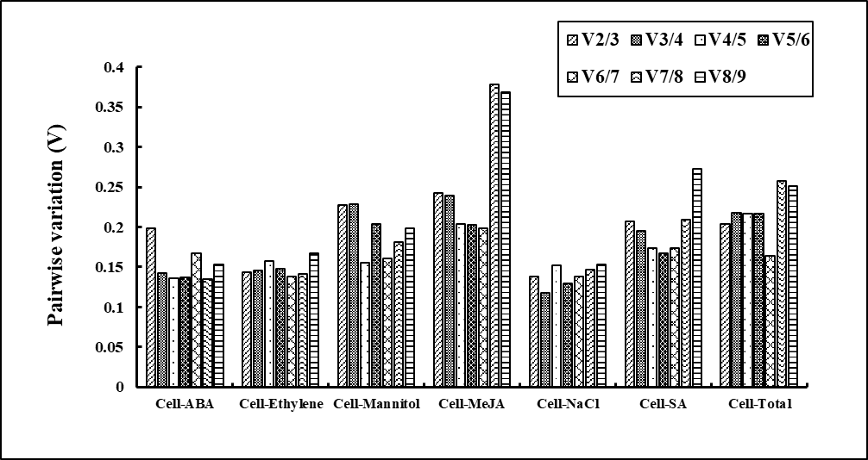

**B**

Additional file 2 Pairwise variation (V) analysis of the 9 candidate reference genes. The pairwise variation (Vn/Vn+1) was analyzed between the normalization factors Vn and Vn+1 by the geNorm software to determine the optimal number of reference genes required for RT-qPCR data normalization.

A: The pairwise variations of leaf were obtained under various stimuli; B: The pairwise variations of leaf were obtained under various stimuli.