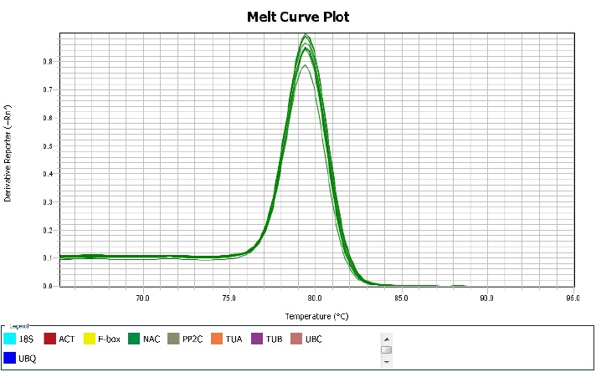

***ACT***

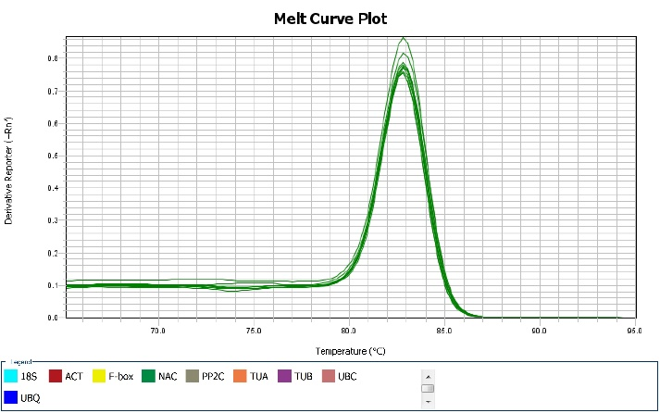

***UBQ***

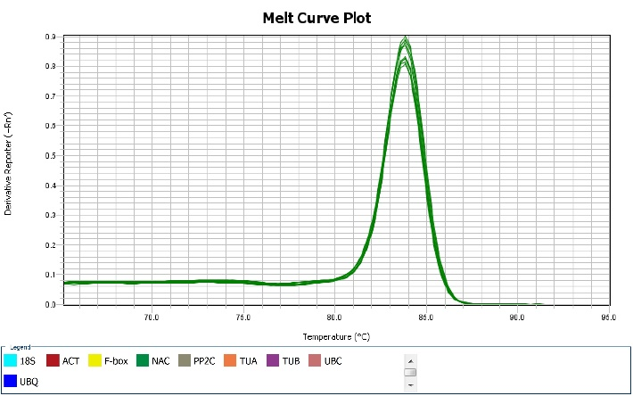

***NAC***

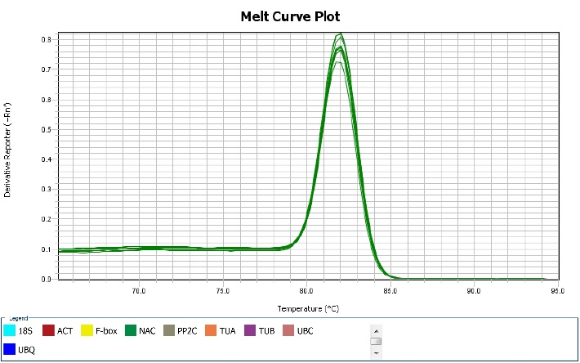

***F-box***

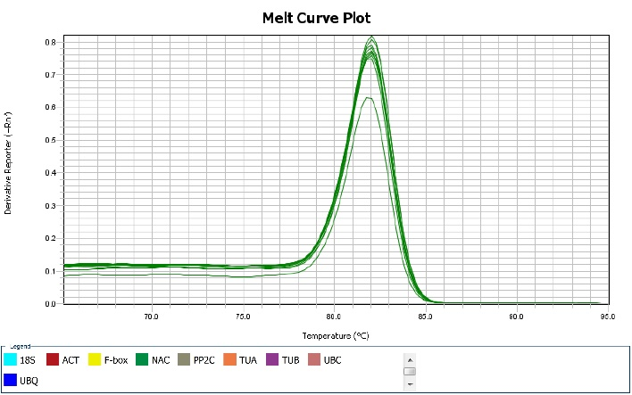

***PP2C***

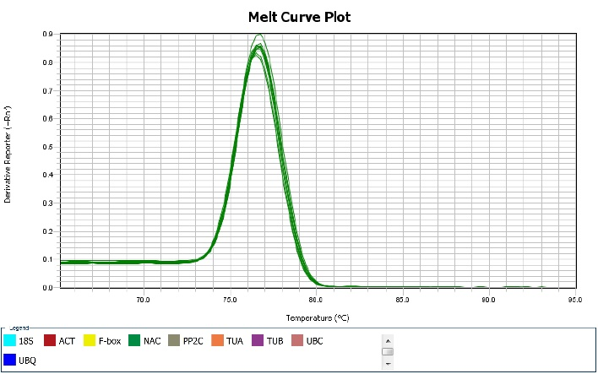

***TUA***

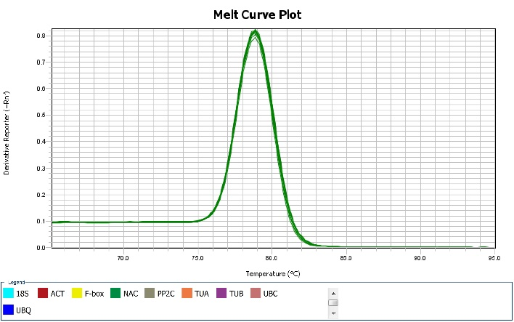

***TUB***

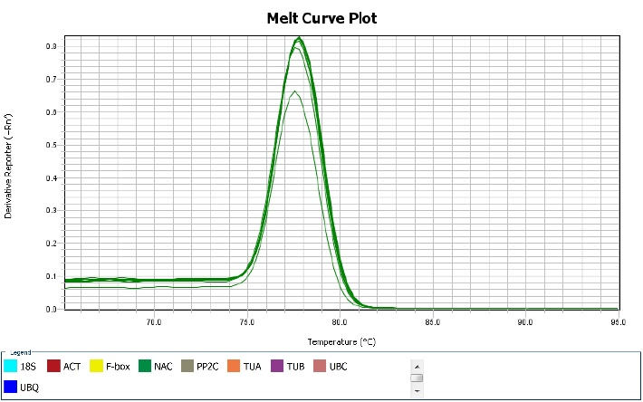

***UBC***

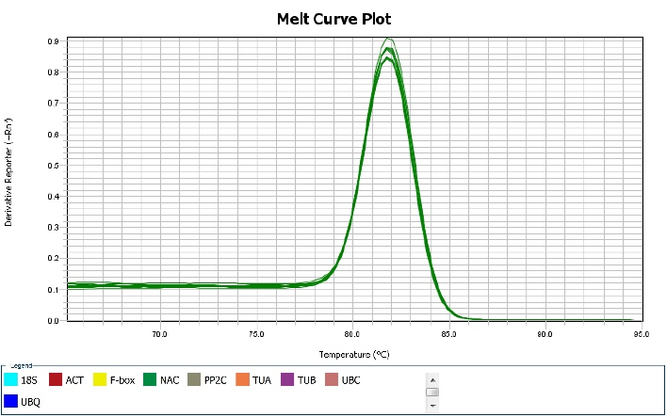

***18S***

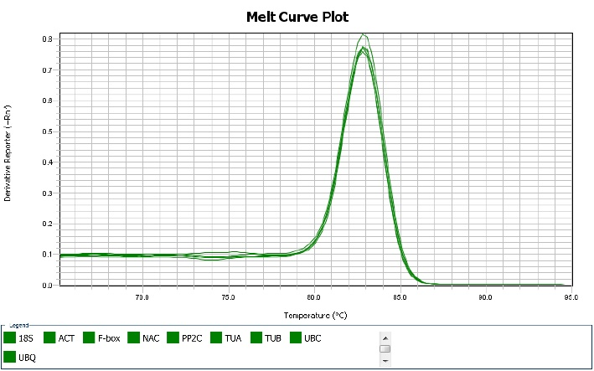

***ChNCS***

**A**

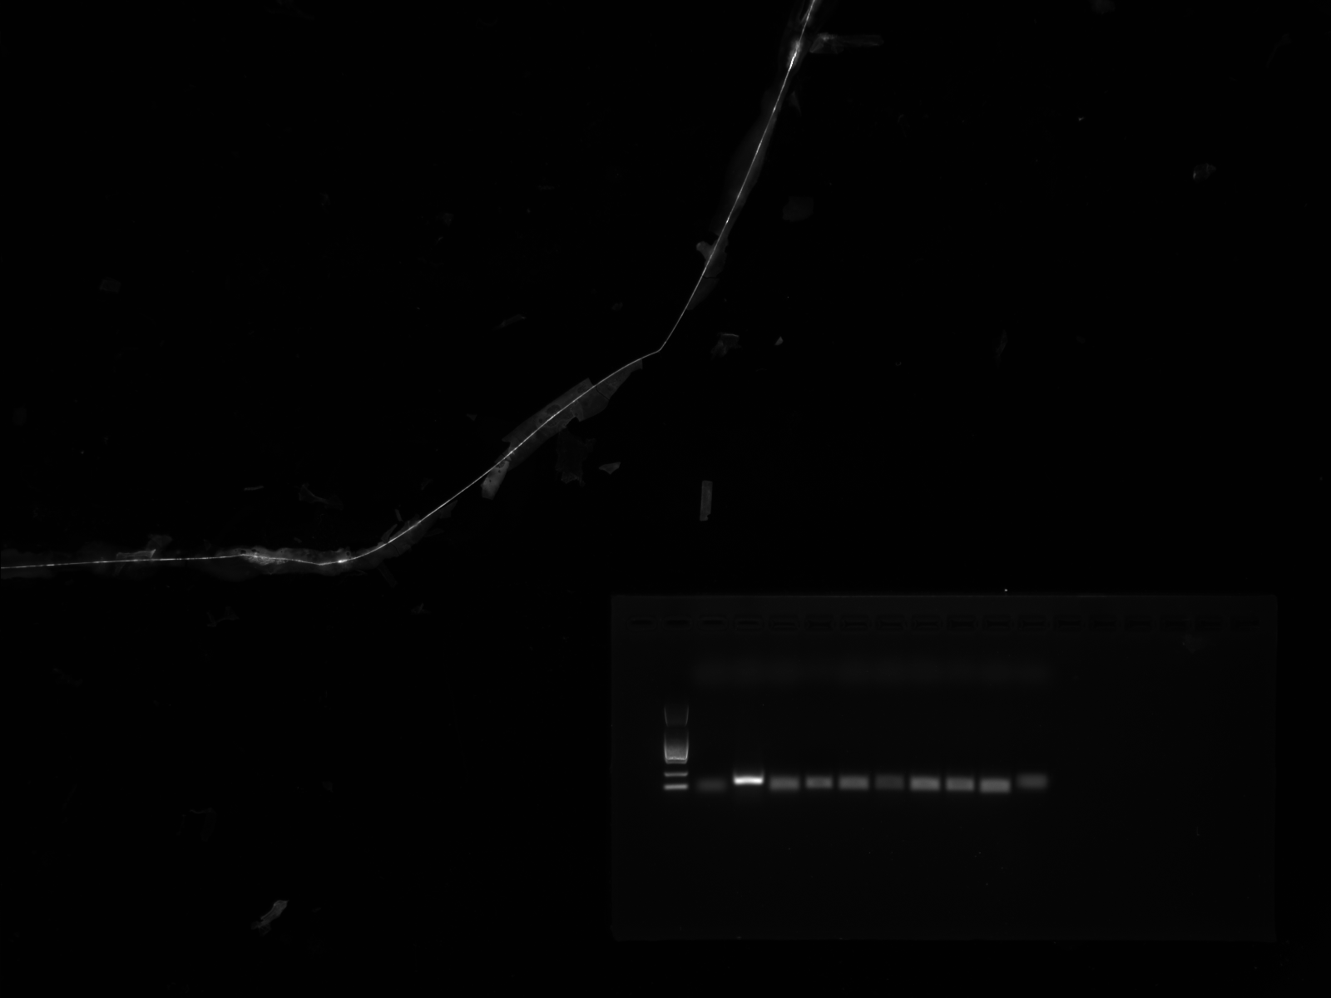

*ACT*

*UBQ*

*NAC*

*F-box*

*PP2C*

*TUA*

*TUB*

*UBC*

*18S*

*ChNCS*

M

100bp

**B**

200bp

Additional file 1 Gene specificity and amplicon size. A: Melting curves of 9 reference genes and *ChNCS* showing single peaks; B: Agarose gel (2.0 %) electrophoresis showing amplification of a specific PCR product of the expected size for each gene.