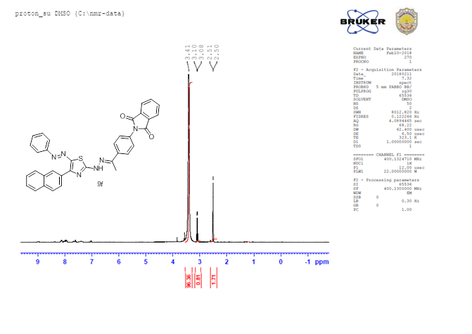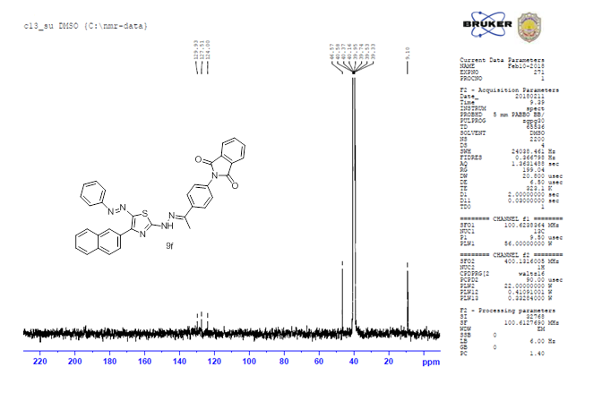

Figure S7: The 1H NMR and 13C NMR of compound **(9f).**