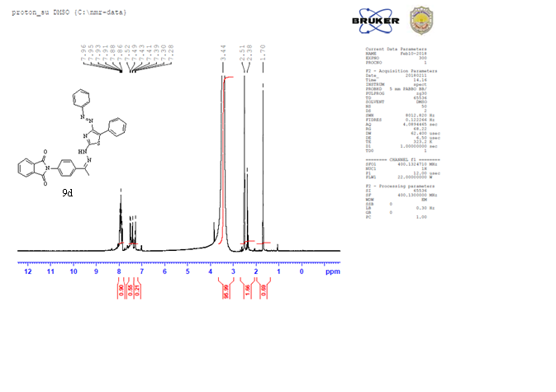

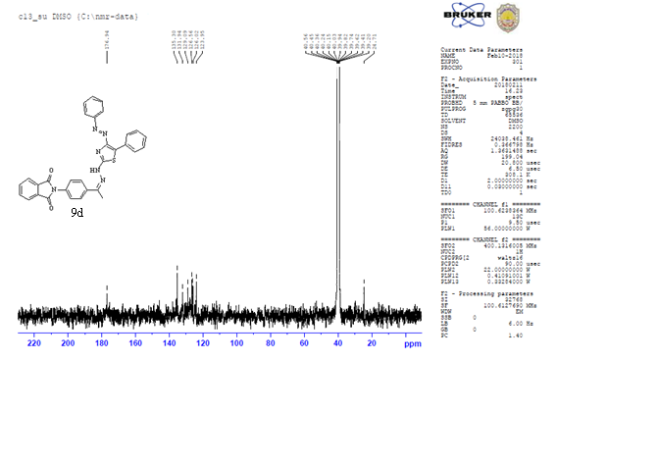

Figure S5: The 1H NMR and 13C NMR of compound **(9d).**