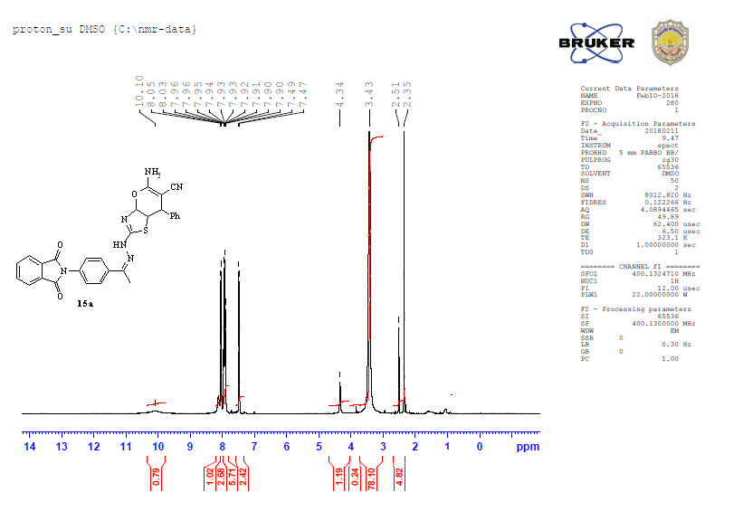

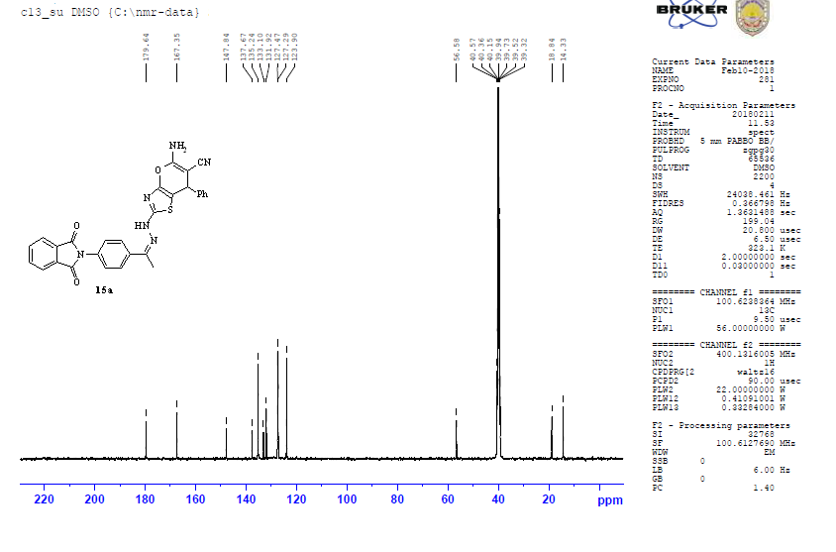

Figure S13: The 1H NMR and 13C NMR of compound **(15a).**