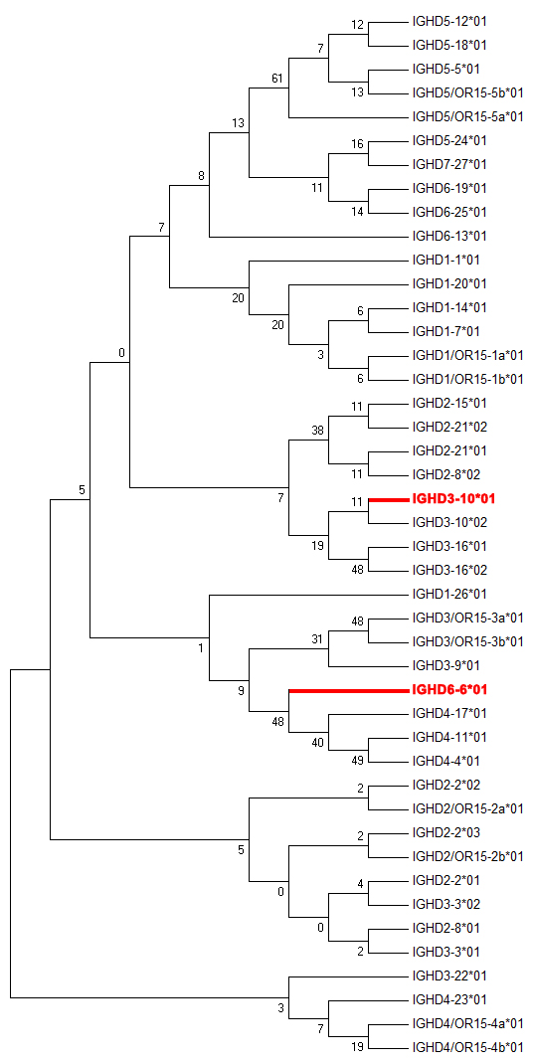
Fig. S5 Unrooted tree of IGHD germlines. Unrooted tree of IGHD germlines was built using MEGA7.0.

