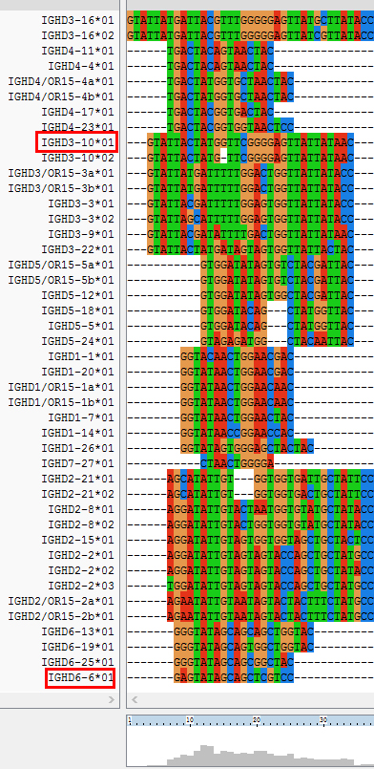
Fig. S4 Alignment of IGHD germlines. IGHD germlines were aligned using clustalX2.

