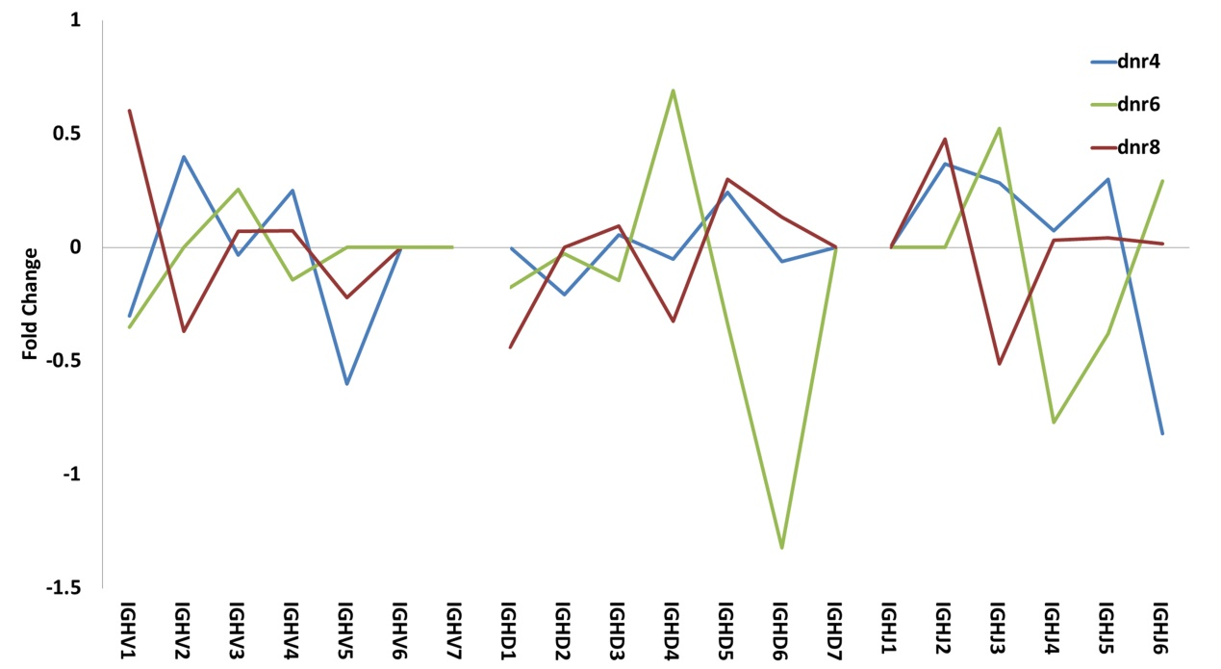
Fig. S3 Frequency changes of gene family usage in ASCs comparing to naïve B cells. The lines represent the fold changes of the proportion of each VDJ family used in ASCs comparing to naïve B cells.

