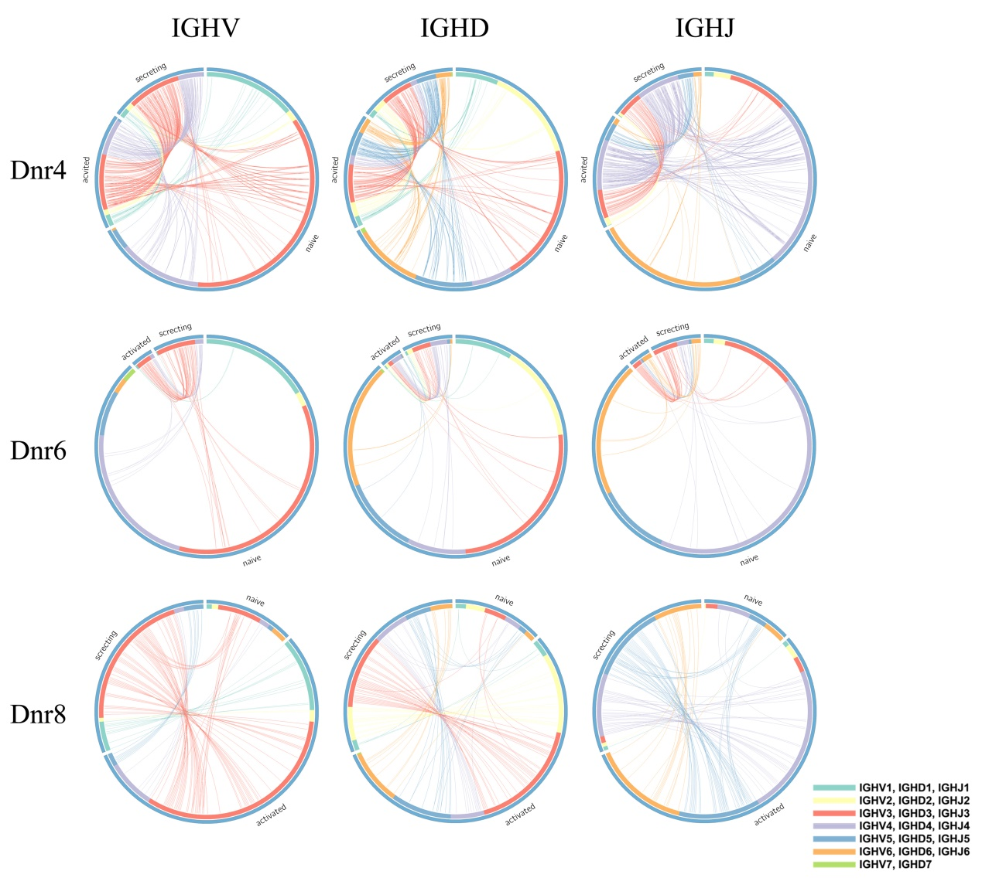
Fig. S2 VDJ gene family expression profile of naïve B cells, ASCs and ABCs. Each line represents one donor, while each column represents IGHV, IGHD and IGHJ respectively. The outside circle represents the proportion of total number of gene types in naïve B cells, ASCs and ABCs, and the inside circle represents the proportion of the number of gene types within each gene family. The lines connect the same gene type between different cells.

