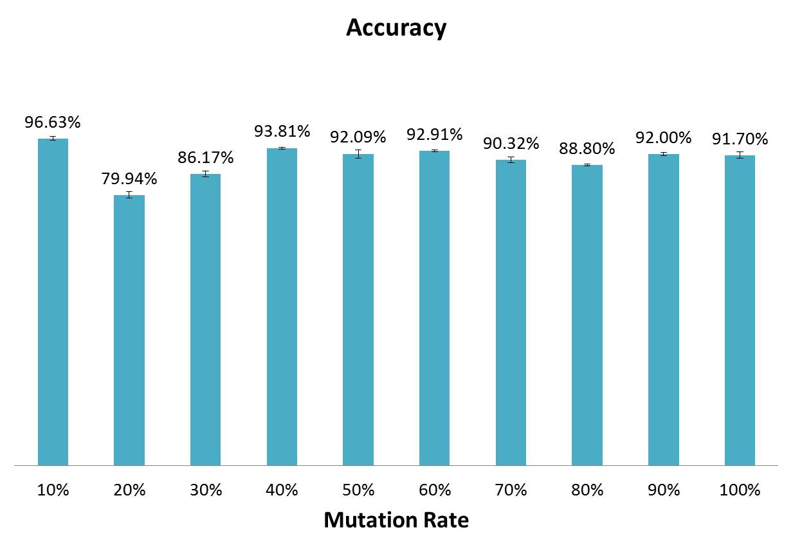
Fig. S1 The performance of DSab-origin as somatic hyper-mutation rates increase. To evaluate the performance of DSab-origin degrade as somatic hyper-mutation rates increase, we generated 10% to 100% mutation rates with a step of 10% using IgSimulator.

