**Additional information**

**List:**

**Fig. S1** Schematic figure of *Spirulina subsalsa* production with seawater and MSGR: (a) flask bench to optimize the addition of MSGR for cell growth; (b) baggy reactor trial with reused seawater as a preliminary step of scaling up; (c) photo of baggy reactor.

**Fig. S2** Carbohydrate accumulation for *Spirulina subsalsa* grown in mZM and in seawater supplemented with MSGR in different volume ratios (1/1000, 1/500, 1/200, 1/100 and 1/50, VMSGR/Vseawater). All data are averages of biological triplicates ± standard deviation.

**Fig. S3** Microscopy images of *Spirulina subsalsa* grown in seawater supplemented with MSGR in different volume ratio (VMSGR/Vseawater; a 1/1000, b 1/500, c 1/200, d 1/100, e 1/50, f 1/25, g 1/10), in (f) mZM. The blue round cycled bacterium. Scale bar, 20 µm.

**Fig. S4** Microscopy images of *Spirulina subsalsa* grown in seawater supplemented with 1/50 MSGR (VMSGR/Vseawater). Scale bar, 20 µm.

**Fig. S5** The pH value of *Spirulina subsalsa* culture from mZM, and from seawater supplemented with MSGR in different volume ratios (1/1000, 1/500, 1/200, 1/100 and 1/50, VMSGR/Vseawater). All data are averages of biological triplicates ± standard deviation.

**Fig. S6** Total organic carbon in mZM, in seawater supplemented with MSGR in different volume ratios (1/1000, 1/500, 1/200, 1/100 and 1/50, VMSGR/Vseawater) for cultivating *Spirulina subsalsa*. All data are averages of biological triplicates ± standard deviation.

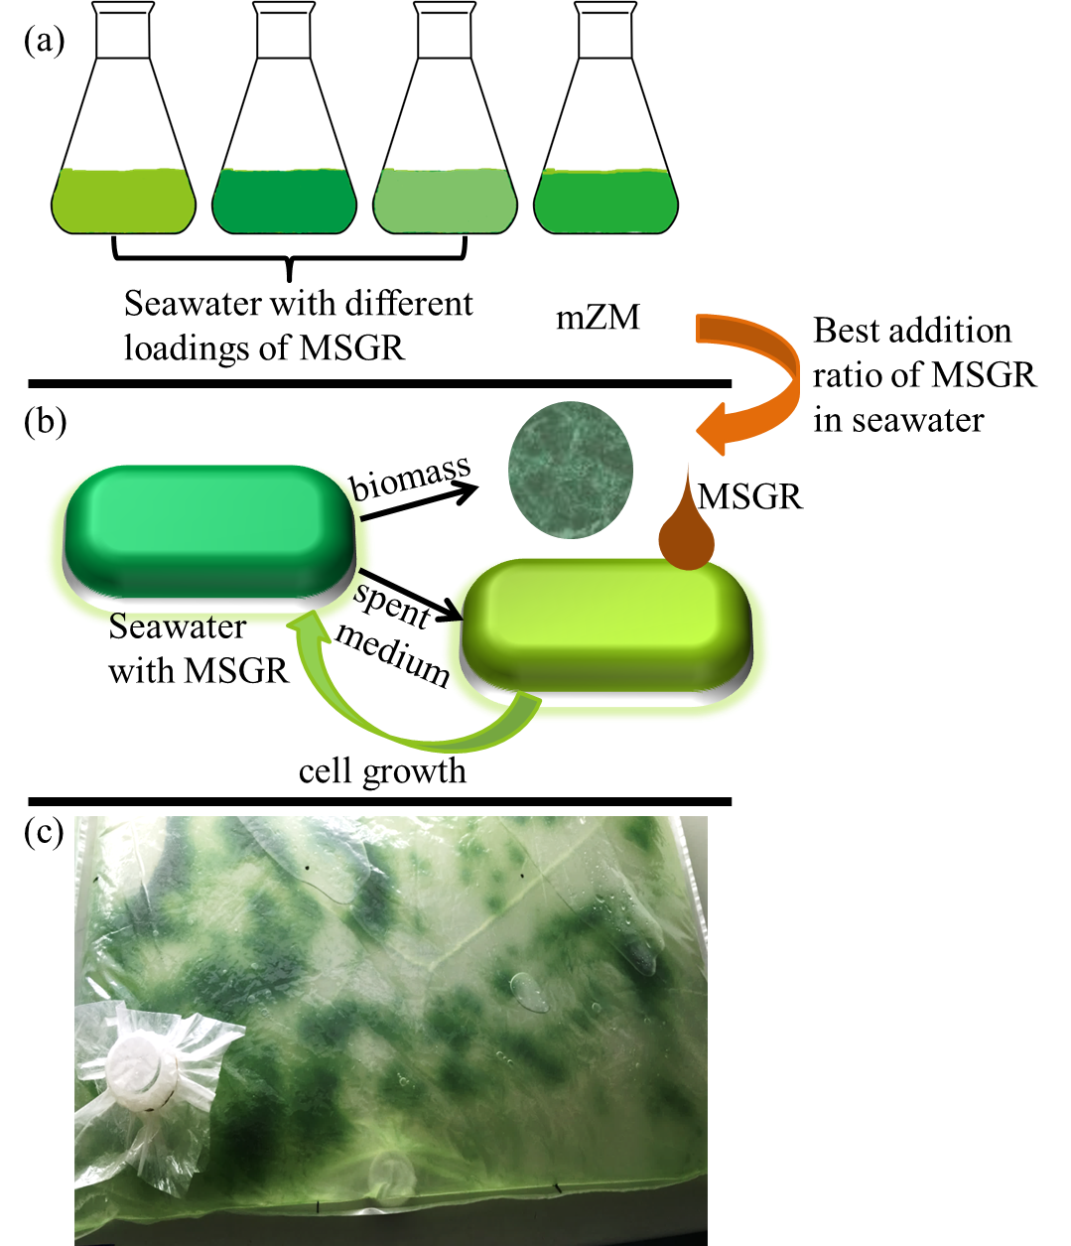

**Fig. S1**



**Fig. S2**



**Fig. S3**

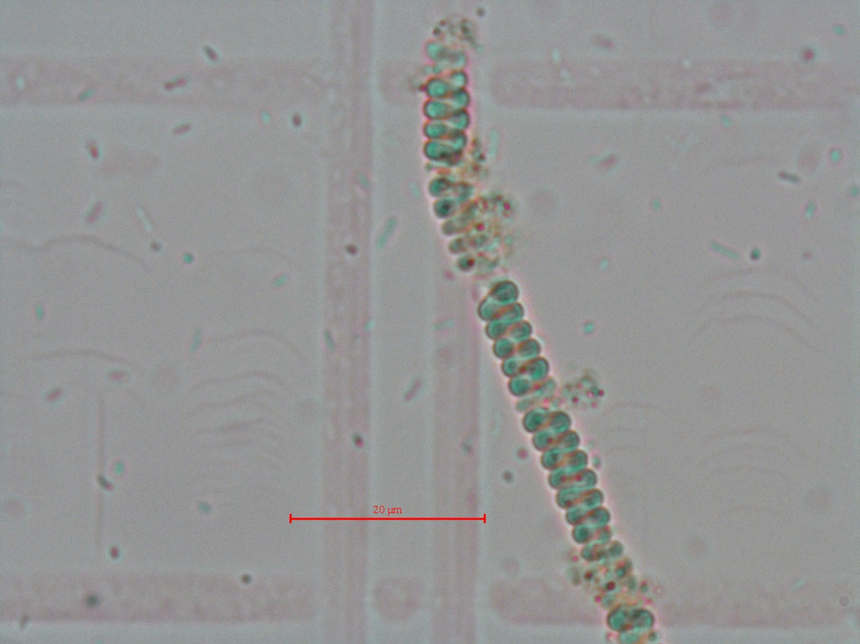

**Fig. S4**



**Fig. S5**



**Fig. S6**