Metabolic engineering of Clostridium beijerinckii to improve glycerol metabolism and furfural tolerance

Chidozie Victor Agu^{1,2}, Victor Ujor³, and Thaddeus Chukwuemeka Ezeji^{1*}

SUPPLEMENTARY MATERIALS

Table S1: Similarities (%) between Cp and Cb Gldh protein sequences. NCBI Blastp algorithm was used for alignment.
Protein sequence identity (%) | Cb GldA | Cp DhaD1 | Cp DhaD2 | Cp GldA1 | Cp GldA2
Cp DhaD1 | 51 | 100 | 43 | 29 | 27
Cp DhaD2 | 54 | 43 | 100 | 28 | 36
Cp GldA1 | 27 | 29 | 28 | 100 | 27
Cp GldA2 | 37 | 27 | 36 | 27 | 100

Table S2: Root mean square deviation (RMSD) values for secondary structure alignment of Cp Gldhs.
RMSD | Cp DhaD1 | Cp GldA1 | Cp DhaD2 | Cp GldA2
Cp DhaD1 | 0 | 3.53 | 5.81 | 98.49
Cp GldA1 | 3.53 | 0 | 5.16 | 97.98
Cp DhaD2 | 5.81 | 5.164 | 0 | 98.83
Cp GldA2 | 98.49 | 97.98 | 98.83 | 0

Table S3: Comparison of DhaK protein sequences between Cp and Cb DhaK proteins. NCBI Blastp algorithm was used for alignment.
Identity (%) | %Similarity with Cp DhaK
Cb DhaK subunit Cbei_2148 | 55
Cb DhaK L subunit Cbei_2149 | 35
Cb DhaK phosphotransferase subunit Cbei_2150 | 0

Table S4: List of primers and PCR protocols used to generate constructs.
S/N | Insert | Primers (5' to 3') and PCR strategy
1 | dhaD1 | 12753-F: ATAGGGCCCAGGAGGTATCCATGGATGAGAAAAGCATTTATTTGTCC  dhaD1-R1: TAAAAAAATAAGAGTTACCATTTATTATTTACACATCCTCTTCTTTTCC  6017-R2: CGACCTCGAGAATTCACTATGAAACAATATTAAAAAAATAAGAGTTACCATTTATTAGA  PCR strategy: (1) dhaD1 was amplified from Cp gDNA using primers 12753-F and DhaD1-R1 (AT1 = 54˚C, AT2 = 64˚C), (2) Next, amplicon (1) was re-amplified using 12753-F and 6017-R2 (AT1= 52˚C, AT2 = 67˚C). NB: In all cases, including below, primers R1 & R2 were used to add terminator sequence to inserts
2 | gldA1 | gldA1-F: ATAGGGCCCAGGAGGTATCCATGGATGAGTTATAGTGTTTTTTTACCAAG  6017-R1: TAAAAAAATAAGAGTTACCATTTATTAGACAGCTTTCACAGGC  6017-R2: CGACCTCGAGAATTCACTATGAAACAATATTAAAAAAATAAGAGTTACCATTTATTAGA  PCR strategy: (1) gldA1 was amplified from Cp gDNA using primers gldA1-F and 6017-R1 (AT1 = 54˚C, AT2 = 66˚C), (2) Next, the amplicon from 1 was re-amplified above using gldA1-F and 6017-R2 (AT1 = 52˚C, AT2 = 67˚C)
3 | dhaD1 + gldA1 | 12753-F: ATAGGGCCCAGGAGGTATCCATGGATGAGAAAAGCATTTATTTGTCC  12753-R: ACCACCACCACCACC TTTACACATCCTCTTCTTTTCC  6017-F: AAA GGTGGTGGTGGTGGT ATGAGTTATAGTGTTTTTTTACCAAG  6017-R1: TAAAAAAATAAGAGTTACCATTTATTAGACAGCTTTCACAGGC  6017-R2: CGACCTCGAGAATTCACTATGAAACAATATTAAAAAAATAAGAGTTACCATTTATTAGA  PCR strategy: (1) dhaD1 was amplified with primer pair 12753-F & R (AT1 = 54˚C, AT2 = 71˚C) (2) gldA1 was amplified with primer pair 6017-F & R1 (AT1 = 54˚C, AT2 = 66˚C), then re-amplify the resulting amplicon with 6017-F & R2 (AT1 = 52˚C, AT2 = 67˚C). (3) dhaD1 and gldA1 amplicons were spliced via two step SOE PCR – Step 1: dhaD1 and gldA1 served as both primers and template (forward and reverse templating fragments, respectively). Annealing temp. = overlap region; step 2: amplicon resulting from step 1 SOE was used as template for normal PCR using primers 12753-F and 6017-R2 (AT = 67˚C)
4 | [dhaD1+gldA1] + dhaK | 12753-F: ATAGGGCCCAGGAGGTATCCATGGATGAGAAAAGCATTTATTTGTCC  Gldh-R: cttgcaaCCTCCTacgctaTTAGACAGCTTTCACAGGCTC  dhaK-F1: GGAGGttgcaagat ATGAAAAAGATAATAAATAAACCAG  dhaK-F2: AAAGCTGTCTAAtagcgtA GGAGGttgcaagatATGAAAAAG  dhaK-R1: TAAAAAAATAAGAGTTACCATTTA CTACTTTATAACCTCTGAAATC  dhaK-R2: cgacctcgagaattcACTATGAAACAATAT TAAAAAAATAAGAGTTACCATTTACTACT  PCR strategy: (1) dhaD1+gldA1 was re-amplified with primers 12753-F and Gldh-R (AT1 = 54˚C, AT2 = 72˚C), (2) dhaK was amplified from Cp gDNA with primers dhaK-F1 and dhaK-R2 (AT1 = 50˚C, AT2 = 62˚C), (3) Re-amplified PCR product from 2 using primers dhaK-F2 and dhaK-R2 (AT1 = 54˚C, AT2 = 67˚C), (4) PCR products 1 and 3 above were spliced via two step SOE-PCR; Step 1: AT of overlap region (69˚C) using PCR amplicons 1 and 3 as forward and reverse templating fragments; Step 2: the resulting amplicon from step 1 SOE was used as template for normal PCR with primers 12753-F and dhaK-R2 (AT = 67˚C).  NB: AT of overlap region must be at least 65˚C for efficient SOEing
5 | dhaD1 + dhaK | 12753-F: ATAGGGCCCAGGAGGTATCCATGGATGAGAAAAGCATTTATTTGTCC  12753-R: ACCACCACCACCACC TTTACACATCCTCTTCTTTTCC  dhaK-F4: AAAGGTGGTGGTGGTGGT ATGAAAAAGATAATAAATAAACCAG  dhaK-R1: TAAAAAAATAAGAGTTACCATTTA CTACTTTATAACCTCTGAAATC  dhaK-R2: cgacctcgagaattcACTATGAAACAATAT TAAAAAAATAAGAGTTACCATTTACTACT  PCR strategy: (1) dhaD1 was amplified from Cp gDNA using primers 12753-F and 12753-R (AT1 = 54˚C, AT2 = 71˚C), (2) dhaK was amplified using primers dhaK-F4 and dhaK-R1 (AT1 = 50˚C, AT2 = 62˚C); the resulting amplicon was re-amplified using dhaK-F4 and dhaK-F2 (AT1 = 50˚C, AT2 = 67˚C), (3) Spliced amplicons 1 and 2 by SOE PCR. Step 1: AT = 59˚C; Step 2: AT = 67˚C
6 | gldA1 + dhaK | gldA1-F: ATAGGGCCCAGGAGGTATCCATGG ATGAGTTATAGTGTTTTTTTACCAAG  gldA1-R: ACCACCACCACCACC GACAGCTTTCACAGGCTCATTAC  dhaK-F5: GTCGGTGGTGGTGGTGGT ATGAAAAAGATAATAAATAAACCAG  dhaK-R1: TAAAAAAATAAGAGTTACCATTTA CTACTTTATAACCTCTGAAATC  dhaK-R2: cgacctcgagaattcACTATGAAACAATAT TAAAAAAATAAGAGTTACCATTTACTACT  PCR strategy: (1) gldA1 was amplified from Cp gDNA using primer set gldA1-F and gldA1-R (AT1 = 54˚C, AT2 = 71˚C), (2) Amplified dhaK gene from Cp gDNA using primer set dhaK-F5 and dhaK-R1 (AT1 = 50˚C, AT2 = 62˚C), then re-amplified the resulting amplicon using primers dhaK-F5 and dhaK-R2 (AT1 = 50˚C, AT2 = 67˚C). (3) Spliced amplicons 1 and 2 by SOE PCR. Step 1: AT = 63˚C; Step 2: AT = 67˚C
7 | gldA2 + dhaD2 | 14565-F: TATGGGCCCAGGAGGATATTACCATGGATGATAAAAATTAAGGCACCAG  14565-R: ACCACCACCACCACC TACTATAGCTTTCAACTTTAAACTACTAC  17742-F: GTAGGTGGTGGTGGTGGT ATGGTAAAATCAATTTACTCAC  17742-F1: CAATATTAAAAAAATAAGAGTTACCATTTA CTATTTAAATTGCTTTCCAAGTTC  17742-R2: GCGG CTCGAGGATCC ACTATGAAA CAATATTAAAAAAATAAGAGTTACC  PCR strategy: (1) gldA2 was amplified from Cp gDNA using primer pair 14565-F & R (AT1 = 53˚C, AT2 = 69˚C), (2) Amplified gene dhaD2 with primer pair 17742-F & R1 (AT1 = 50˚C, AT2 = 64˚C), then re-amplify the resulting amplicon with 17742-F & R2 (AT1 = 49˚C, AT2 = 69˚C). (3) Spliced gldA2 and dhaD2 amplicons from 1 and 2 via two step SOE PCR – Step 1: gldA2 and dhaD2 amplicons served as both primers and template (forward and reverse templating fragments, respectively). Annealing temp. = overlap region; step 2 SOE: amplicon resulting from step 1 SOE was used as template for normal PCR using primers 14565-F and 17742-R2 (AT = 69˚C)

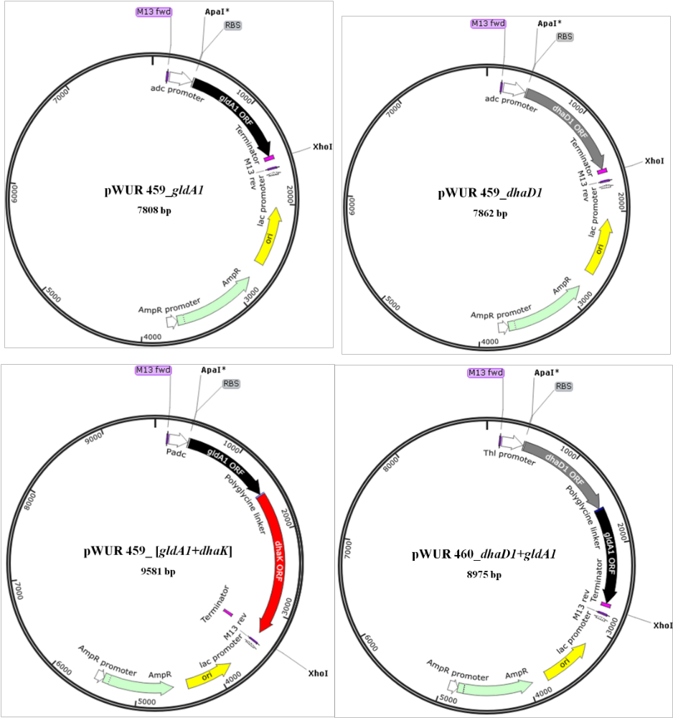
Fig. S1: Schematics of some recombinant plasmids that were used to transform electrocompetent Cb.
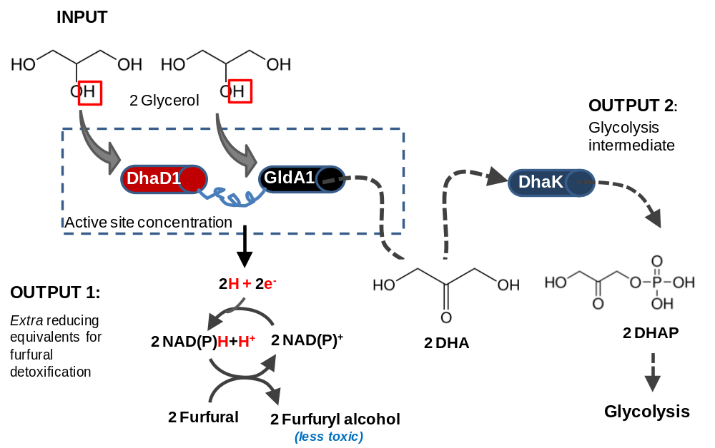

Fig. S2: Enzyme-substrate conduit demonstrating putative metabolic function of Cp glycerol catabolic pathway engineering in Cb. Engineering of two Gldh as fused protein was designed to increase the active site concentration per location, thereby improving the efficiency of NAD(P)H generation during glycerol catabolism.. DHA = dihydroxyacetone; DHAP = DHA phosphate; DhaK = DHA kinase; DhaD1 and GldA1 = Cp Gldh.
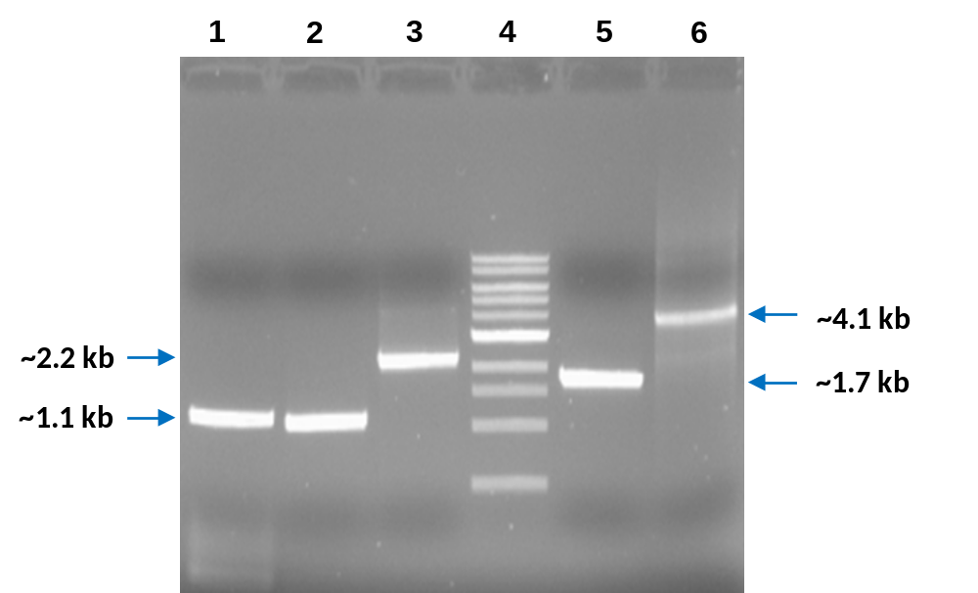
Fig. S3: DNA electrophoresis gel image to confirm PCR amplicons. Lanes (1) dhaD1, (2) gldA1, (3) dhaD1+gldA1, (4) DNA ladder, (5) dhaK, and (6) [dhaD1+gldA1] + dhaK.

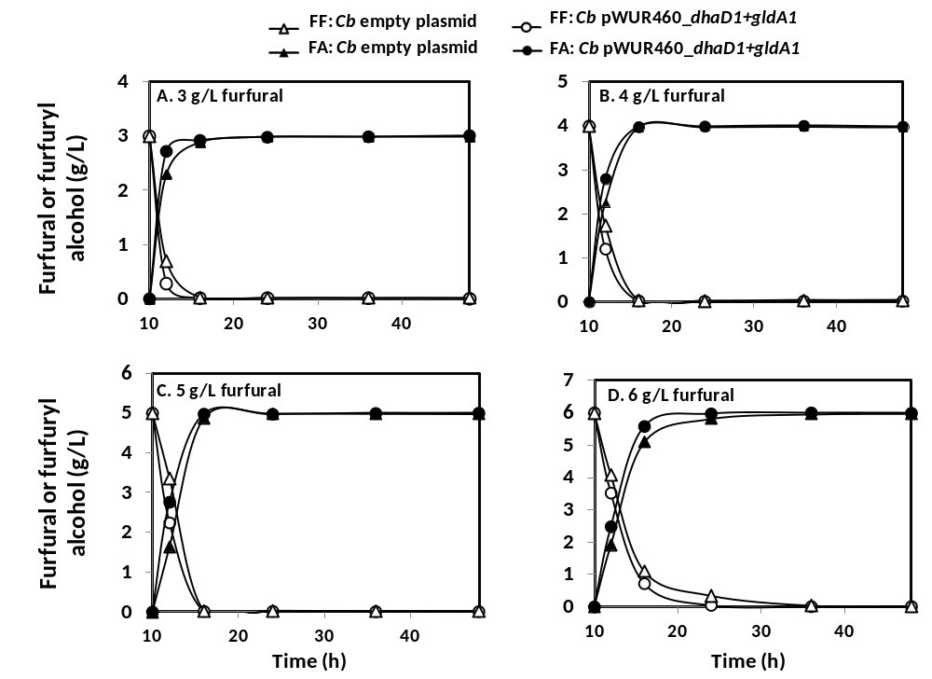
Fig. S4: Furfural detoxification profile of C. berijerinckii-pWUR460_dhaD1+gldA1 during the fermentation of glucose + glycerol (1: 2 molar ratio) challenged with 3 g/L (A), 4 g/L (B), 5 g/L (C), and 6 g/L furfural (D). (FF: Furfural; FA: Furfuryl alcohol).

