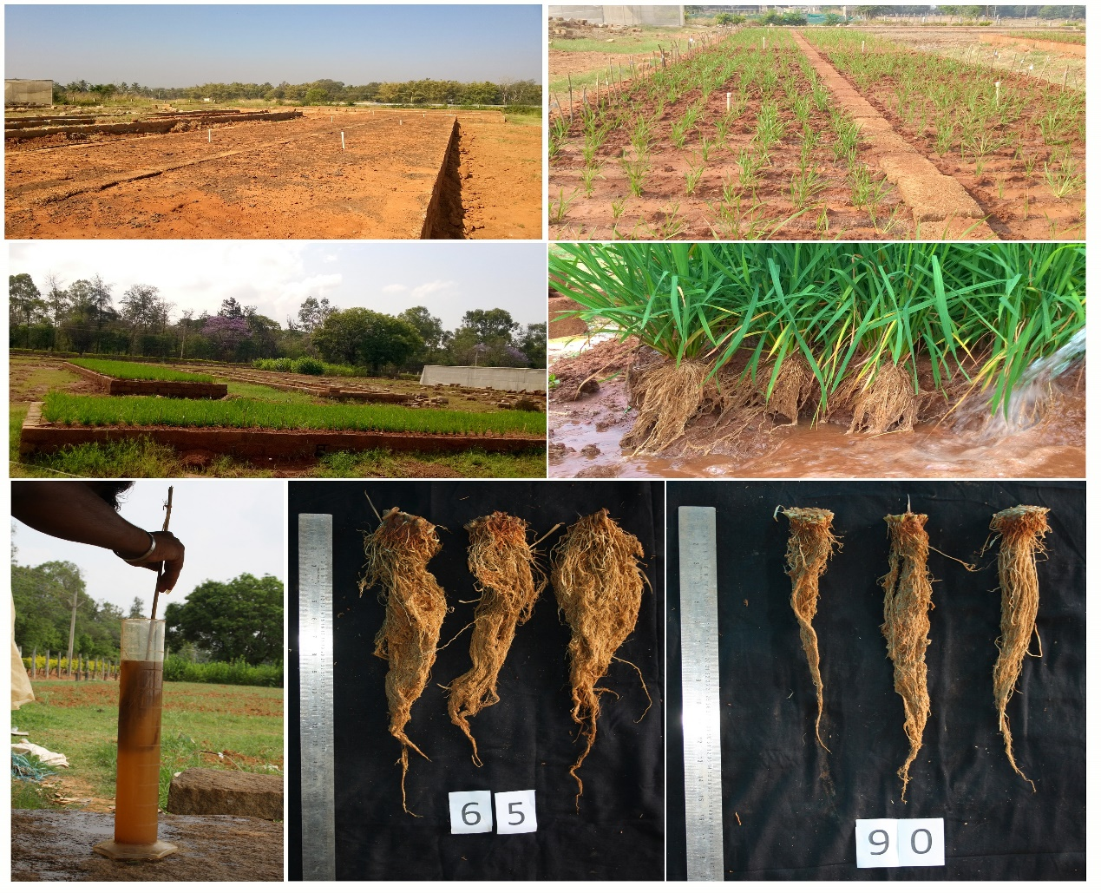
A
B
C
D
E
F

Additional file 1

Figure S1. Root phenotyping using root structures.
Foot note: Specially designed root structure (Raju et al., 2014) ensures accurate phenotyping for root traits under natural conditions and with interplant competition like in real field conditions (A-C). The soil can be washed by dismantling the side walls using a jet water (D). Determination of root volume by water displacement approach (E). Genetic variability in root traits (F).

Figure S2. Identification of trait introgressed lines for advancing at BC₃F₂ stage.
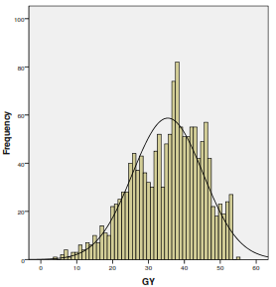
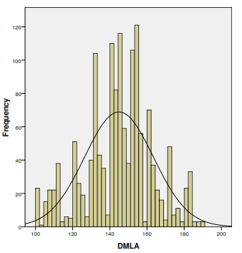
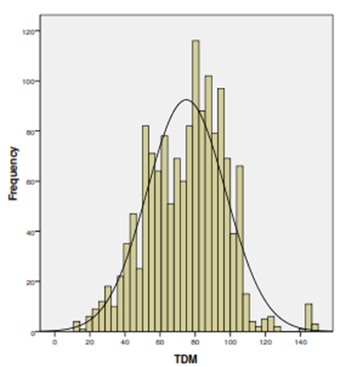
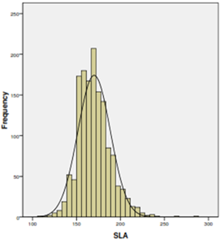
#
#
#
#

Figure S3. Frequency distribution of BC₃F₂ population for various morpho-physiological traits under aerobic condition. # indicates the value for recurrent parent IR-64.

Foot note: SLA – Specific leaf area (cm² g⁻¹), TDM – Total dry matter (g pl⁻¹), DM/LA – Dry matter per unit leaf area (g mt²), GY – Grain yield (g pl⁻¹).
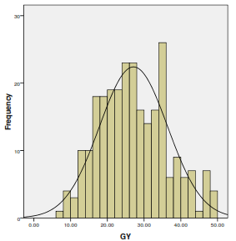
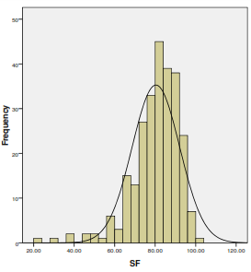
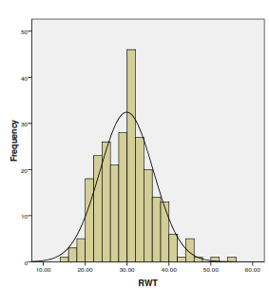
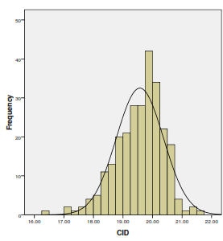
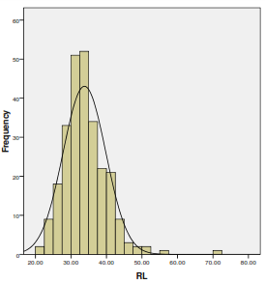
#
#
#
#
#

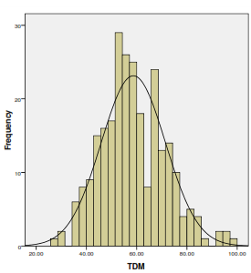
#

Figure S5. Frequency distribution of BC₃F₃ population for various morpho-physiological traits in root structure. # indicates the value for recurrent parent IR-64.
Foot note: RW - Root weight (g pl⁻¹), RL – Root length (cm), Δ¹³C - Carbon isotope discrimination (parts per mill), TDM - Total dry matter (g pl⁻¹), GY – Grain yield (g pl⁻¹), SF – Spikelet fertility (%).

Figure S6. Improved phenotype of the selected TILs along with parents. A - IR-64, B - AC-39020, C - IET-16348,D - TIL-32-1-40-84-54, E - 32-1-40-24-57, F - 32-1-40-78-84, G - 81-23-27-378-93, H - 81-23-31-75-157
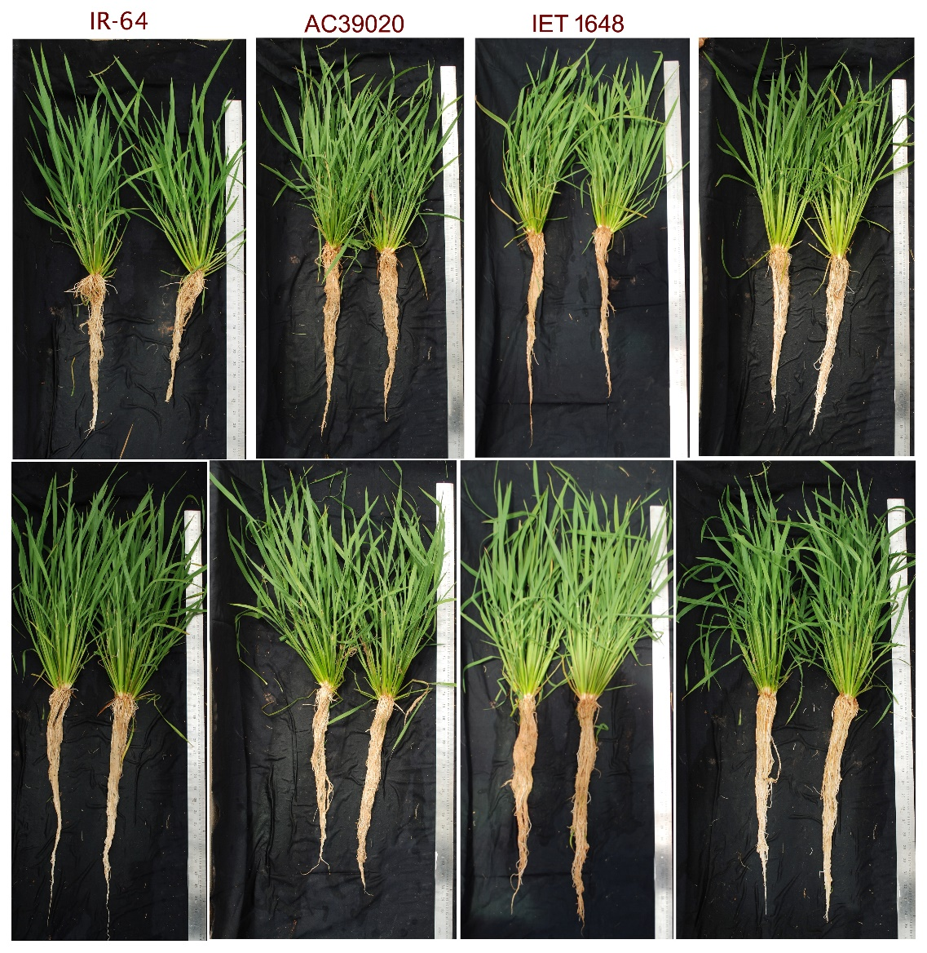
A
B
C
D
E
F
G
H

Table S1. Background markers used in the study for reconstructing IR-64 background
Chr. # | No. of markers analysed | Total number of polymorphic markers | Name of the polymorphic markers
1 | 38 | 11 | RM10793, RM495, RM292, RM1067, RM3412, RM306, RM10748, RM297, RM1387, RM302, RM5310
2 | 34 | 12 | RM154, RM211, RM279, RM324, RM327, RM561, RM341, RM475, RM3515, RM573, RM497, RM250
3 | 37 | 13 | RM523, RM175, RM218, RM81, RM157, RM251, RM8208, RM16, RM227, RM520, RM143, RM514,RM570
4 | 33 | 15 | RM307, RM518, RM119, RM167, RM5635, RM1388, RM3288, RM5503, RM3276, RM3335, RM1153, RM470, RM451, RM1113, RM131
5 | 37 | 8 | RM5374, RM194, RM421, RM7363, RM305, RM6054, RM188, RM26
6 | 37 | 11 | RM1369, RM588, RM276, RM6857, RM539, RM3, RM564, RM1370, RM3343, RM340, RM5818
7 | 42 | 11 | RM427, RM7454, RM125, RM501, RM214, RM180, RM336, RM346, RM118, RM3552, RM1306
8 | 36 | 9 | RM337, RM6925, RM1235, RM8020, RM544, RM547, RM350, RM210, RM230
9 | 32 | 11 | RM3769, RM5122, RM7424, RM257, RM3164, RM288, RM553, RM342, RM3808, RM201, RM278
10 | 41 | 8 | RM5095, RM3214, RM8201, RM591, RM7300, RM7217, RM4477, RM590
11 | 39 | 10 | RM4, RM1240, RM7557, RM536, RM3428, RM21, RM229, RM5349, RM457, RM20
12 | 36 | 10 | RM6296, RM3472, RM491, RM101, RM511, RM519, RM309, RM270, RM17, RM12

Table S2. Differences in weather parameters between experimental locations (Bengaluru and Mandya)

Experiment | Root traits and WUE | Yield parameters
Place | GKVK campus, Bengaluru | VC Farm, ZARS, Mandya
Year and season | 2015 (Summer) | 2015 (Summer)
Latitude and longitude | 13° 05'N;770 34'E | 12°.31' 27'N;76.530 44'E
Altitude (MSL) | 930 | 678
Mean sun shine hours | 8.6 | 8.8
Mean temperatures (º C)(mini-max) | 22.3-33.6 | 25.3-34.6
Mean relative humidity (%) | 60.8 | 65.8
Average annual rainfall (mm) | 859 | 700
Site/conditions | Aerobic condition | Aerobic and puddled
Soil type | Red loamy | Red loamy and clay loamy

Table S3. Improvement of yield and yield-attributes among selected trait introgressed BC₃F₁ progenies
Trait | IR-64 | Selected plants in DCBC₃F₁
 |  | 32-1-34 | 32-1-40 | 81-23-107 | 81-23-115
SLA | 188.04 | 157.24 | 179.54 | 136.8 | 226.5
TDM | 62.75 | 118.50 | 119.4 | 117.4 | 122.1
GY | 28.50 | 57.00 | 58.40 | 47.40 | 48.10
HI | 0.45 | 0.48 | 0.49 | 0.40 | 0.39
SF | 60.69 | 85.57 | 86.36 | 90.24 | 75.77
GL/GW | 4.57 | 4.27 | 4.08 | 3.78 | 4.53
DM/LA | 135.6 | 167.6 | 156.6 | 165.4 | 134.4

Note: SLA – Specific leaf area (cm² g⁻¹), TDM – Total dry matter (g pl⁻¹), GY – Grain yield (g pl⁻¹), HI – Harvest index, SF – Spikelet fertility (%), GL/GW – Grain length to width ratio, DM/LA – Dry matter per unit leaf area (g mt²).
Note: See Table 2 B for Δ¹³C and LT for these four trait introgressed BC₃F₁ plants

Table S6: Morphophysiological characters of TILs under well-watered and water limited condition along with IR-64

TIL # | PH |  | SCMR |  | TN |  | PN |  | TW |  | GL/GW
 | WW | WL | WW | WL | WW | WL | WW | WL | WW | WL | WW | WL
32-1-40-84-54 | 63.00 | 56.83 | 38.00 | 32.77 | 34.00 | 29.67 | 32.33 | 19.33 | 27.18 | 18.17 | 2.6 | 2.1
32-1-40-24-57 | 70.67 | 63.56 | 36.13 | 34.80 | 31.67 | 28.00 | 22.00 | 23.00 | 25.57 | 18.25 | 2.3 | 2.2
32-1-40-78-84 | 62.33 | 59.94 | 41.00 | 38.10 | 33.00 | 27.00 | 20.67 | 18.50 | 24.61 | 20.15 | 2.2 | 2.0
81-23-27-378-93 | 65.00 | 58.44 | 41.53 | 35.20 | 29.33 | 20.50 | 20.33 | 18.50 | 28.35 | 18.35 | 2.4 | 2.3
81-23-31-75-157 | 67.33 | 56.44 | 34.50 | 38.15 | 28.00 | 26.00 | 20.50 | 18.00 | 25.98 | 17.63 | 2.5 | 2.2
IR-64 | 55.33 | 50.78 | 30.93 | 32.75 | 25.33 | 13.33 | 18.00 | 15.00 | 24.30 | 16.10 | 2.2 | 2.0
CD | 5.8 |  | 3.6 |  | 5.4 |  | 4.5 |  | 4.3 |  | 0.01
CV | 8.4 |  | 10.4 |  | 10.5 |  | 9.2 |  | 3.4 |  | 2.1

Note: WW – Well watered (100% FC), WL – Water limited (60 % FC)
PH – Plant height (cm), SCMR – SPAD chlorophyll meter reading, TN – Tiller number (#), PN – Panicle number (#), TW – Test weight (g),
GL/GW – Grain length to width ratio.

