Additional file 1
An MRI-guided HIFU-triggered wax-coated capsule for supertargeted drug release
Original Research Article

Table S1. Quality control of lanolin (source Hänseler AG, Switzerland).
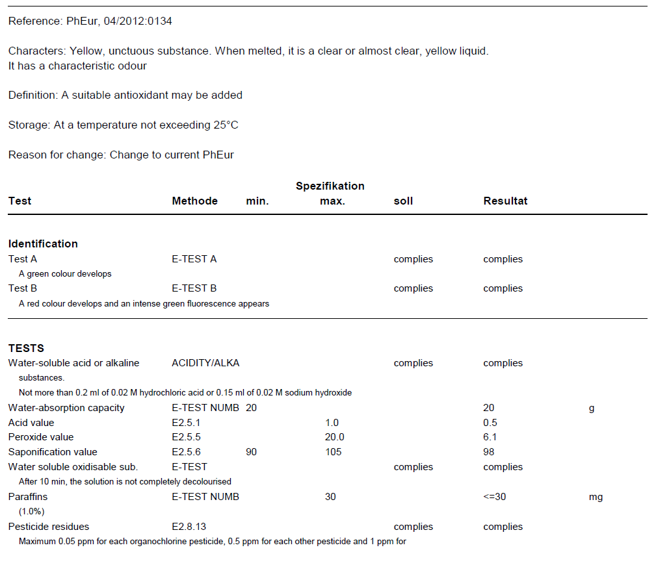
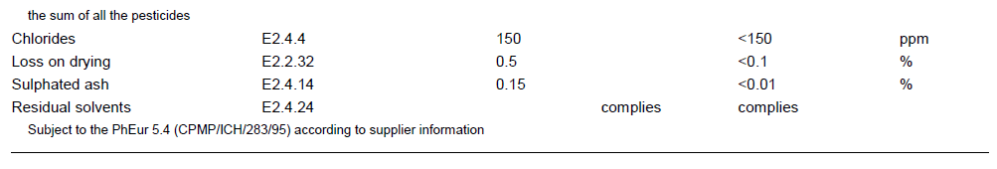

Table S2. Quality control of cetyl alcohol (source Hänseler AG, Switzerland).
