Figure S1. Genetic Power Calculator plots showing the power of the GWAS analysis (y-axis) for a population of 350 Duroc pigs. The effect size (from 0 to 0.35) is plotted in the y-axis. We have assumed an allele frequency of 0.35 and two potential r² values (0.6 and 0.8) between the unknown causal mutation and the marker SNP.

Figure S2. Boxplots depicting the mRNA expression levels of cis-eQTL regulated genes measured with RNA-Seq and microarrays in the gluteus medius muscle of 52 and 103 Duroc pigs, respectively. Means were compared with a Student’s t- test: P-value > 0.05 (ns); P-value ≤ 0.05 (*); P-value ≤ 0.01 (**); P-value ≤ 0.001 (***) and P-value ≤ 0.0001 (****).

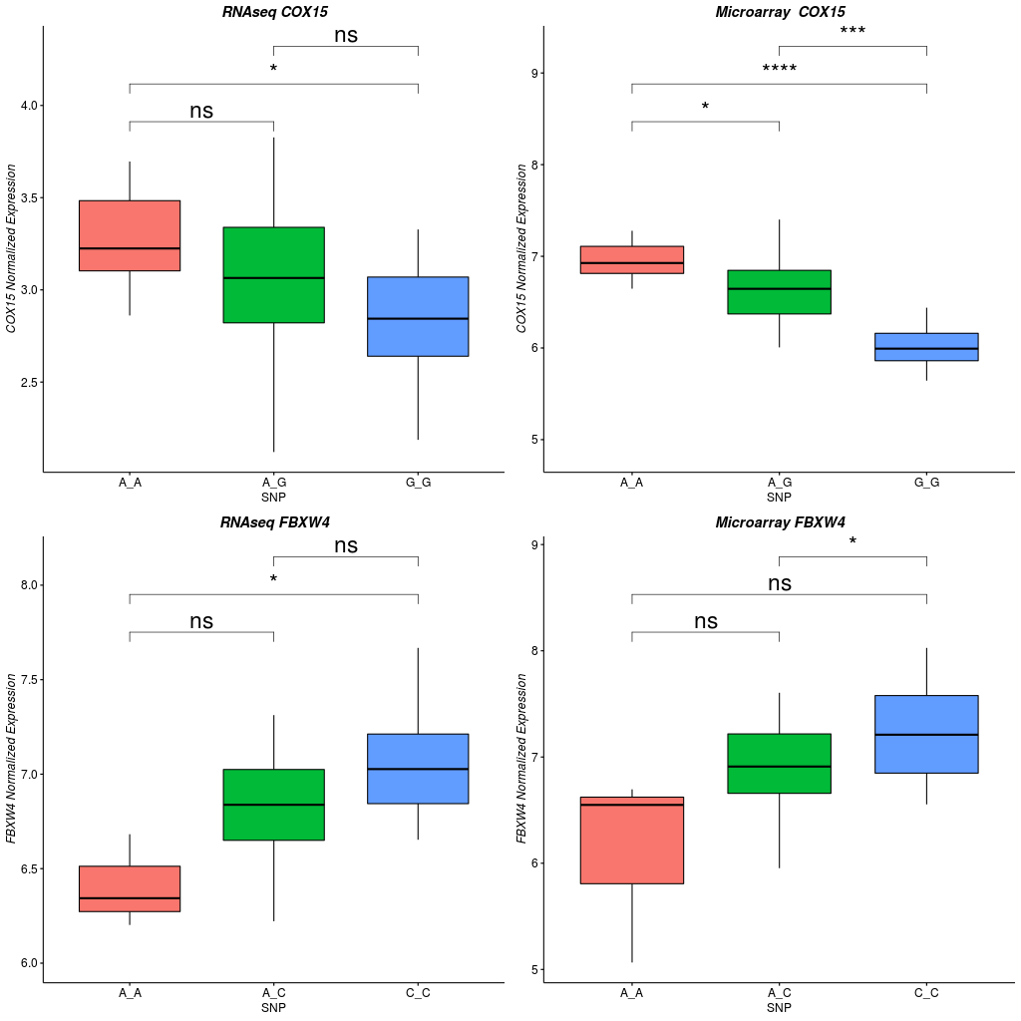
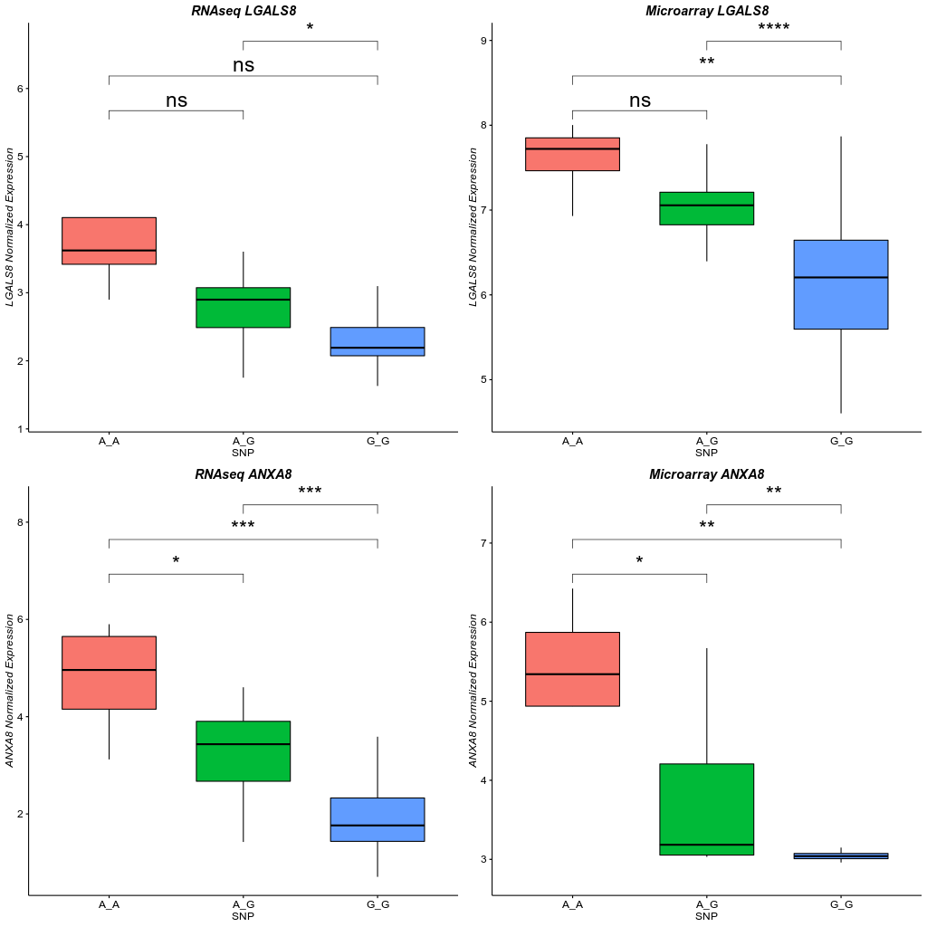

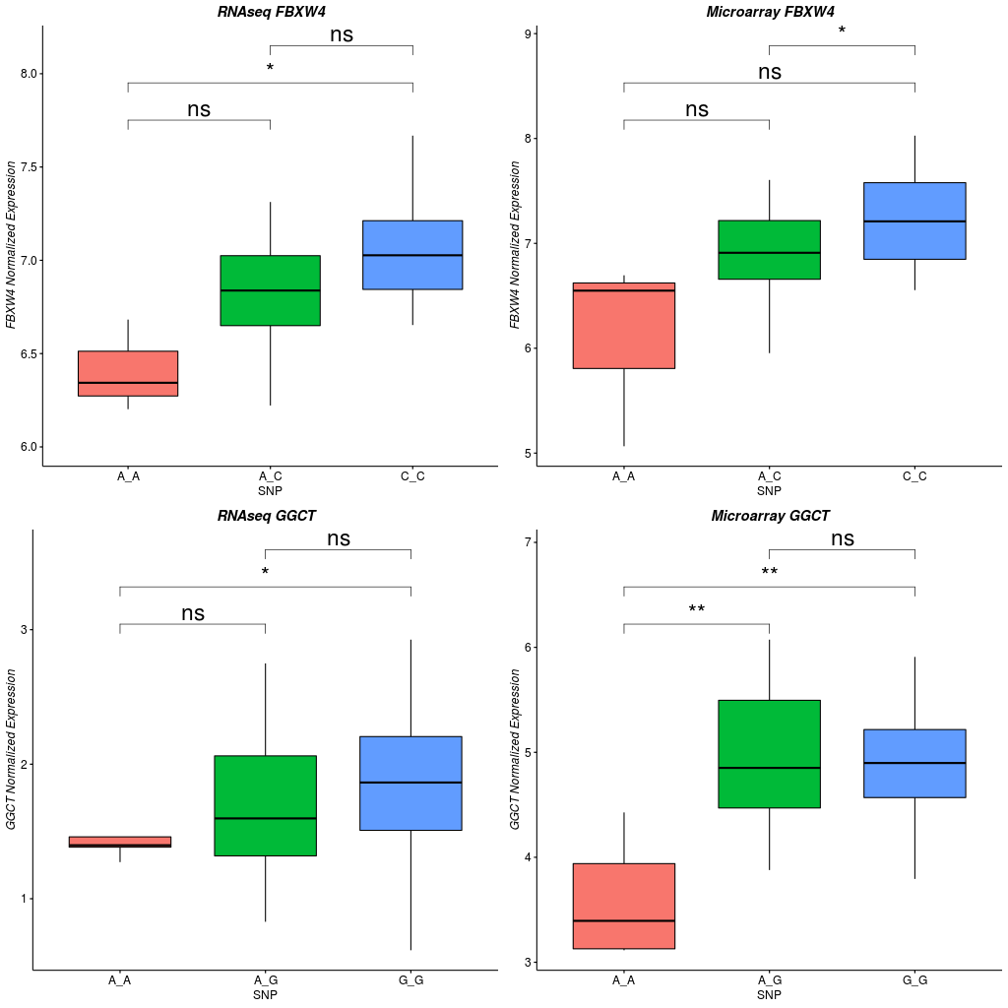

Figure S3. Least square means of the stearoyl-CoA desaturase (SCD) mRNA expression levels measured with microarrays (TT, N=4; TC, N=20 and CC, N=18) and RNA-Seq (TT, N=4; TC, N=20 and CC, N=18) in the gluteus medius muscle of Duroc pigs with known genotypes for a polymorphism located in the 5’end of the porcine SCD gene (g.2228T > C). Means were compared with a Student’s t- test. Although in both analyses CT pigs show a higher SCD mRNA expression than the CC and TT ones, differences are non-significant (ns).

